**Spring 1 2020 Topic Letter**

**Wonderful World**

**Well what an incredible half term we had. The school performance I think we can all agree was amazing and I was so proud of all the children and their ability to stand on the stage in front of an audience. We had so much fun looking at the polar animals and of course not forgetting our class Elf, Buddy who provided the children with great excitement each morning. I can’t wait for another fun filled adventurous term exploring our new topic, ‘Wonderful World’.**

**Just a few reminders:**

Please make sure your child has a suitable waterproof coat with a hood and a hat, scarf and gloves.

Please can you make sure all belongings are named as things have started to go missing and often get muddled up.

We cover Physical Development throughout the week. Some examples of this are—Dough Disco, obstacle courses, jumping, riding the bikes, throwing, catching, digging and balancing. We provide lots of opportunities to develop fine and gross motor skills throughout the continuous provision. So don’t be concerned if your child has not used their PE kit they are still getting lots of exercise.

We are also looking at another form of Tapestry but don’t worry we have still been taking lots of photos of your children which will be uploaded when we choose the new app.

**Wonderful World...**

**Literacy**

This term Reception will be continuing in short daily RWinc sessions to secure their recognition of all of Set1 sounds. We will be consolidating blending and segmenting simple CVC words. We will be emphasising the importance of learning ‘red’ words which the children cannot read using their phonics skills. We will be continuing with learning how to structure sentences and apply our knowledge to writing them.

Reception will continue to take home reading books to share at home along with their RWInc phonic formation book and green word cards to practise reading. Nursery will start to take home a picture book which we encourage you to take the time to discuss each page with them and ask questions about what is happening.

In Nursery there will be a focused RWInc session for them which will include identifying the initial sound in words and what words rhyme.

We will be promoting independent mark making and making sure the children understand the different purposes of writing/mark making. For example, writing a list of ingredients for a fruit salad and descriptions of animals.

We will be looking closely at Non-fiction books about jungle animals and how they are different to the fiction stories we are used to sharing. We will be using lots of power words and adjectives to describe the animals and fruit.

A big thank you to parents/legal guardians for supporting your child with their reading, phonics cards and mark making at home.

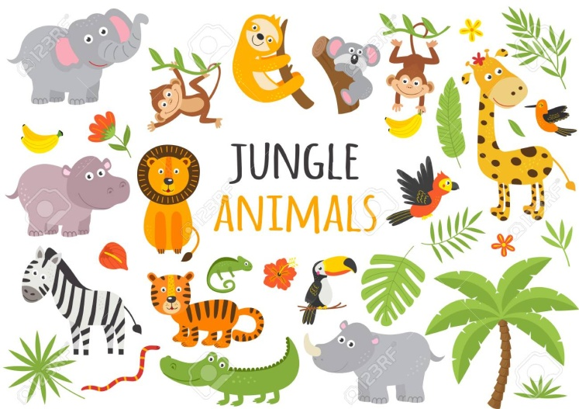Please continue to do so as this has been shown to have a massive impact on your child’s learning.

**Mathematics**

We are following the White Rose maths scheme along with the fantastic Numberblocks. The children have enjoyed meeting numbers 1-10 so far. Looking at the shapes related to each of the numbers ie number 1 likes circles, number 3 likes triangles, number 4 likes squares and rectangles and number 5 likes pentagons. We have also looked the 1p, 2p and 5p. If you can continue to build on this at home while out for a walk or in a shop letting the children look at the coins etc.

Reception have been learning their number bonds to 10 so please continue to help them at home with these.

This term Reception will be securing our knowledge of our number bonds to 10. We then will continue learning the number facts to 20. When out and about please support your child by asking them what numbers they can see and what is one more/one less than the number.

We will be learning about 3D shapes and their properties. When out shopping if you could support your child by asking them what shape is a cereal box, a tin can etc. We will be comparing heights, weights and capacity of various objects.

In Nursery they will be securing recognising numbers to 5 and moving on to recognising numbers to 10 and counting beyond 10. With learning lots of nursery rhymes to support their fluency in counting like 10 green bottles, 5 little ducks and 5 little speckled frogs. Please ensure if they are counting at home that they are counting accurately by pointing/touching one object at a time and saying a number. In Nursery we will also be exploring shapes and describing them using words like big, round etc.

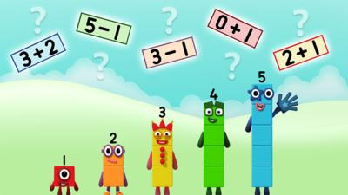Both Reception and Nursery will have a focus on positional language ie on, in front of behind etc. We will be exploring these outside by completing obstacle courses and treasure hunts.

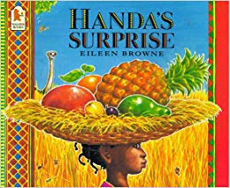**Understanding the World**

We will be learning about different countries focusing on Africa and the story Handa’s surprise. The children will be seeing if they can spot the differences between us and them and thinking about the similarities and differences between where we live and where they do. We will be learning about the different materials that they use to make their houses and seeing if we can create our own versions. We will be looking at the various jungle animals and the habitat in which they live. The children will continue to attend forest school weekly. We will also look at how we can be more environmentally friendly and what materials can be recycled.

**Personal, Social, Emotional Development**

These skills are promoted at all times and we work on these attributes in everything we do in Early Years as they are very important. However this term we will be particularly focusing on:

* Can play in a group for extended periods of time and keeps play going by responding to others.
* Understanding that our actions have consequences.
* Enjoys carrying out small tasks.

**Communication and Language**

We will be learning some jungle songs and exploring animal noises. The children will be developing their listening skills to be able to follow multiple instructions. We will be continuing to develop a wide range of vocabulary based on our new topic. In Reception they will be continuing to listen to the new sounds in RWI. In Nursery they will be focusing on hearing the initial sounds in words. When reading stories to the children we will be discussing what might happen next and getting the children to ask question about what is happening in the story.

**Physical Development**

All children will take part in Dough Disco using theraputty to help strengthen the muscles in their fingers supporting their fine motor skills. They will also complete daily finger gym exercises including, using tweezers, balancing objects on golf tees and following the pattern.

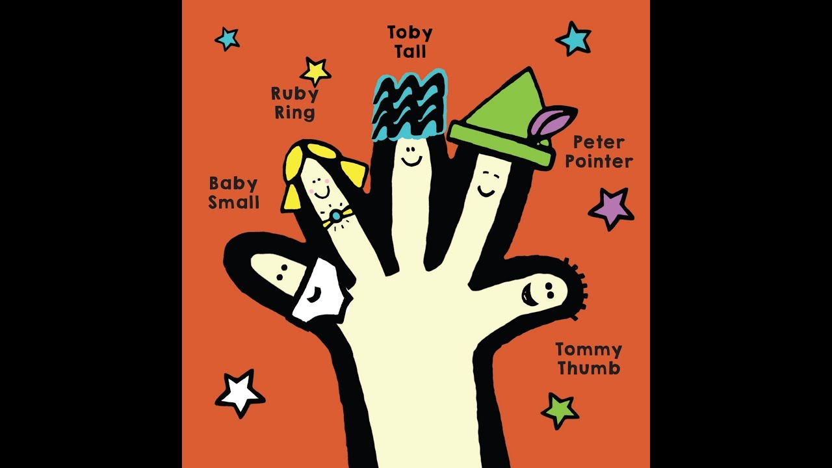

Nursery and Reception will be working on pencil control and using the correct pencil grip. In Nursery and Reception we will be working very hard to make sure we are correctly forming all of the letters in our name. We will be reminding children about the correct starting position for each letter. Some of us will be beginning to think about the size of our writing and begin to write along a line. In Reception we will be forming words and sentences.

We will be promoting independent toileting at all times and will continue to spend a lot of time working on this. We will also be revisiting hand washing to make sure the children are effectively washing their hands.

**Expressive Art and Design**

We will be promoting independent use of the craft and painting areas. We hope the children will create their own work and have their own ideas independently. The children will be experimenting and working out what we can use to cut and stick and attach items together. We will be promoting construction for a purpose like African houses and clothing. We will also explore different tribal and animal patterns.

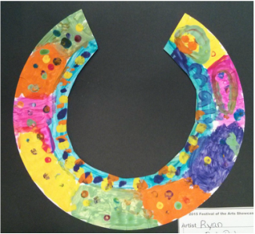

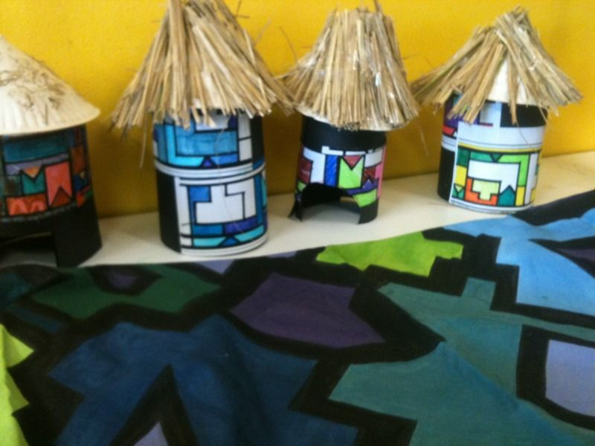

**SRE**

As part of our statutory SRE curriculum this half term we will be thinking about body awareness. The children will learn that humans produce babies that grow into adults, to know the accurate names for some body parts and what their function is and to consider ways they have changed since being a baby.

**RE**

This half term Reception will take part in RE sessions to understand Christianity and will focus on ‘God’. Nursery will talk about special times, take part in special worships and learn about special festivals and celebration such as Easter and Chinese New Year.



Thank you again for your continued support and we hope to have another fantastic term in Early years. If you have any questions please don’t hesitate to contact myself, Miss Armstrong or Mrs Manners