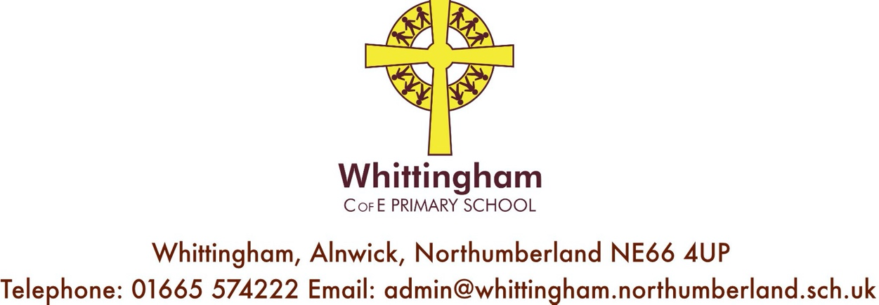

Website: www.whittinghamprimaryschool.co.uk
Thursday 10th September 2020
Reading in School

Dear Parents and Carers,

As we return to school we are looking as a staff at how best to organise reading, whilst meeting expected guidelines for COVID-19. Reading is so important for our pupils and we need to ensure we organize reading materials in as safe a way as possible.

All children in Key Stage 1 and 2 have been re-assessed this week, using the Star Reading Assessment, which is part of our Accelerated Reader Program. They each complete a comprehension type quiz, which is tailored to their level of understanding. These tests are completed on a laptop, and provide detailed information about each child’s reading growth, showing which skills they have mastered from the National Curriculum, allowing us as teachers to see the skills each student needs to focus on to meet or exceed expected standards for their age.

Obviously the children have been absent from school for a significant period of time and we are aware that getting used to being in the classroom environment, and using devices they may not have used in a long time to complete these assessments, may take a bit of adjustment. Because of this we have seen some children have dipped in their reading age and ZPD level range. After completing these assessments, the children are given a ZPD level which is linked to our reading books, for example 2.6 – 3.8. As we are at the start of a new school year, following a significant break from school, the children have been given books at the lower end of their given ZPD range. However, this is being monitored regularly by your child’s class teacher and the children will be moved up this ZPD range if we feel it is necessary. Children will also be tested again at the end of the half term to monitor progress. Children have been issued two new school reading books this week based on this most recent data – one to keep in school and one to read at home.

Each classroom has a quarantine box, in which finished books are placed and this is emptied every Monday. This means all books are untouched for at least 48 hours, to ensure safety.

Finally, when we finished school in March for lockdown, all pupils were given a number of reading books to take home. Although some pupils have already returned these, a number of our school books have not yet been returned. Please could all pupils return any school reading books as soon as possible?

Thank you again for your continued support.

Best wishes,

Mrs Erin Fletcher
Literacy Co-ordinator

