1) Label all the world’s continents and oceans indicated by where the lines to write on are.
2) Research facts about each of the continents you’ve labelled and add this to your map (bullet-points are fine).

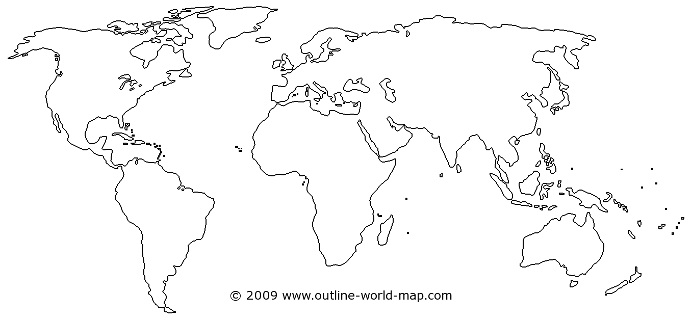

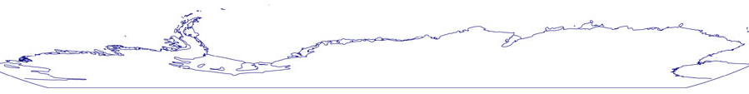

Continents: Africa, Antarctica, Asia, Oceania, Europe, North America, South America,

Oceans: Pacific, Atlantic, Indian, Arctic, Southern Ocean

