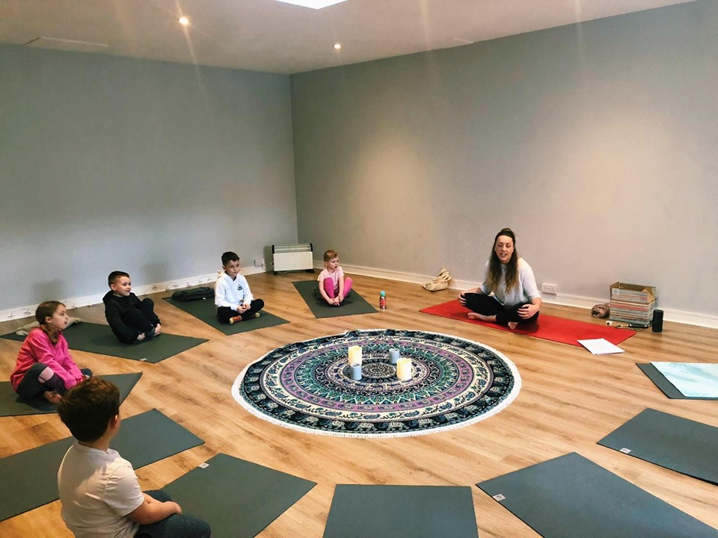

**WHITTINGHAM VILLAGE HALL**

**SUNDAY 8TH MARCH**

**10-10:45AM**

**Drop your little one off for 45 minutes of all things yoga fun! Meditation, pranayama, yoga poses, songs and games and more!**

**Class for 4-8 year olds**

**£7.50 per child**

**Please contact me directly via the contact details below to book a spot.**

