

0.25

LO: read and write decimal numbers as fractions (lesson 3)

**Diagnostic ANSWERS**

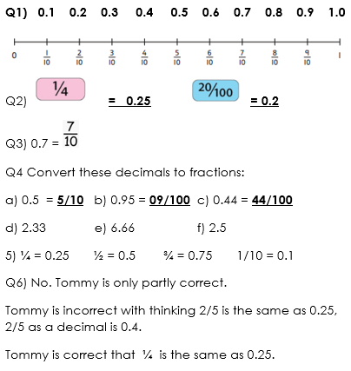

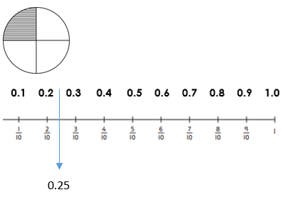

LO: read and write decimal numbers as fractions (lesson 3)

**Diagnostic ANSWERS**

**Q1) 0.1 0.2 0.3 0.4 0.5 0.6 0.7 0.8 0.9 1.0**

Q2)  **= 0.25**  **= 0.2**

Q3) 0.7 = 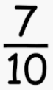

Q4 Convert these decimals to fractions:

a) 0.5 = **5/10** b) 0.95 = **09/100** c) 0.44 = **44/100**

d) 2.33 e) 6.66 f) 2.5

5) ¼ = 0.25 ½ = 0.5 ¾ = 0.75 1/10 = 0.1

Q6) No. Tommy is only partly correct.

Tommy is incorrect with thinking 2/5 is the same as 0.25, 2/5 as a decimal is 0.4.

Tommy is correct that ¼ is the same as 0.25.

