Class One Topic Letter
Autumn Term 2nd Half 2020
Miss Armstrong supported by Miss Clark
Dear Parents/ Carers,
I am pleased to say the children have made a good start to the first half of Autumn Term; the children are getting back to being used to the routine of school . We will now have PE on a Wednesday and Friday. Children should come dressed in full PE kit on these days. Please ensure that your child brings a water bottle and coat each day. Now that the weather is getting colder, I would advise a hat, scarf and gloves as well. Even though the run up to Christmas will be different due to the new normal we will still be taking part in lots of festive activities and you will hear about these by letter, email or I may send class messages on Class Dojo.
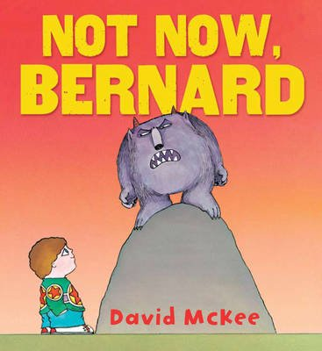
English
We will be looking at some non-fiction texts about animals and creating our own information texts about them. We will be learning the key vocabulary related to this including heading, sub-heading, illustration etc. Then we will be taking a look at another fiction story with a familiar setting. We will be looking at ‘Not Now, Bernard’, ‘The Slightly Annoying Elephant’ and many more. We will be focusing on a lot of SPaG ( spelling and grammar) work including looking at expanded noun phrases, adjectives, adverbs, verbs and also past and present tenses. Linked with our topic we will be looking at the story, ‘The Sand Horse.’
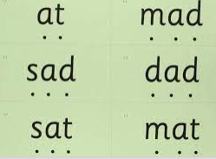
Reading
As always, we will have lots of time to listen to a story as this develops the children’s love of books and also develops their early comprehension skills as they listen to a story and answer some questions along the way. We will be continuing the Read Write Inc programme which develops their phonics.
Please support your child at home in learning to read (and eventually spell) their High Frequency Words as this will also make reading easier for them. It is also of great help if you can read some stories to your child as well as this helps to build their imaginations along with developing their range of vocabulary.
We will be having weekly spelling tests so please ensure that you support your child at home to learn the spellings given and to keep practising these spellings so that they can consistently apply spellings learnt into their independent writing.
Maths
One of my favourite subjects which I hope I will inspire the children in their learning.
Year 1 will be looking at addition and subtraction within 20. Making sure we can compare numbers and use the vocabulary greater than/smaller than and equal. We will be looking at lots of different shapes and their properties. Please support your child in recalling their number bonds to 10 and 20.
Year 2 will be looking at addition and subtraction within 100. We will be learning about the column method and how to set this out correctly. We will be recalling our number bonds to 10,20 and 100. Then we will be looking at addition and subtraction using money.
A great resource which we use for remote learning is https://whiterosemaths.com/homelearning/
You may find this useful to help support your child at home anytime.
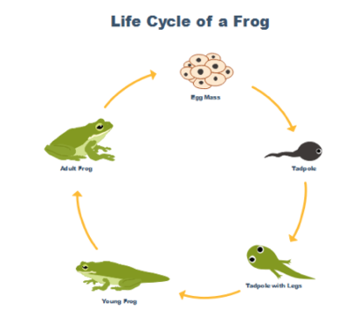
Science
In Science we will be continuing to explore the topic, Animals including Humans. We will also carry out some simple scientific experiments making predictions about what might happen and seeing if we are correct. We will be looking at life cycles, habitats, micro-habitats, food chains and so much more.
Art and Design
We will be using clay create some beautiful Diva lamps. We will be using different painting and sketching techniques to create some amazing animals designs and prints.
Computing
We will be continuing to learn how to log on and off and use the internet safety. We will also be looking at programming and using the programming tool, ‘Scratch’.
RE
We will be looking at Hinduism and Christianity. Within Hinduism we will be exploring Diwali and in Christianity we will be exploring the Harvest festival has this not already been done? and Christmas.
PE
Forest Schools
Music – Charanga or not on timetable this half term?
Homework
Please keep up the excellent work of supporting your child complete their homework and uploading photos onto Class Dojo. We also set work for Maths on Sumdog please ensure your child completes these tasks and also plays on the games for Maths, Reading and Spelling as they are tailored accurately to your child’s current learning and are a fun way to learn.
I look forward to this exciting jam packed half term and if you have any queries or questions please don’t hesitate to ask.
Miss Armstrong.

