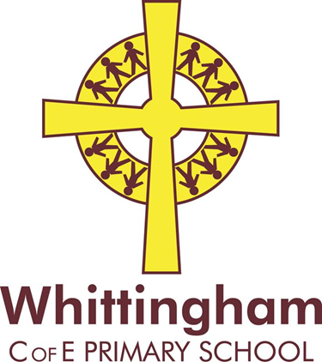

Friday 9th March 2017
Trip to Arcinova
Dear Parents/ Legal Guardians,
Our Key Stage Two pupils have been offered an exciting opportunity to visit Arcinova pharmaceutical research centre in Alnwick. The visit will take place on the morning of Friday 31st March and we will be accompanied by the Key Stage Two children from Branton and Swarland Primary Schools.
On the visit the children will have the chance to explore the centre to discover how medicines are created. We will meet the scientists that work in the centre and be able to see the process of creating pharmaceuticals from the initial mixing of chemical components in the laboratory, to testing, dosage and how they should be taken.
Arcinova have kindly offered this visit free of charge but we ask for a contribution of £2.00 to cover the cost of the bus.
Photographs will be taken by school staff whilst on the trip and Arcinova have asked if some of these photographs could be used by them for publicity purposes. This may include their website, within their building and possibly to advertise trips for other schools. If you do NOT wish for your child’s image to be used, please indicate below.
Please complete the slip below and return to school.
Please note: We will return to school for dinner as usual.
Yours sincerely,
Mrs Fletcher and Mrs Fortescue
_________________________________________________________________
Arcinova Visit – March 2017

Name: _____________________________ Class: _____________

▪ I give permission for my child to visit Arcinova
▪ I enclose a voluntary contribution of £2.00
▪ I DO NOT give permission for my child’s image to be used by Arcinova for publicity purposes.
Signed: ____________________________________________Parent/Carer

