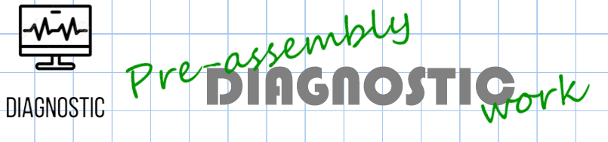





Date: ___________________________

LO: to read and write decimals as fractions (L4)

**Diagnostic ANSWERS:**

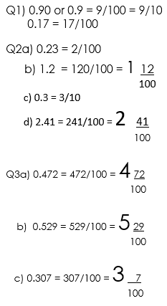

Q4) Table answers:

|  |  |  |  |  |
| --- | --- | --- | --- | --- |
| **Decimal** | **Decimal expanded form** | **fraction** | **Fraction expanded form** | **In words** |
| 3.01 | 3 + 0 + 0.1 |  | 3 + 1  100 | Three ones, zero tenths and one hundredth |
| 3.42 | 3 + 0.4 + 0.02 | 3 42  100 |  | Three ones, four tenths and two hundredths |
| 2.32 | 2 + 0.3 + 0.02 | 2 32  100 | 2 + 3 + 2  10 100 |  |

Date: ___________________________

LO: to read and write decimals as fractions (L4)

**Diagnostic ANSWERS:**

Q1) 0.90 or 0.9 = 9/100 = 9/10

0.17 = 17/100

Q2a) 0.23 = 2/100

b) 1.2 = 120/100 = 1 12

100

c) 0.3 = 3/10

d) 2.41 = 241/100 = 2 41

100

Q3a) 0.472 = 472/100 = 4 72

100

b) 0.529 = 529/100 = 5 29

100

c) 0.307 = 307/100 = 3 7

100

Q4) Table answers:

|  |  |  |  |  |
| --- | --- | --- | --- | --- |
| **Decimal** | **Decimal expanded form** | **fraction** | **Fraction expanded form** | **In words** |
| 3.01 | 3 + 0 + 0.1 |  | 3 + 1  100 | Three ones, zero tenths and one hundredth |
| 3.42 | 3 + 0.4 + 0.02 | 3 42  100 |  | Three ones, four tenths and two hundredths |
| 2.32 | 2 + 0.3 + 0.02 | 2 32  100 | 2 + 3 + 2  10 100 |  |