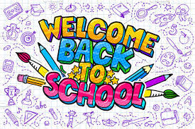
Class Teacher - Mrs E Fletcher (Monday -Thursday)
Mrs B Athey (Friday)
Supported by Mrs Morris – TA

Welcome back Class Three! It is so lovely to see the new Year 5s and 6s back in school safe, happy and well!
I know these are strange times, but we will soon feel like we’ve never been away, and we have lots of exciting learning to catch up on this half term. Our main focus this half term will be on revision and securing of previously taught learning and work covered during school closure. We will also look at mental wellbeing and develop coping strategies which can help us all during these strange times.

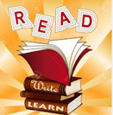  In Literacy we will begin the term by looking at one of my favourite books, 'The Boy, the mole, the fox and the Horse' by Charlie Mackesy.  I have been picking up my copy regularly over the last few months and the beautiful messages have brought me so much comfort in this difficult and uncertain time. I thought it would be a nice start to share this as part of our back to school ‘Literacy Bootcamp’. We will use it to revise conventions of the English Language together; such as word classes, sentence types and descriptive language techniques.  We will then be looking at biographies and autobiographies, using example texts to study dialogue, noun phrases and complex sentence structures, before creating our own.  Our final topic of the half term is Recount Texts - UFOs and Aliens. We will be exploring recounts, investigating genuine documents, discussing famous sightings and researching notorious hoaxes. The children will then write a diary entry and create their own hoax UFO report.  Our poetry unit this half term is ‘The Highwayman’ linked to our Crime and Punishment History Topic.  We will continue to develop our reading comprehension skills through our guided reading sessions and use of Accelerated Reader, as well as increasing understanding of written grammar through writing analysis.  The children will be expected to learn, use and spell correctly all of the spellings from the Years 3,4,5, and 6 spelling lists. This will be tested randomly at points throughout the week and children are expected to spell these words correctly in their everyday work. | Numeracy  Our main focus this half term will be on revising and consolidating understanding of Place Value and Four Operations.  Place Value  - Representing numbers to 1,000,000  - Comparing and ordering numbers to 1,000,000  - Rounding  - Negative Numbers  Four Operations  - Adding and subtracting numbers with more than 4-digits  - Inverse Operations  - Multi-step addition and subtraction problems  - Multiples and Common Multiples  - Multiplying numbers up to 4 digit by 2 digits  - Factors and Common Factors  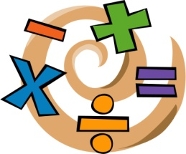  We will continue to improve our Problem Solving and Reasoning skills and strategies through daily tasks.  Please note: ALL children MUST know their times tables up to 12 times 12, and be able to recall quickly.  We are working hard as a school to help our children to become confident and fluent mathematical thinkers. We will continue our daily arithmetic lessons so that we are able to answer questions at speed.  In addition to our daily lessons, it would be helpful if your child could go on School 360 Times Table blast and KS2 SATS Blaster at least 4 x per week to develop speed and fluency.
Music – The children will be looking at Rock Music, including Bon Jovi ‘Livin’ On a Prayer’ from our Charanga Music scheme. | Reminders  Please could you ensure all equipment and clothing is clearly labelled with your child’s name.  Children will not be given planners or reading logs this half term. One piece of Literacy and Numeracy homework will be set each week, along with daily reading, Sumdog and School360 activities.  Many thanks, Mrs Fletcher.  Blended Learning –  On the school website there is now a Home Learning section and we will be using a mix of online learning using Oak National Academy https://www.thenational.academy/ and paper based activities. Watch this space for further details – Mrs Athey
Forest School and PSHE / RHE
Mindfulness Forest school- Mindfulness involves learning to direct our attention to our experience as it unfolds, moment by moment, with open-minded curiosity and acceptance. Rather than worrying about what has happened or might happen, it trains us to respond skillfully to whatever is happening right now. We will be using all our senses each week to complete tasks to connect with nature and have a sense of calm and wellbeing.

Computing  We will be using scratch to programme.  We will be using online learning and timetables effectively.  We will be producing short films/ presentations which we may use to attract the best possible Deputy Headteachers to apply for a job at our school too! | Modern Foreign Language  We will recap our French studies so far, including numbers to 30, days and months and also family members.
PE - Cricket  exploring different throwing and catching techniques. develop bowling through overarm and rapid bowling, develop consistent striking action for hitting a ball and skills for running between wickets. The children will aslo develop their ability to decision make on pitch, collaborate with peers through fair play and develop the ability to improve their own skills.  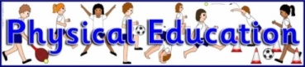  PE – Rounders. We will be using the techniques learnt in cricket to play rounders. | In RE -We use the Northumberland County Council  Agreed Syllabus for Religious Education and will be looking at how religions are celebrated around the world.
Art/DT – We will develop observational portrait skills to design wanted posters for criminals.

Designing an instrument of torture – junk modelling.
In Science / STEM - we will learn to describe the differences in the life cycles of a mammal, an amphibian, an insect and a bird.  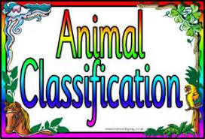  We will describe how living things are grouped and classified based on similarities and differences. | 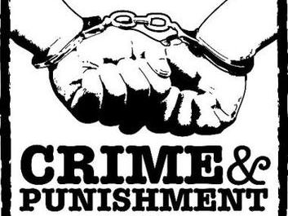  In History we will be taking a journey through British History to discover how crime and punishment has changed through the ages. Beginning with the Romans and travelling along our class timeline through the Anglo-Saxons, Vikings, Tudors, Early Modern Period to the Victorians. We will discover how changes in society create changes in the kinds of crimes that are committed, as well as the ways in which they are punished.

