

Class Teacher – Mr Charlton
Supported by Mrs Chisholm & Mrs Lewis.

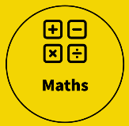  Place value  - Numbers up to 10 million  - Rounding  - Multiplying & dividing by 10, 100 & 1000  - Negative numbers  - Roman numerals  Four operations  - Addition with numbers of 4 or more digits  - Subtraction with numbers of 4 or more digits  - Short multiplication  - Long multiplication (formal long multiplication and ‘lattice method’)  - Factors  - Multiples  - Prime numbers  - Square numbers  - Cube numbers  - BODMAS  - Inverse operations  - Short division  - Long division  Please note: ALL children MUST know their times tables up to 12 times 12, and be able to recall quickly. TTRS should be used to develop speed and fluency as part of weekly homework.  Key vocabulary:  Place value, rounding, numerals, inverse, partition, equivalent, multiple, factor, prime number, operations, divisible, exchange. | 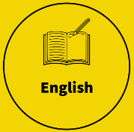  In this half-term, we begin by reviewing and practising several aspects of SPaG (spelling, punctuation and grammar). This will ensure that we begin the year with a sound understanding of some of the fundamental areas of writing for Years 5 and 6.  Next, we will then study our first genre of writing for this year which will be play-scripts. For this, we will look at several examples, including some classics such as from Shakespeare as well as more contemporary examples, such as Harry Potter And The Cursed Child. We will also write a section of playscript ourselves, using the features that we’ve studied and practised.  Our second genre of writing will be setting descriptions. We will look at various examples taken from famous books, like Mortal Engines by Philip Reeve as well as the Percy Jackson series by Rick Riordan. From these examples, we will develop our use and range of descriptive language and sentence structures.  Our class book for this half-term will be democratically selected by the pupils from the Percy Jackson series. We will use this not only as our class story but also within our guiding reading sessions. We will continue to develop our reading comprehension skills through our guided reading sessions and use of Accelerated Reader, as well as increasing understanding of written grammar through writing analysis.  Please hear your child read daily and write a message/ sign/ initial your child’s Reading Record book.  The children will be expected to learn, use and spell correctly all of the spellings from the Years 3,4,5, and 6 spelling lists. https://assets.publishing.service.gov.uk/government/uploads/system/uploads/attachment_data/file/239784/English_Appendix_1_-_Spelling.pdf  This will be tested weekly throughout the half-term and children are expected to spell these words correctly in their everyday work.  Key vocabulary:  Word class, proper noun, common noun, collective noun, abstract noun, adjective, verb, adverb, determiner, preposition, fronted adverbial, subordinate clause, simile, metaphor, personification, descriptive, emphasis, exaggeration and emotive, formal & informal language.
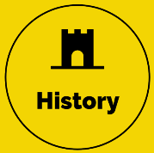  During this half-term, we will be studying the Olympics. This will include:  - Why did the Olympics begin?  - Where are the Olympics held?  - What happens at the Olympics?  -What do the games represent?  -How and why have the Olympics adapted over time?  Key vocabulary:  Athlete, Olympian, Olympia, Mount Olympus, Ancient Greek gods, honour, competitor, truce, wreath, medal, torch, tolerance, sportsmanship, equality, diversity. | 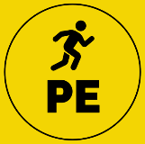  Children will be taking part in daily exercise each morning through our ‘daily mile’.  Key taught sessions during this half-term will include football and rugby.  Key vocabulary:  Stretch, muscles, ligaments, tendons, corner, the box, off-side, throw-in, substitute, structure, marking, jockeying, defensive/ offensive lines, tackle, shadowing, sportsmanship, respect, tenacity, teamwork, communicating, anticipation.
Children will be taking part in daily exercise each morning through our ‘daily mile’.  Key taught sessions during this half-term will include football and rugby.  Key vocabulary:  Stretch, muscles, ligaments, tendons, corner, the box, off-side, throw-in, substitute, structure, marking, jockeying, defensive/ offensive lines, tackle, shadowing, sportsmanship, respect, tenacity, teamwork, communicating, anticipation. | 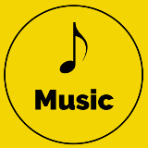  We will be focusing on Classical music. This will include:  - Identifying what Classical music is.  - Distinguishing the different timbres of instrument families so that we can identify musical instruments when listening and appraising.  - Learn about the range of ensemble structures that exist in Classical music.  Key vocabulary:  Rhythm, beat, pulse, dynamics, pitch, timbre, texture, tempo, duration, brass, woodwind, strings, percussion, symphony, orchestra, camber group, quartet, soloist, conductor.
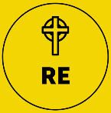  Our unit for this half-term is ‘Creation and Science: conflicting or complementary?’ where the children will look at information from science and the Creation story, weighing up evidence and influence for both, recognising where aspects of both contrast or are supportive of each other. | 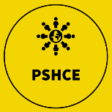  In our PSHCE/ RHE work we will be focusing on healthy life-styles, including physical health (a balanced diet and exercise) and mental health and well-being. We will also look at personal identity and to be reflective about ourselves, celebrating who and what we are as well as having tolerance, acceptance and an open-mind for things or people that are different.
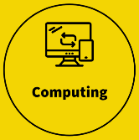  During this half-term, we will be looking at E-safety as well as computing systems and networks - communication. The aspects of communication will cover:  - Search engines (how they function and how ranking of sites works)  - Different methods of communication  - Forms of internet-based communication.  Key vocabulary:  Safety settings, acceptable use, electronic devices, respect, responsibility, trusted sites, reporting, search engines, search-bar, ranking, popularity. | 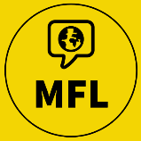  After recapping our learning from the end of last year briefly, including introducing ourselves, describing our family and recalling numbers, days and months in French, we will be continuing our language skills through naming and describing animals including pets.
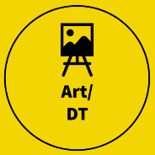  This unit focuses on understanding retrofuturism, developing skills in evaluating images and creating art through various drawing processes, including collagraph printmaking. It emphasises the development of pupils’ independent artistic skills and their ability to generate, test and refine ideas in their sketchbooks, leading to a final piece of artwork.  Key vocabulary: cold war, collagraph, collagraphy, composition, culture, decision, develop, evaluate, futuristic, imagery, printing plate, printmaking, process, propaganda, purpose, repetition, retrofuturism, revisit, space race, stimulus, technique. | REMINDERS:  Homework will be weekly, comprised of:  -spellings and times-tables will be given on a Friday, ready for a mini test on the following Friday,  -Accelerated Reader (an average of at least 5 times per week – please remember to sign your child’s reading record book periodically),  -a maths task linked to the recent learning/ revision (CGP books),  -an English task that is linked to recent learning/ revision.  As ever, myself and everyone at school are here to support. If there are ever any concerns, queries or things to celebrate, just let us know either in person, via our Class Dojo or the school office.  In our classroom, we have a ‘Wow wall’ where I display achievements of the children. If your child would like to share an achievement (this could be as a certificate, rosette or photo) then please feel free to message me on Class Dojo or email.  (Please note that I will monitor and respond to Class Dojo message between the hours of 08:30-17:30. It is absolutely fine to message me outside of these times but you won’t necessarily get a response until I’m within working hours of the day again).

