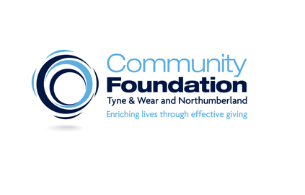

Dear parent/ carer,

We have a fantastic open evening event coming to DCHS on 15th and 16th July this year to explore the universe, with astronomy specialists, in the Wonderdome! The event will run from 4-6pm. You are welcome to attend the school, look around our facilities, visit the shop and children can visit the planetarium (if booked via the online booking form that can be found here);

https://sites.google.com/dchs-alnwick.uk/wonderdome

The Wonderdome is a fascinating, fun and interactive School Mobile Planetarium which takes the learners on a journey through the Milky Way. The use of the completely dark inflatable planetarium makes for an amazing 360-degree immersive experience which is awe inspiring. We hope this will be a learning experience the students will enjoy and remember for years to come. This show reinforces key points that have been taught through school including; the planets in our solar system, the sun and moon and how they rotate around each other and what it is like to experience life outside earth. It may also include; gravity and how it differs on different planets, a detailed look at the sun and how it compares to other stars in the universe, how the tilt of the earth affects the seasons, and light years. http://wonderdome.co.uk/about-us/

The Science department and Greenpower team will also be running their popular STEM pocket money shops, all proceeds of which will help to fund further, whole school, extra curricular activities. This has items for sale from between £1 to £5.

We will also be selling refreshments which can be purchased when your child is in the Wonderdome.

If you wish to attend the event and would like to book a place in the planetarium for your child, please visit the website using the first link above and click the link for the Wonderdome booking form. There are three sessions per evening and we expect that they will fill up quickly so book up asap. Unfortunately the Wonderdome is not suitable for adults.

If you have any queries about the event or would like to further support STEM activities in school, please feel free to contact us via email at admin@dchs-alnwick.uk

Yours sincerely,
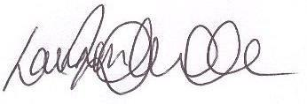

Emma Robertson and Lauren Whitelock
Science Coordinator and Assistant SENCo Y7 & 8

