

Date: ___________________________

LO: read and write decimal numbers as fractions (lesson 3)

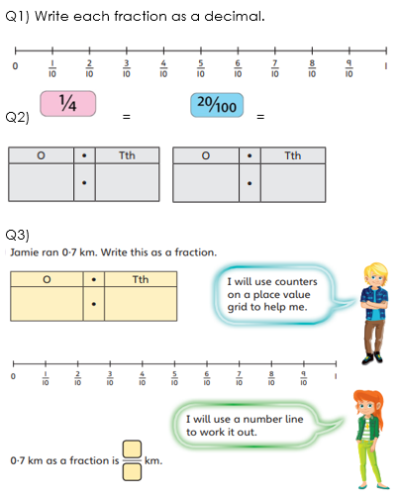

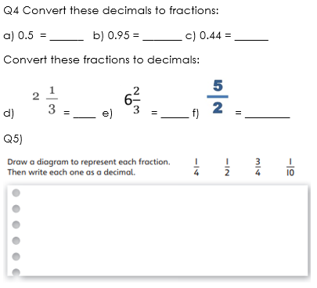

Q6) Tommy says “I think one twentieth is the same as writing as 0.25, which is equivalent to one quarter”. Do you agree? Use diagrams and reasons to explain your answer as fully as you can.



Date: ___________________________

LO: read and write decimal numbers as fractions (lesson 3)

Q1) Write each fraction as a decimal.

Q2)  =  =

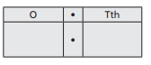

Q3) 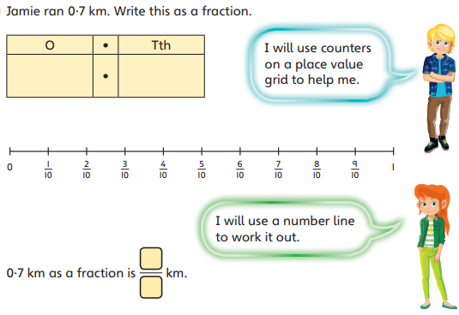Q4 Convert these decimals to fractions:

a) 0.5 = ______ b) 0.95 = _______ c) 0.44 = ______

Convert these fractions to decimals:

d) 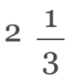 = ____ e)  = _____ f)  = ________

Q5)

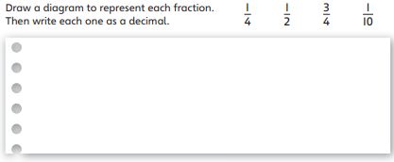

Q6) Tommy says “I think one twentieth is the same as writing as 0.25, which is equivalent to one quarter”. Do you agree? Use diagrams and reasons to explain your answer as fully as you can.

