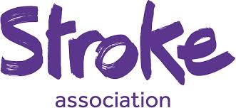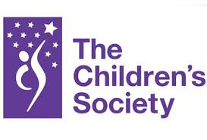

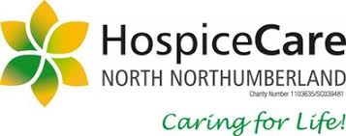

Fundraising at Whittingham C of E Primary 2020
Friday 6th November 2020.
Dear Parents/ Carers,

I have been asked if we will be doing anything to raise money for Children in Need.

A number of years ago we supported this charity as it supports some excellent causes.

It was then decided that we wanted to choose charities because of the significance they may have or have had in the past to our lives as a Church School or that they are a charity that does excellent work locally. These charities form part of the header of this letter.

I would prefer to limit our fundraising activities at the moment as I appreciate how the global pandemic has affected many families financially.

However, I am happy to have feedback regarding this and if there are families who wish to suggest any new charities or events please let me know.

Best wishes,
Belinda Athey – Headteacher.

