Whittingham C of E Primary School presents………
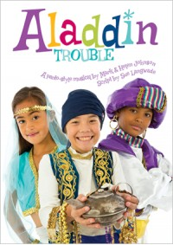

Whittingham Memorial Hall
Tuesday 13th December 2016
Performances
9.30 am Dress Rehearsal –
(Parents with Toddlers/babies are welcome to attend this session – Thank you)
1.30pm
6.00pm
Raffle - Donations - Everyone welcome

