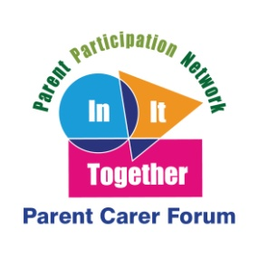
In It Together Parent Carer Forum - Annual Conference 2019
"Getting it Right"
Preparing for Adulthood from the earliest years is the theme for this year's In It Together conference. It will be of interest to all parents and carers of children and young people with SEND (special educational needs and disabilities) in Northumberland, but particularly Year 6 and above.
DATE/TIME | VENUE
Tuesday 19th March 9.45 - 14.00  To book your place visit:  https://www.eventbrite.com/e/in-it-together-conference-alnwick-getting-it-right-tickets-56294686924 | Alnwick Rugby Club,  Willowburn Avenue  Alnwick.  NE66 1BE
Wednesday 20th March 9.45 - 14.00  To book your place visit:  https://www.eventbrite.com/e/in-it-together-conference-hexham-getting-it-right-tickets-56369401397 | Hexham Mart Function Suite  Tyne Green  Hexham  NE46 3SG
For further information, please contact In It Together Parent Carer Forum: info@in-it-together.org.uk or 07729192909.

