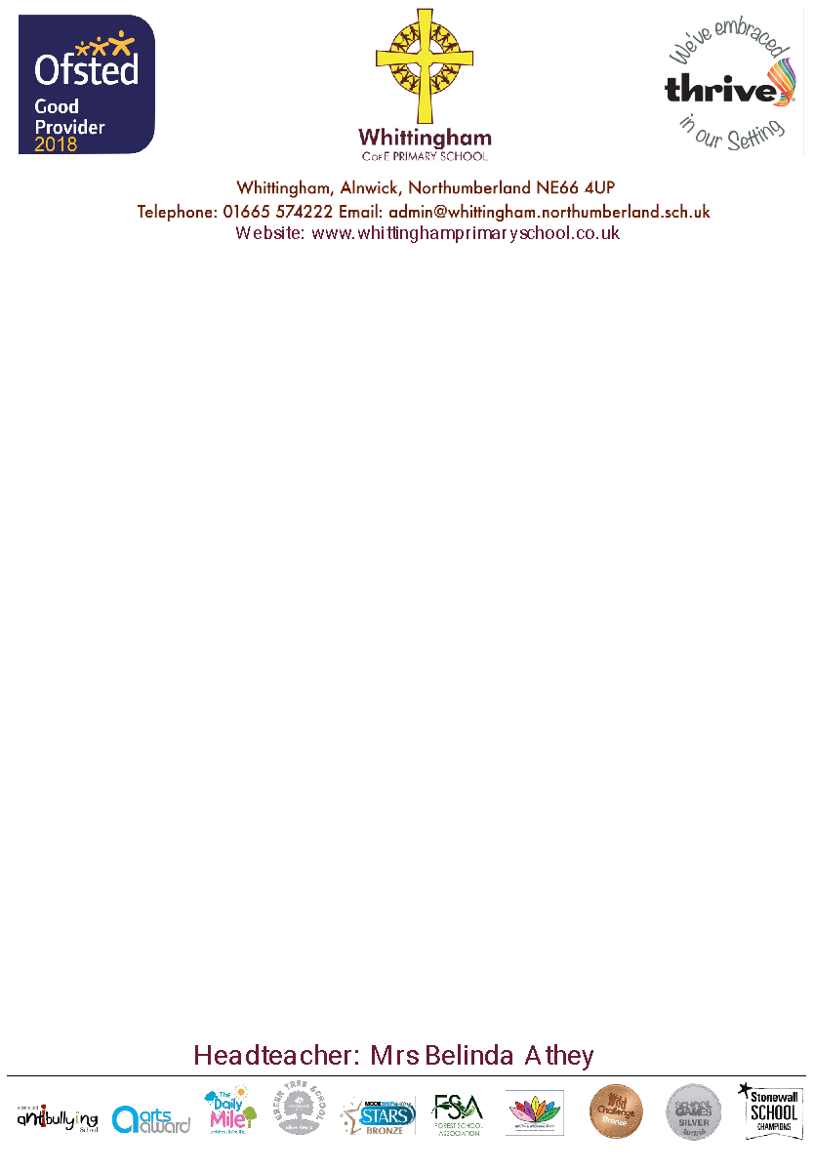

Wednesday 21st May 2025

Dear Parents and Carers,

We are excited to announce that Early Years and Class One will be attending a trip to Northumberland Zoo. We have planned a full day visit, where we will have an animal groups and classification workshop with some of the zoo staff and we will then have the opportunity to explore the grounds of the zoo at our own leisure.

As Class One continues their science topic next half term of looking at plants and seasonal changes, thinking about how climate can impact plants and animals, as well as looking at our local area and the comparison to St Lucia and Early Years will be recapping their knowledge learned from this year on animals and the great outdoors, we thought that this was the perfect opportunity to for the children to visit Northumberland Zoo.

The trip is on **Thursday 3rd July 2025** and we will be departing school by bus at **9.15am** and we will be returning to school for normal pick-up time of **3.15pm**.

The cost of the trip will be **£17.45** per child for **Class One** children. This will be available to pay via school money. If your child is in receipt of Pupil Premium Free School Meals and would like funding to be used to pay the cost of the trip please let the office know by Thursday 5th June 2025.

For Early Years children the cost of this trip per child would usually be £17.45. However, just like every class in school, our brilliant PTA are raising funds to help us provide unforgettable experiences they have agreed to cover the full cost.

Children will need to come to school as normal in their school uniform, a light waterproof coat, bring a **packed lunch** with a **water bottle** and a **cap** in a small bag that they are able to carry.

If those children in receipt of Pupil Premium Free School meals and would like a packed lunch from school, please let the office know by Thursday 5th June 2025.

We are very excited about this opportunity and are sure the children will love it!

If you have any questions, please do not hesitate to contact me.

Kind regards,

Miss Lazenby and Mrs Marsden

Class One and Early Years Teacher