Early Years Topic Letter – Autumn 1

Super duper you!

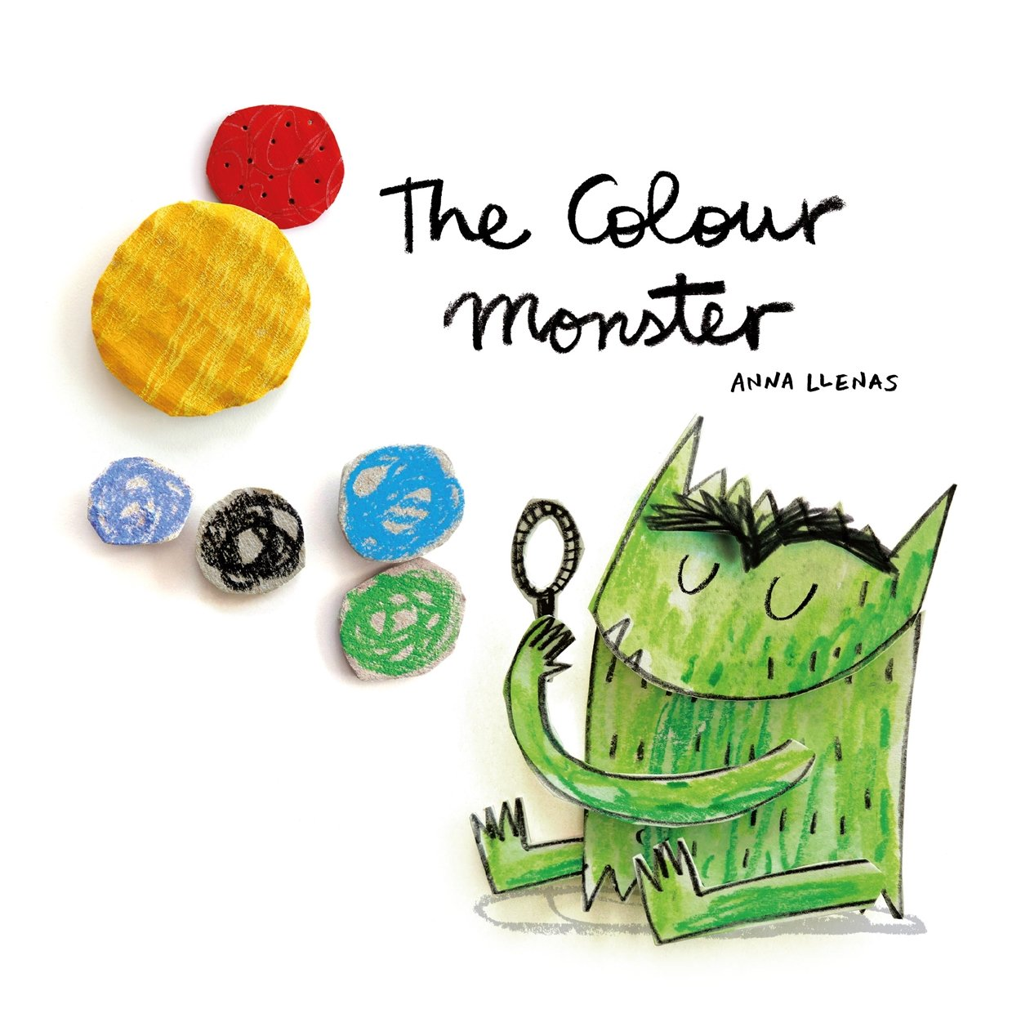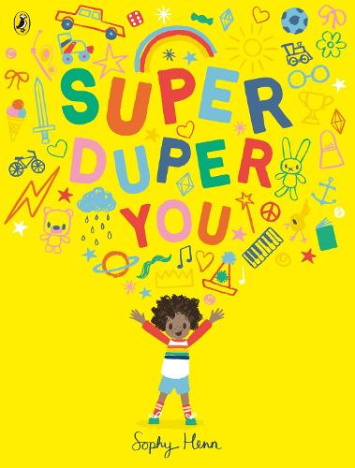

Welcome back to children who were with us before the Summer holidays and a big welcome to the new children joining us!

I hope you have all had a wonderful Summer holiday. I cannot wait to hear about all your adventures and tell you all about mine too!

In Early Years we are supported by Mrs Manners on a Monday, Tuesday, Wednesday and Thursday and by Miss Forrest on a Friday. Mrs Chisholm and Mrs Lewis will be covering my planning, preparation and admin time on a Thursday afternoon and they will be covering RE and PE in this time.

Gentle reminders

* Drop off for all children is 8.45am (prompt please as this allows our day to run smoothly, so we can settle children into their new routines.) Pick up is 3.15pm or 11.45am if your child goes home after lunch.
* Please ensure your child has a change of clothing in school in case we need them. If your child is in nappies please provide nappies/pull ups and wipes.
* Children in Early Years should only bring a book bag reading folder to school as our cloakroom and storage space is very small! I am happy for changes of clothes to be left on the children’s pegs either in a carrier bag or a drawstring style bag as these do not take up too much space.
* Please email any end of day changes to Mrs Kennedy in the office – I cannot always guarantee messages on tapestry will be seen straight away.
* Please always remember a waterproof coat, we go out in all weathers! As the weather changes and is colder a hat, scarf and gloves may be needed, water bottles are also essential please.
* Please make sure every item of clothing and water bottle is clearly marked with your child’s name. This makes it easier for us to make sure items are not lost and are reunited with their owner quickly.
* PE will be on a **Thursday afternoon** and Forest school sessions will be on a **Monday afternoon**, so please can your child come to school dressed in their PE kit on these days. If there are ever any changes to this, I will notify you on tapestry.
* Please remember to log onto your child’s tapestry account regularly, this will help you to see what your child’s next steps are and will help you to support your child’s learning. Further to this, it is a lovely way to see what we have been up to and talk about school with your children. Don’t forget to upload achievements and experiences at home too! If anyone is having any problems accessing tapestry, please just let me know.

| Personal, Social and Emotional Development    We will reinforce positive behaviour at all times in EYFS. Supporting the children to develop their personal, social and emotional development is at the core of what we do in every way.  This half term we will place particular emphasis on:  New beginnings  See themselves as a valuable individual.  Being me in my world  Class rules and routines  Supporting children to build relationships  Dreams and goals | Physical Development    This half term we will be developing our independence! We will be working on putting our own shoes or wellies on, going to the toilet, identifying when we need our nappy changed, going on the potty or toilet, putting our coat on, peeling our fruit and putting our straw in our milk! You can help at home by supporting your child to get dressed by themselves and have a go at putting their coat on before you help them. You can also support them to wash their hands.  We will also be working hard to develop our fine motor and gross motor skills. We will be doing this through our dough disco and ‘squiggle while you wiggle’ sessions as well as daily name writing and lots of fine motor activities which will help to develop the strength in our fingers and support us to hold a pencil effectively. These will include things like pinching, threading, using pegs, twisting, brushing, stacking, dough disco and using tweezers.  We will promote gross motor activities like climbing, jumping, running, throwing and catching through physical activities and when using our climbing frame and the cars and bikes. This will be alongside our weekly PE lesson which will be ball skills for this half term.  We will be developing our pencil control and Reception will be focussing on accurate letter formation in our names and other words. In Nursery, if we are ready, we will also be working hard to write our names. |
| --- | --- |
| RE    This half term Reception will take part in RE sessions and our main focus this term will be looking at being special and where we belong, we will cover this by looking at some Multi –faith comparative units.  We will be learning:  To understand what a community is.  To understand why it is important to be part of a community.  To be able to give an example of a community they are part of.  To have an awareness of our Christian Church community as well as other religions and beliefs. | Communication and Language    We develop the children’s listening and attention, understanding and speaking skills each day in many of our activities.  This half term we will be focusing on:  Learning ‘The Colour Monster’ story off by heart through retelling and learning new vocabulary in relation to the story and characters. We will talk about feelings.  Singing and learning lots of new and familiar nursery rhymes. |

| Reception Literacy  This half term in Reception we will begin to learn RWInc set 1 sounds through short and snappy ‘speed sounds’ sessions each morning, designed to teach the children to recognise and pronounce the pure sounds, before reading them in simple CVC words such as ‘cat, top, sit.’ I plan to start these sessions in the second week and we will be hosting an information meeting for parents on this. Your child will have a plastic wallet in their bags and as we learn and introduce new sounds these will be placed in your child’s pack, please support us and practise these at home daily, little and often is key and really does make a BIG difference. If you can pop a little note in your child’s reading record with what you have done and how they have got on, this is a good way to communicate between home and school as well as tapestry.  We will also begin to introduce new red words this half term such as ‘I, the’. These words are words that cannot be sounded out and they just need to be learnt by sight.  We will send a ‘reading for pleasure’ book home each week – please keep this at home and return back to school on a Thursday – when we will change them. These books along with books you have at home are a great way to share how stories are structured so that your child becomes used to and can possibly join in with repeated refrains, please take the opportunity to all your child to listen to you reading the story, create their own retelling of the story and talk about the characters and settings and the characters feelings.  We will be developing our writing skills this half term so that children can begin to label pictures and write for various purposes using initial sounds and single words. It is very important as children pick up the sounds in Read, Write, Inc that they practise forming them correctly, starting in the correct place.  We will develop our recognition of rhyming and alliteration through fun games, songs and rhymes. It is vital that children develop their sound discrimination skills before they can become fluent readers.  We will encourage dominant hand, tripod grip, mark making, giving meaning to marks and labelling. We will write shopping lists, initial sounds and simple captions. Use initial sounds to label characters and images. |
| --- |
| Nursery Literacy  This half term in Nursery we will focus on learning and retelling familiar and new Nursery rhymes. We will be sharing our focus text of ‘The Colour Monster’ as we take part in many activities linked to the story and we will learn to retell the story and put actions to it.  We will work on having a go at writing our names and developing our mark making skills.  This half term we will be placing our emphasis on creating confident mark maker’s, allowing the children to explore the different marks they make using a variety of tools including chalk, pens, pencils, crayons, water and in sensory trays. We will take part in ‘Squiggle While you Wiggle’ sessions to help us to develop our early writing skills in an energetic and fun way.  We will also be promoting drawing and supporting the children to talk about what they have drawn and the marks they have made.  We will take part in short daily phase one phonics sessions which will help us to develop our sound discrimination and listening skills. This half term we will be focussing on body percussion and rhythm and rhyme.  Key vocabulary: fiction, non-fiction, rhyme.  Maths  Maths happens all day in Early Years, during the register, at snack time and while the children play. Before the day has even started, we have counted and added up how many children we have at school and recorded this using Numicon and on tens frames.  Maths is covered in all areas of the provision, but we also take part in a short, directed Maths activity each day. The children can then apply the skills they have used in the provision. |

| Nursery Maths  This half term we will focus on:  Counting to 10 through nursery rhymes, songs and games  Counting a small group of objects  Use language relating to size – small, big, tall etc  Using language like ‘more’ and ‘a lot’.  Sorting and matching  Exploring patterns  Key vocabulary: How many? More, less, bigger, smaller, tall, short, number, same, different. | Reception Maths  This half term we will focus on:  Matching and Sorting  Comparing amounts  Comparing mass, size and capacity  Exploring patterns  Representing 1,2,3  Key vocabulary: same, different, more, less, bigger, smaller, equal, heavier, lighter, number, amount, quantity. |
| --- | --- |
| Expressive, Art and Design    This term the children will have the opportunity to:    Independently explore the classroom areas and resources.  Join in with songs; beginning to mix colours, join in with role play games and use resources available for props; build models using construction equipment.  Join in with sing call-and-response songs, so that children can echo phrases of songs you sing.  Do self-portraits, junk modelling – talk about what they did and their creations.  Listen to Julia Donaldson songs, exploring sounds and how they can be changed, tapping out of simple rhythms.  Take opportunities to work together to develop and realise creative ideas.  Make Superhero masks.  Make their own colour monsters. | Understanding the World    This term we will be:  Identifying their family. Commenting on photos of their family; naming who they can see and of what relation they are to them.  Talking about what they do with their family and places they have been with their family. Draw similarities and make comparisons between other families. Name and describe people who are familiar to them.  Read fictional stories about families and start to tell the difference between real and fiction. Talk about members of their immediate family and community.  Navigating around our classroom and outdoor areas.  Thinking about long ago – How time has changed. Using cameras.  Key vocabulary: family, community, mum, dad, brother, sister, grandma, grandad, uncle, aunt, cousin, friend, jobs, occupation, birthdays, celebrations, time, change, different, same. |