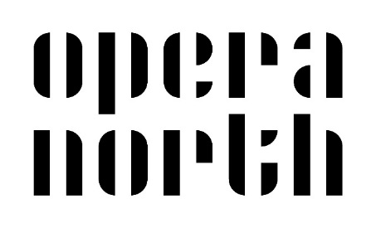

**Opera North Black T-Shirts for Final Performance**

For the final performance of the Big Sing, Opera North are kindly providing black t-shirts for participating pupils to wear for the day of the final rehearsal and performance.

As part of concert dress, the t-shirt should be worn with school trousers/skirt and school shoes.

T-shirts are free of charge and pupils will be able to keep their t-shirts after the performance.

In order to ensure that the correct t-shirt sizes are ordered for your child, please complete this form, indicating on the form the size required for your child, returning to school **no later than Tuesday 1st May.**

If you are in any doubt, please order a slightly larger size. Size information is included in the table below for reference.

Once ordered and printed, t-shirts will be sent directly to school in the post.

Teacher Name ____________________________________________________

School _________________________________________________________

7 – 8 years _________

9 – 11 years _________

12 – 13 years _________

Adult Small _________

Adult Medium _________

Adult Large _________

Size Guide

|  |  |  |  |  |  |  |  |  |
| --- | --- | --- | --- | --- | --- | --- | --- | --- |
|  | **3-4** | **5-6** | **7-8** | **9-11** | **12-13** | **Adult S** | **Adult M** | **Adult L** |
| Chest to fit (inches) | 22-24 | 26-28 | 30 | 32 | 34 | 35-37 | 38-40 | 41-43 |
| Actual chest (cm) | 38 | 40.5 | 43 | 46 | 48.5 | 48.5 | 53.5 | 56 |
| Body length (cm) | 45 | 50 | 55 | 60 | 65 | 69.5 | 72 | 74.5 |
| Size tolerance +/- 2.5cm |  |  |  |  |  |  |  |  |

**Please complete and return the form to school no later than Tuesday 1st May.**