Calculations in Early Years
Addition | Subtraction | Multiplication | Division
Children begin to record in the context of play or practical activities and problems.
Begin to relate addition to combining two groups of objects.  • Make a record in pictures, words or symbols of addition activities  already carried out.  • Construct number sentences to go with practical activities.  • Use of games and songs, for example, 1,2,3,4,5, Once I caught a fish alive, and practical activities to begin using vocabulary.  Using real life contexts, for example,  counting how many children there are present at registration time and how many children there are in each ‘learning area’ of the classroom.  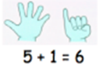  Solve simple word problems using their fingers.  Can find one more to ten (then 20 and 50 as appropriate).  Children progress to using a number line. They jump forwards along the number line using their finger.  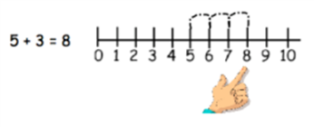 | Begin to relate subtraction to ‘taking away.’  • Make a record in pictures, words or symbols of subtraction activities already carried out.  • Use of games and songs, for example, Five Little Monkeys and practical activities to begin using vocabulary.  • Construct number sentences to go with practical activities.  • Relate subtraction to taking away and counting how many objects  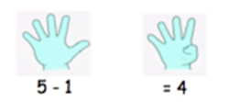  are left.  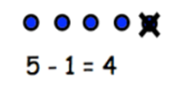  Can find one less to ten (then 20 and 50 as appropriate).  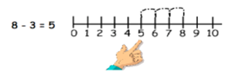  Counting backwards along a number line using their finger. | Real life contexts and use of practical  equipment to count in repeated groups of the same size:  • Count in twos; fives; tens  Also chanting in 2s, 5s and 10s.  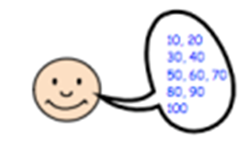 | Share objects into equal groups.  Use related vocabulary.  Activities might include:  • Sharing of milk at break time  • Sharing sweets on a child’s birthday  • Sharing activities in the home corner  • Counting in tens/twos  • Separating a given number of objects (counting bears) into two groups (addition and subtraction objective in Reception being preliminary to multiplication and division).

