Miss Donkin supported by Mrs Chisholm
Welcome back Class 2! I hope you are all well rested after a nice week off. A big well done to all of you for settling back in last term, working hard and taking it all in your stride. You are all just fabulous!
In Literacy we will be focusing first on non-chronological reports, creating images through poetry and writing Christmas letters. Through this work we will be focussing on the use of key punctuation, adjectives, nouns and verbs and varying sentence structure, as well as improving comprehension and stamina for writing. We will be continuing the Read Write Inc spelling programme which was introduced last year and reading daily. Sumdog can also be used in school and at home for English (spelling and grammar). | 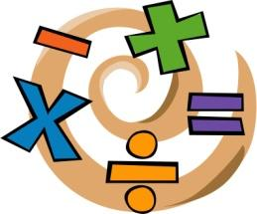  In Numeracy we will be continuing with addition and subtraction of numbers with up to 4 digits. We will then be moving on to multiplication and division. Sumdog and times table practise will be used in class to help children with maths fluency and these are both able to be practised at home. For each topic the children cover in maths there will be work set alongside this on Sumdog which the children are expected to complete. The recall of simple maths facts is vital for your child to make progress in maths.
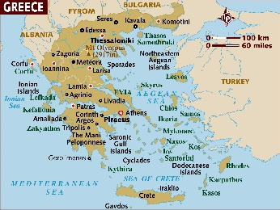
In Geography we will be looking at the continents and oceans which make up the world, especially looking at Europe, and within this, Greece. We will be learning how to locate different countries on a map, as well as studying Greece and the UK and learning about their similarities and differences.

In French we will be continuing to learn to listen, respond and show understanding of the French language, beginning to build our French vocabulary and take part in conversations. | In R.E we will be continuing to explore Christianity using stories from the old testament and stories told by Jesus to reveal what Christians believe about God.
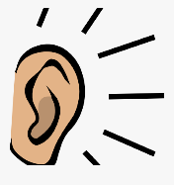
In Science we will be learning about sound. We are acting as consultants for a new band, through this we will be exploring how everyday objects make sounds and how these can be turned into music, learning about how sounds are made and changed, how sound travels and how we can hear.
In Music we will be continuing to take part in Violin lessons where children will learn to play and perform in solo and ensemble contexts, playing with increasing fluency. | 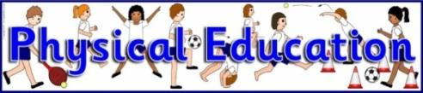  In P.E we will be developing our cricket skills such as bowling, catching and fielding skills with Mrs Chisholm . Miss Donkin will be teaching hockey, where we will learn and develop skills such as dribbling, passing and shooting.
In PSHE we will be learning all about healthy lifestyles and choices, mental health and how to take care of our minds, keeping safe in a range of situations and how to recognise our own individuality and personal qualities. We will also be taking part in Anti-bullying week to raise awareness where children will be completing activities around this topic. We will be continuing to promote e-safety and revisiting rules and regulations for being safe online at home and in school. | 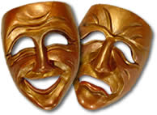  In Art/DT we will be continuing to use a range of different materials and tools to create Greek themed art. We will be designing and creating our own Ancient Greek Theatre masks using paper mache.
Reminders:
- Remember to hear your child read daily and send a message on Dojo once they have read their book at home.
- Come to school in trainers ready to run the daily mile but have school shoes to change into and please make sure your child has a spare pair of socks in their bag as socks get wet if it has been raining.
- Make sure your child is bringing at least one full water bottle each day.
- Children should be completing one section of their maths and English work books per week and pictures of these can be uploaded to Class Dojo.
- Weekly spellings and times tables can be found on Google Classroom.

Many thanks and welcome back!
Miss Donkin

