KS 2 Writing Ideas and Support
Dear Parents/ Carers,
In addition to the resources already mentioned to help your child with writing and the daily lessons on Oak National Academy if they are off school beyond a 14-day quarantine period please find below lots of writing ideas and resources.

The green words on this piece of text will also take you to some useful videos and websites for creative writing tips:
Oxford Owl, Usborne publishing, Suspense writing, Tips for parents, Relative Clauses, Similes and Metaphors, Using speech, Parenthesis song, Expanded noun phrase song, Persuasive writing videos, Parenthesis, Creative writing tips, Expanded noun phrases, Personification, Describing characters, Describing settings, Planning a story

Please find some ideas below.
Enjoy!
Mrs Athey – temporary co-ordinator for English.

Big Write Ideas!

Task 1 – We are learning to write at least 2 pages using the following title.
I never should have gone there!

Your writing can be real, or imaginary.

In your writing you could:
- Explain the situation;
- Describe the thoughts and feelings of the person or people involved;
- Try to make your reader share the experience through your choice of words and sentences.

PLAN YOUR ANSWER!
In your writing you should:
- Make your writing interesting for your reader – use verbs, adverbs and adjectives to achieve effects;
- Present your ideas clearly, organising your writing into paragraphs;
- Write using accurate grammar, spelling and punctuation;
- Include an interesting beginning and ending for your writing.

In your writing, try to use the following:
- Similes
- Alliteration
- Onomatopoeia
More tasks:
We are learning to complete a piece of creative writing.
What you need to do:
Choose from one of the following story starters/writing prompts. You can write in any type of genre:
A letter, a poem, a story, a short story, a play, a blog, a diary, a newspaper report, persuasive writing
Remember that you need to include some powerful vocabulary but just start writing and have fun!
Writing prompts/starters:
You’re digging in your garden and find a fist-sized nugget of gold.
The asteroid was hurtling straight for Earth…
There’s a guy sitting on a park bench reading a newspaper…
He turned the key in the lock and opened the door. To his horror, he saw…
Silvery flakes drifted down, glittering in the bright light of the harvest moon. The blackbird swooped down…
The detective saw his opportunity. He grabbed the waitress’s arm and said…
There are three children sitting on a log near a stream. One of them looks up at the sky and says…
You find a door at the end of the garden. What do you do?
And you thought dragons didn’t exist…
Write about nature.
You walk into your house and it’s completely different — furniture, decor, all changed. And nobody’s home.
Write about one (or both) of your parents. Start with “I was born…”
The most beautiful smile I ever saw…

Poetry task -

Here is a poem using metaphors about James Bond

He is a bar of dark chocolate,
A smooth black cat’s coat,
An exotic fruit cocktail,
A silver Porsche disappearing into the distance.
He is a plate of caviar,
A blade on a knife,
A frothy cappuccino,
A piece of black silk.
He is a midnight alarm,
A tiger disguised as a pussycat,
A jet plane,
A perfect day.

Poetry Task
Your task is to write a poem in the same style about either a fictional character or a celebrity. It could be about a character from a book or film. It could be a celebrity from sport, the music industry, the film industry or even the Royal family.

Think about these questions and write some interesting metaphors: What do they look like? What do they do? What are they famous for? What is their character like?

Instructional Writing task - How to Play a Favourite Game
You have been asked to make a book of instructions for children’s favourite games. These might be games you play at home or school. It could be a game you enjoy playing with your friends. It must not be a game you play on the computer.
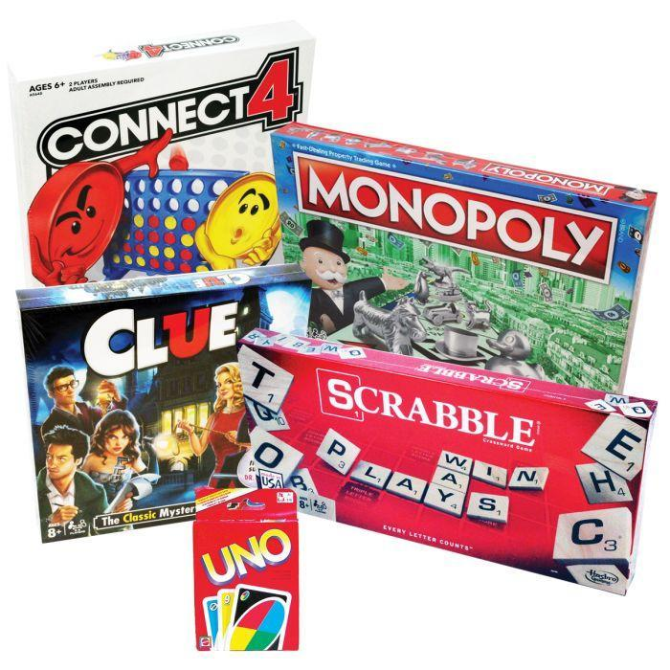
Task
Your task is to write a set of exact instructions to explain how to play your favourite game. Remember, the person who will be reading your instructions will never have played this game before.
Planning ideas - Title of the game, equipment needed, aim of the game, step-by-step details

Persuasive Writing Task - The Electric Skateboard
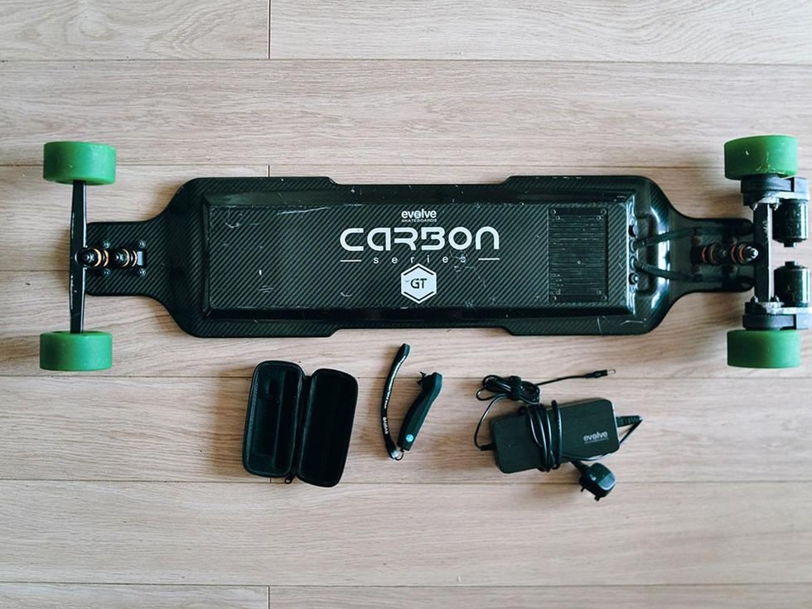
You have been asked to promote a new type of skateboard. It is powered by an electric motor and has rechargeable batteries. It is operated from a wireless hand controller.

Your task is to write a persuasive article for a parent’s magazine explaining the functions and advantages of the electric skateboard. You need to make it sound like the best Christmas present any child could ever want!

Planning Questions
What are its uses? How is it unique? Why is it fun? Cost and maintenence? Features?
Collect words and phrases to help you persuade parents to buy this skateboard.

Playscript task - The Argument
A group of friends, who are slightly older than you, have asked if you can come to town on Saturday. Your parents are not keen for you to go. Continue the play script below

(Emma and Mum are in the kitchen.)
Emma: Mum! Anna and Henna are going to town on Saturday. They asked if I could go too. Is that O.K.?
(Mum has a concerned look on her face.)
Mum: I don’t think so dear, you’re much too young.
(Emma pleads.)
Emma: But Mum, I’ll be fine.
(Dad enters the room.)
Dad: What are you two talking about?

Planning ideas - Think about the characters in the play. What are they like? What are the arguments for and against Emma going to town?

Descriptive Writing Task - Time Travel
One evening you go to your computer and accidentally press one of the keys you have never pressed before. Suddenly you are transported into a different time! Your task is to write about where you travel to, what the place is like, who you meet and how you manage to get home again.
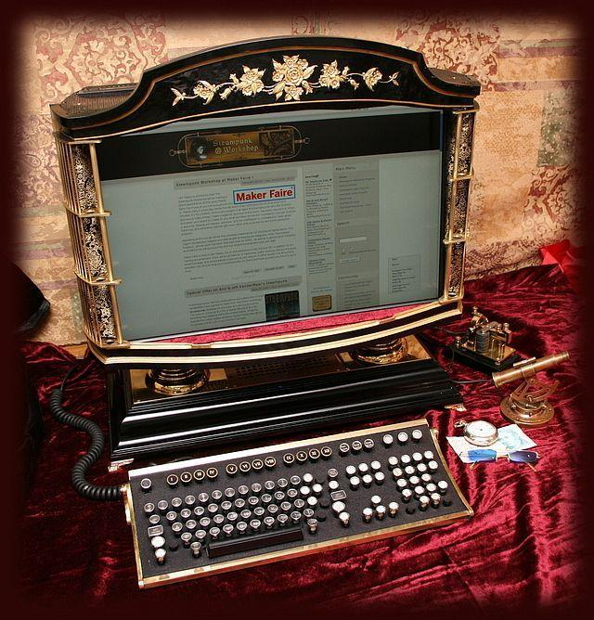

Planning Questions
Where did you travel to and what form did your transport/journey take? (Remember: You can travel back or forwards in time.) What is the place you visit like? Who do you meet? What are they like? How do you manage to get back home?

