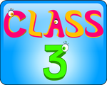
Class Three will be taught Monday – Thursday by Mrs Fletcher
and on Friday by Mrs Athey/Mrs Chisholm.
Literacy  The children will be reading short, spooky stories from  ‘Short!’ by Kevin Crossley-Holland.  We will use these to develop our own creative writing, as well as exploring grammar and written techniques used by the author.  We will also be focussing on our Spelling, Punctuation and Grammar (SPaG) and reading strategies in the run up to Year 6 taking their SATs in May.  Spelling will continue to be a class focus, developing spelling strategies and applying these in their writing. We will continue weekly grammar activities through our class work and daily focussed activities in lessons.  We will continue using Accelerated Reader to develop our reading comprehension skills, through independent and group guided reading. | Numeracy  We will begin the half term by consolidating our knowledge and understanding of the concepts we have covered this year, in preparation for Year 6 sitting their KS2 SATs.  We will develop our mental calculation strategies, as well as working on problem solving activities.  Decimals and Percentages  -Identify the value of each digit in numbers given to 3 decimal places and multiply numbers by 10, 100 and 1,000 giving answers up to 3 decimal places.  - Solve problems involving the calculation of percentages.  Recall and use equivalences between simple fractions, decimals and percentages, including in different contexts.  Properties of Shapes  The children MUST know their times tables and be able to recall quickly.
In Geography we will complete our work on The Americas. The children will learn to locate the world’s countries using maps, with a focus on North and South America. They will concentrate on their environmental regions, key physical and human characteristics, countries, and major cities in North and South America.  Then, following on from our fantastic Beach trip last half term we will be learning about how coasts are formed. We will explore the physical features of the local coastline and learn about management strategies used on Britain’s beaches. We will be describing coastal areas and changes in land use, making links with local mining and fishing industries. | In Science our topic is  ‘All Living Things’.  We will:  Explain the differences in life cycles of mammals and plants.  Learn about reproduction in flowering plants.  Learn about sexual and asexual reproduction in plants and animals.  Understand that all living things can be classified through common characteristics.  Look at the lifecycles of insects, amphibians, birds and mammals.  Becoming natural scientists.
In French the children will be working with pupils from the Duchess Community High School to develop their conversational French; revising greetings, numbers, family members  and discussing the weather. | In R.E the children will respond to the challenges of commitment, both in their own lives and within religious traditions, recognising how commitment to religion is shown in a variety of ways. Discuss their own and others’ views of religious truth and belief, expressing their own ideas.
In Music KS2 are lucky enough to be taking part in the ‘Big Sing’ project. We are learning lots of fantastic songs, which we will perform at the Sage, Gateshead in July. (more information coming soon!) | Art this half term will focus on ‘Sunset Skylines’ linked to our Geography topic of coasts.  We will also be completing our competition entries for the Summer Shows.
Forest School  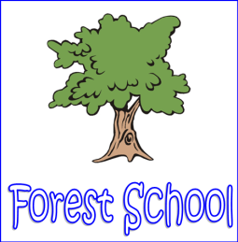  Our sessions will happen every week on Fridays. During these sessions we will also cover -Technology – Using tools and making things and now that Mrs Chisholm is a qualified Forest Schools Leader our Food Technology session will take place out on the Fire Pit. A lot of the work we do in PSHE such as resilience, teamwork and confidence will be covered in these sessions. | 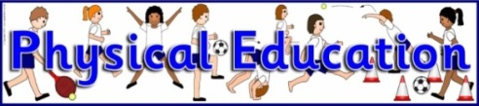  In P.E the children will:  Refresh their skills in netball as we are taking part in a competition and also want to make the most of our MUGA!  Athletics  British Cycling  Please note – change of day - P.E kit is needed in school on Thursdays and Fridays.  In the interest of space in the Class 3 cloakroom please could PE kit be only brought in on these days.
In Computing we will be developing our internet skills and looking at mapping and Google Earth. We will also revise key topics learnt this school year including developing our skills in scratch and using the ozobots. | PHSE the children will be developing resilience and awareness of others through our work on the #i will campaign, where we will be building on the success of our litter pick and choosing new ways to volunteer.  Understanding our role in the world and we will be taking part in Christian Aid Global Leaders Award. Thinking ahead to our next steps in life and learning techniques to help us develop our resilience.

