Monday 5th October 2020

**Wear yellow to show our support of mental health and well-being**

Dear Parents/ Carers,

As you know, we are committed to the academic, physical, emotional and mental well-being of our pupils in school and would like to show this commitment by also recognising the important work of the charity, Young Minds.

For your reference, there is also a good reference section on their website - https://youngminds.org.uk/resources/

**We are going to join in with Wear Yellow for Young Minds on Friday 9th October and would like to invite every pupil to either wear something yellow ( it could even be their PE top) or dress head to toe in yellow!.**

We are not asking for donations to be made to school but if you would like to support this charity and donate please do this by either buying something from their online shop –

<https://youngminds.org.uk/the-youngminds-shop/> or following the donate link.

<https://youngminds.org.uk/donate/>

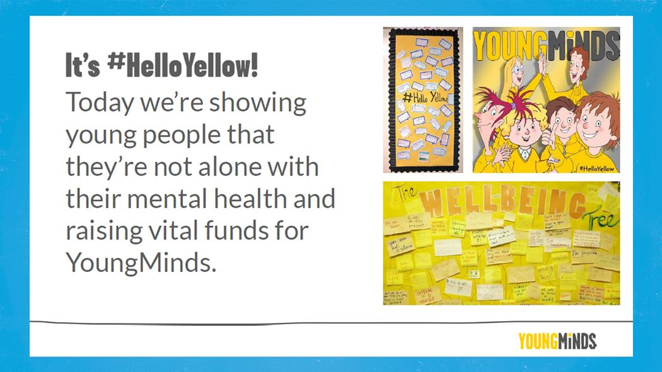

Thank you for your support,

Best wishes,

Belinda Athey – Headteacher.

