Website: www.whittinghamprimaryschool.co.uk
Monday 7th September 2020.
Child Illness other than COVID 19 and Staying Off School
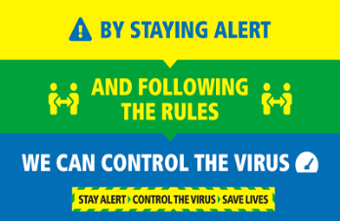
Dear Parents/ Carers,
We have had a number of phone calls today enquiring what to do if your child is unwell as we return to school and is displaying non – COVID symptoms.
The current government guidance is -
The main symptoms of coronavirus (COVID-19) are a high temperature, a new, continuous cough and a loss or change to your sense of smell or taste.
In further detail this means –
The main symptoms of coronavirus (COVID-19) are:
a high temperature – this means you feel hot to touch on your chest or back (you do not need to measure your temperature)
a new, continuous cough – this means coughing a lot for more than an hour, or 3 or more coughing episodes in 24 hours (if you usually have a cough, it may be worse than usual)
a loss or change to your sense of smell or taste – this means you've noticed you cannot smell or taste anything, or things smell or taste different to normal
To protect others, do not go to places like a GP surgery, pharmacy or hospital if you have any of these symptoms. Get a test to check if you have coronavirus and stay at home until you get your result.

If your child displays one or all of these symptoms please do not send them into school but follow the procedure outlined above.

It is current practice if your child displays other symptoms which may be common in children such as a cold and DO NOT have any of the symptoms above our current guidance is if they are well enough to be in school and administer good (and age appropriate) self-care and hygiene procedures regarding handwashing etc. they are expected to attend school as usual.

Please help us to help keep our school and wider community safe and if you are in any doubt and that the symptoms may possibly be COVID 19 or if they are not well enough to participate fully in the school day they should be off school.

I would also like to alert you to a padlet from NCC you may find useful - https://padlet.com/nies1/return_to_school

I am office based 10.00 -2.30 Monday – Thursday on 01665574222 if you wish to speak to me directly.

Best Wishes,
Belinda Athey

