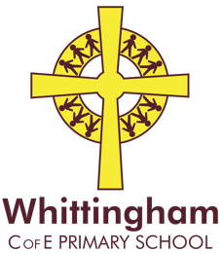
The National School Games Santa Dash
Friday 11th December 2020
#santasmiles #yourschoolgames
Nursery – Year 6
On Friday 11th December we would love our children to join thousands of other young people across the country who will be pulling on their Santa hats for the National School Games Santa Dash!
We will hopefully follow a timetable which will mean that each Year group will be running at the same time across the UK.
If your child has a Santa or Christmassy hat on this day, please can they come into school wearing it and it would be helpful if everyone wore their trainers on this day too.
Best wishes,
Belinda Athey – Headteacher.

