Miss Donkin supported by Mrs Chisholm
Welcome back virtually Class 2 and happy new year! Hope you all had an amazing Christmas and great new year, as weird and quiet as this one may have been! Well done for all your hard work last term, I hope you can all get into a fantastic routine of learning from home, and I can’t wait to continue seeing everything you’re up too! Our topic letter will cover what we should have been doing in school this half term, so may give you some ideas of things additionally you can do at home.
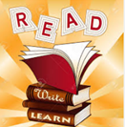  In Literacy we will be using the Oak Academy video lessons. We will be covering both fiction and non-fiction texts. We will also be looking at grammar and reading comprehension lessons. Through this work we will be focussing on the use of key punctuation, adjectives, nouns and verbs and varying sentence structure, as well as improving comprehension and stamina for writing. It is important that children are continuing to complete their English CGP books, and using Sumdog for grammar and spelling daily. Year 3 and 4 statutory spellings and high frequency words are available to access on the school website for practise.  Key vocabulary: noun, verb, adjective, adverb, conjunction, time connective, paragraph, fronted adverbial, comma, full stop, brackets, exclamation mark, question mark, speech marks, heading, sub heading, first and third person, past and present tense, bullet points, facts, fiction, non-fiction, subordinate clause, preposition, constant, vowel. | 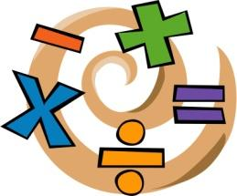  In Numeracy we will be continuing with multiplication and division, then moving onto measurement (length perimeter and area) and finally, fractions. Children will complete their home learning following the White Rose scheme which we use in school, using video lessons and Powerpoints alongside worksheets and problem solving activities. CGP books and Sumdog should also be used at home for maths activities daily.  Key vocabulary for multiplication and division:  Group, grouping, sharing, half, halves, share equally, equal groups, share, divide, multiply, times, groups of, lots of, repeated addition, product, multiplied by, array.  Key vocabulary for measurement: millimetre, metre, kilometre, centimetre, length, measure, compare, perimeter, area.  Key vocabulary for fractions: fraction, equivalent fraction, rounding, numerator, denominator, compare, quarters, half, fraction of a quantity, nearest whole number, order, halves, tenths, unit fraction, decimal, sixths, hundredths, non-unit fraction, thirds, whole, fifths,
In Geography we will be learning all about rivers. How they are formed, the journey of a river and where rivers end up. We will learn about the water cycle, world rivers and study local rivers. We will look into how and why rivers are used by people all over the world.

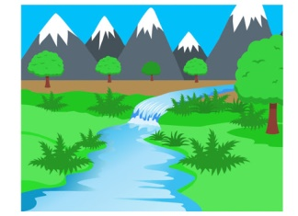
Key vocabulary: valley, source, mountain, stream, erosion, downstream, bank, meander, floodplain, riverbed, mouth, current, saltwater, basin, bay, canal. Channel, confluence, dam, deposit, estuary, flood, freshwater, lake, rapids, silt, sediment, spring, waterfall, watershed.

In French we will be continuing to learn to listen, respond and show understanding of the French language, beginning to build our French vocabulary and take part in conversations. | In R.E we will be using the Oak National Academy lessons to learn about Hinduism.  Key vocabulary: Hinduism, hindu, aum, shrine, god, lotus, prayer, garland, manjira, conch, diva lamp, temple, Diwali, yoga, caste, karma, Brahman, Genesh, Krishna, Lakshmi, Rama, Sita, Shiva, Vishnu.
In Science we will be learning forces and magnets. Looking at all the different types of forces, and how these can act to change the speed, direction or shape of an object. We will look at measuring forces, contact and non-contact forces, and gears, levers and pulleys. We will be thinking of real life situations where we can see force acting.

Key vocabulary: force, push, pull, object, stop, move, change direction, effect, accelerate, decelerate, surface, friction, gravity, water resistance, air resistance, lever, gear, pulley.
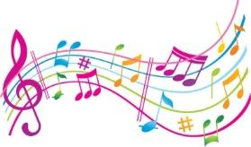  In music we will be looking at different genres of music, styles and different musical processes.  Key vocabulary: rhythm, pitch, timbre, pulse, pitch, harmony. | 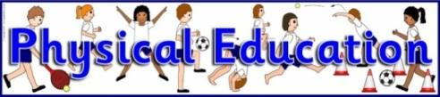  In P.E I would like you to try and complete some form of exercise at least once a day, whether this is the daily mile, Joe Wicks PE lesson or another kind of exercise. Try practising your throwing and catching skills if you have a ball at home, and any shooting, or dribbling skills if you can.
In PSHE we will be learning all about healthy lifestyles and choices, mental health and how to take care of our minds, keeping safe in a range of situations and how to recognise our own individuality and personal qualities. We will also be taking part in Anti-bullying week to raise awareness where children will be completing activities around this topic. We will be continuing to promote e-safety and revisiting rules and regulations for being safe online at home and in school. | 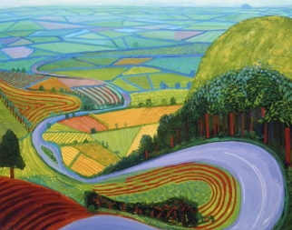  In Art/DT we will be looking at landscape art to fit in with our rivers topic, famous landscape artists and their work and recreating our own versions. For DT we can be looking at how we can build river models and sculptures.  Key vocabulary: sketch, draw, materials, abstract, texture, blending, artist, painting, sculpture, technique, print.
Reminders:
- All home learning will be posted on the class 2 home learning section of the school website.
- Please send in pictures of work, so I can monitor and feedback.
- Regular keeping in touch phone calls, intervention or Google meet will be taking place roughly every 2 weeks.
- Please alongside the lessons set, try to complete some Sumdog and CGP workouts each day.

Many thanks, stay safe! I will miss you all lots but can’t wait to see what you’re all up to with your home learning.
Miss Donkin

