

Q4)

Q3a)

Q21

3.1 3.12 3.15 3.2

1 1.1 1.3 1.5 1.9 2

Q11

0.28 is _____ hundredths.

**0.8**

**6 tenths.**

Q5) In the number 0.62, the difference between the tenths digit and the hundredths digits is 4.

Find all the numbers between 0 and 1 to two decimal places where the tenths and hundredths digits have a difference of 1.

Q6) I am a number between 1 and 2. My tenths digit is less than my hundredths digit. My hundredths digit is less than 2.

I am ... 

Date: ___________________________

LO: to write decimals

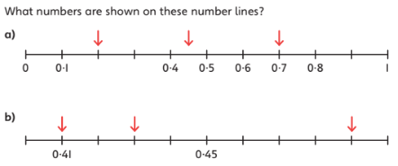

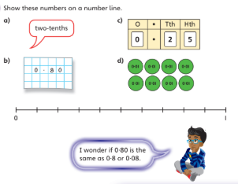

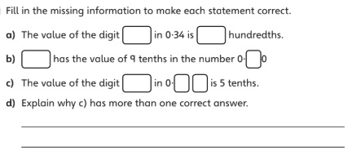

Q3a)

Date: ___________________________

LO: to write decimals

