Children’s University - Once students have evidence of 30 hours of learning they will be eligible for a Bronze Certificate from the National Children's University. A Silver Award is presented to those achieving 65 hours of learning.
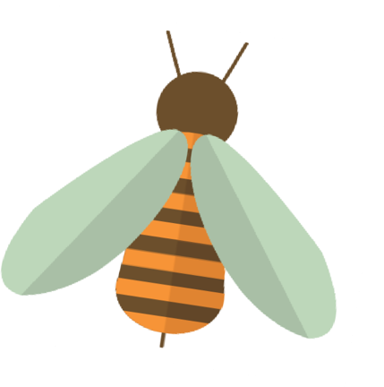
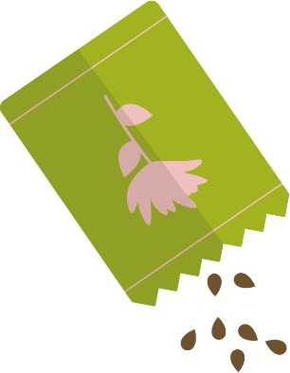
To become a 'Graduate', receive a Gold Award and an invitation to attend a special graduation ceremony, students need to accumulate 100 hours of learning. Please let me know if your child has reached any of these levels.
If you have attended an After-School Club at school these hours count in your pupil passport as I
am able to stamp your passport. This can be done on Thursdays
so, come to the office with your passport to be stamped if this applies to you.
Have a lovely half term.
Mrs Athey.
If you complete any of the challenges below, they are worth 1 point.
Take a photo and share it with your teacher at school.
Any questions - contactus@children’suniversity.co,uk

Spring Half Term Challenge 2019

Get Crafty! Make flower suncatcher mandalas:
https://bit.ly/2DMQAmv

Grow!
Grow some plants or vegetables.
Here you can find out about growing cress:
https://bit.ly/2DNTJm9
Local Litter Log!
Go litter picking in your local area with an adult and tally up each item you find

Get writing! Write a poem about springtime
Science!
Learn all about light refraction with this simple experiment:
https://bit.ly/2Sfzl5B

Get baking! Choose one of these easy bakes to make with family and friends:
https://bit.ly/2TpjXRp
Vlog!
Make a vlog about your favourite Learning Destination

