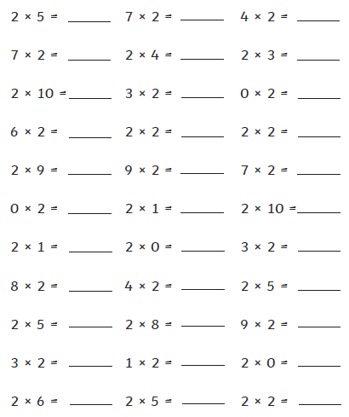Date: ______________________

LO: to recall the multiplication and division facts for the two multiplication table

Diagnostic

Circle all the multiples of 5

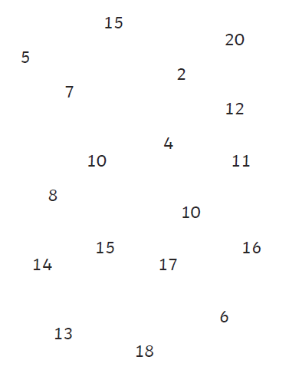

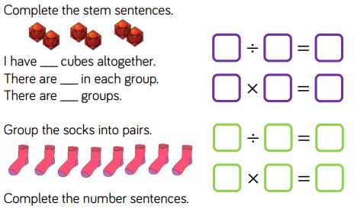Silver

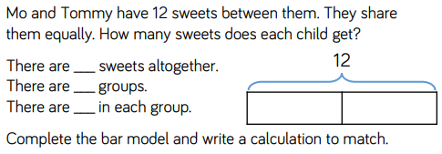

___________________________________________________________________________________________________________________________________________________________________________________________________________________________________________________________________________________________________________________________________________________________________

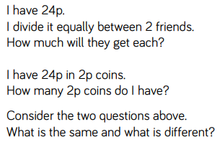

_____________________________________________________________________________________________________________________________________________________________________________________________________________________________________________________________________________________________________________________________________________________________________________________________________________________________________________________________________________________________________________________________________________________________________________________________________________________________________________________________________________________________________________________________________________________________________________________________________________________________________________

Gold