Miss Donkin supported by Mrs Chisholm
Welcome back Class 2! I am so excited to welcome you all back to school after a very odd few months at home. I can’t wait to hear all about what you have been up to over the last few months and during the summer holidays. I am super excited to have the opportunity to teach in Class 2 this year and continue to teach the new Year 3’s and get to know the fabulous Year 4’s a little better. We have a great topic to this term, and I can’t wait for us all to get stuck in!
In Literacy we will be exploring fiction books by different authors including Michael Foreman, and writing our own version of his stories. We will also be looking at non-fiction, information texts, instructions and explanations. Through this work we will be focussing on the use of key punctuation, adjectives, nouns and verbs as well as improving comprehension and stamina for writing. We will be continuing the Read Write Inc spelling programme which was introduced last year and trying to read daily. | 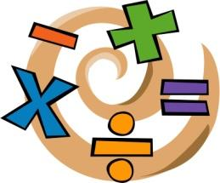  In Numeracy we will be looking at place value up to 10,000 and how to represent, count, order and find more or less of these numbers. We will also be studying addition and subtraction of numbers up to 3 digits. Sumdog and times table practise will be used in class to help children with maths fluency and these are both able to be practised at home. The recall of simple maths facts is vital for your child to make progress in maths.
In History class 2 will be learning all about Ancient Greece. We will learn about the Ancient Greek civilisation and compare this to other historical civilisations we have previously covered. We will study Alexander the Great, Greek myths and legends and Greek religions. We will think about the impact Ancient Greece has had on the wider world and modern day society.

In French we will be learning to listen, respond and show understanding of the French language, beginning to build our French vocabulary and take part in conversations. | In R.E we will be examining Christianity using stories from the old testament and stories told by Jesus to reveal what Christians believe about God.
In Science we will be learning about light. We will be investigating a robbery scenario where clues include lights and shadows to aid our learning and investigate the crime scene to find our suspect. We will be experimenting with different shadows, reflections and light sources.
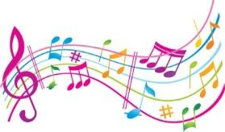  In Music we will be continuing to take part in Violin lessons where children will learn to play and perform in solo and ensemble contexts, playing with increasing fluency.  In order for us to follow government guidelines the children will be taught in year groups in the classroom. Year 4 will be playing for the Autumn Term and Year 3 will play in Spring. Year 3 will be taking part in Forest School outside or mindfulness activities in the school hall (which will be out of bounds to any other classes during this time during this time so as to avoid any mixing of ‘bubbles’) so that the children playing violin can be spaced out even further.  Mrs Athey has been working with the Music Hub at NCC and Mrs Nicklin who is our regular violin teacher to ensure that we are all safe and stringent protocols are in place. Each child will be allocated their own instrument to play. We will not be sending home the instruments. | 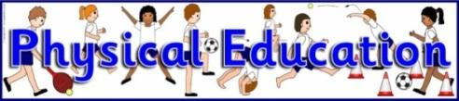  In P.E we will be developing our tennis skills with Mrs Chisholm including racket skills such as volleying and serving, rallying and match play. Miss Donkin will be teaching Tri Golf where we will learn and develop skills such as putting, chipping, striking and playing games.
In PSHE we will be learning all about healthy lifestyles and choices, mental health and how to take care of our minds, keeping safe in a range of situations and how to recognise our own individuality and personal qualities. | In Art we will be exploring the architecture of Ancient Greek buildings and recreating this using a range of materials. We will also be designing and creating our own Greek vases using a range of materials including clay.
Reminders:
- Remember to hear your child read daily.
- Come to school in trainers ready to run the daily mile but have school shoes to change into and please make sure your child has a spare pair of socks in their bag as socks get wet if it has been raining.
- We are not using PE kit for PE for the immediate future but will let you know if this changes.
- Make sure your child is bringing at least one full water bottle each day
- Year 3 will be taking part in Forest Schools every Tuesday while Y4 have violin tuition this term. We will not be wearing wellies or waterproofs but making use of the children’s coat in school and trainers so please ensure they have a warm, waterproof coat.
- We are developing ways in which to inform you of things that we would normally write down in your child’s planner or Reading Record and vice versa so watch this space!

Many thanks and welcome back!
Miss Donkin

