

Q4)

Q4)

1. b) c)

=

c)

d)





Date: ___________________________

LO: to read and write decimals as fractions (L4)

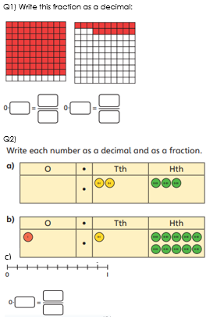

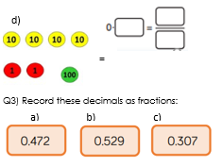

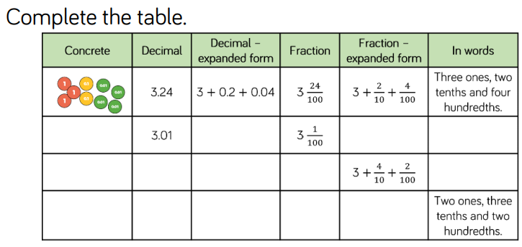

Date: ___________________________

LO: to read and write decimals as fractions (L4)

Q1) Write this fraction as a decimal:

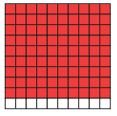 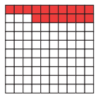



Q2) 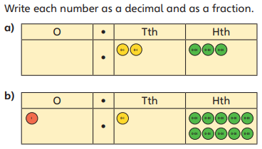 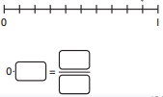

 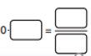

 

Q3) Record these decimals as fractions:

