Early Years Topic Letter –Spring 1
Our topic this half term is - Animals and our planet
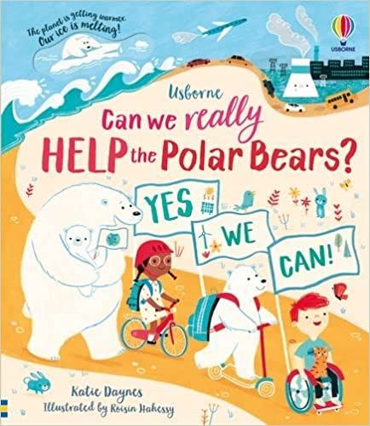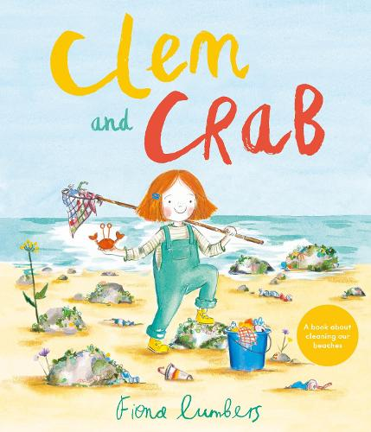

Welcome back! I hope you have all had a wonderful Christmas and New Year. I am looking forward to hearing all about it and sharing our favourite bits!

Gentle reminders:
Drop off for all children is 8.45am (prompt please as this allows our day to run smoothly.) If you are late and the gate into Early Years is locked, please go in via the main office, pick up is 3.15pm or 12 noon if your child goes home after lunch.

Please ensure your child has a change of clothing in school in case we need them. If your child is in nappies, please provide nappies/pull ups, wipes and nappy bags. Children in Early Years should only bring a book bag reading folder to school as our cloakroom and storage space is very small! I am happy for changes of clothes to be left on the children’s pegs either in a carrier bag or a drawstring style bag as these do not take up too much space.

Please email any end of day changes to Mrs Kennedy in the office – I cannot always guarantee messages on tapestry will be seen straight away.

Please always remember a waterproof coat, gloves and a hat, we go out in all weathers! Water bottles are also essential please. Please make sure every item of clothing and water bottle is clearly marked with your child’s name. This makes it easier for us to make sure items are not lost and are reunited with their owner quickly, a lot of jumpers get mixed up and lost daily as we are still learning to be responsible for our own belongings.

PE and forests school/outdoor learning will continue to be on a Friday, so please can your child come to school dressed in their PE kit on this day. If there are ever any changes to this, I will notify you on tapestry.
One of the big things we will be continuing to work on is independence – we are encouraging all children to try and be independent when taking off or putting on their coats, shoes and wellies, please also practise these life skills at home, these are skills that the children need to learn and help to ensure our days are full of fun and learning time is kept to a maximum. Thank you for your support with this.

Please remember to log onto your child’s tapestry account regularly, this will help you to see what your child’s next steps are and will help you to support your child’s learning. It is the way I communicate the most with you regarding any changes. Further to this, it is a lovely way to see what we have been up to and talk about school with your children. Don’t forget to upload achievements and experiences at home too! If anyone is having any problems accessing tapestry, please just let me know.
As ever if you have any queries or concerns, please do not hesitate to contact me, I am always available at drop off or pick up times.

Personal, Social and Emotional Development  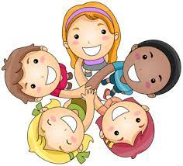  We will reinforce positive behaviour at all times in EYFS. Supporting the children to develop their personal, social and emotional development is at the core of what we do in every way.  This half term we will place particular emphasis on:  Good to be me Feelings  Learning about qualities and differences  Celebrating differences  Identify and moderate their own feelings socially and emotionally  Encouraging them to think about their own feelings and those of others by giving explicit examples of how others might feel in particular scenarios | Physical Development  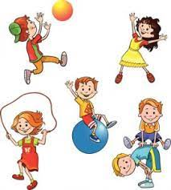  This half term we will be continuing to develop our independence! We will be working on putting our own shoes or wellies on, going to the toilet, identifying when we need our nappy changed, going on the potty or toilet, putting our coat on, peeling our fruit and putting our straw in our milk! You can help at home by supporting your child to get dressed by themselves and have a go at putting their coat on before you help them. You can also support them to wash their hands.  We will also be working hard to develop our fine motor and gross motor skills. We will be doing this through our dough disco and ‘squiggle while you wiggle’ sessions as well as daily name writing.  We will promote gross motor activities like climbing, jumping, running, throwing and catching through physical activities and when using our climbing frame and the cars and bikes.  We will be taking part in lots of fine motor activities which will help to develop the strength in our fingers,and support us to hold a pencil effectively. These will include things like pinching, threading, using pegs, twisting, brushing, stacking, dough disco and using tweezers.  We will be developing our pencil control and Reception will be focussing on accurate letter formation in our names and other words. In Nursery, if we are ready, we will also be working hard to write our names.  In our P.E sessions the focus will be throwing and catching skills.
RE  This half term Reception will take part in RE sessions and our main focus this term is Christianity and why the word ‘God’ is so important to us?  We will be learning about the creation story. | Communication and Language  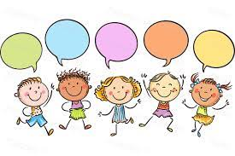  We develop the children’s listening and attention, understanding and speaking skills all the time and often based on your child’s next steps as the children often have specific areas to work on.  This half term we will be focusing on:  Taking turns to talk during circle and group times  Taking each other's ideas on board and work together

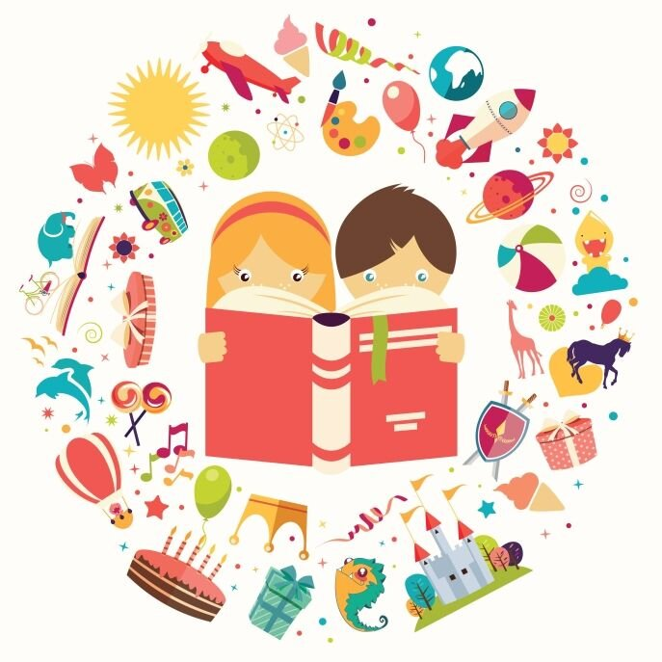
Reception Literacy

This half term in Reception we will continue to consolidate RWInc set 1 sounds and learn RWInc set 2 sounds, through short and snappy ‘speed sounds’ sessions each morning, designed to teach the children to recognise and pronounce the pure sounds, before reading them in simple CVC words such as ‘cat, top, sit.’ As we learn new sounds I will continue to put them in your child's plastic wallet, please support us and practise these at home daily, little and often is key and really does make a BIG difference. If you can pop a little note in your child’s reading record with what you have done and how they have got on, this is a good way to communicate between home and school as well as tapestry.

We will also begin to introduce new red words this half term such as ‘I, the’. These words are words that cannot be sounded out and they just need to be learnt by sight.

We will continue to send a ‘reading for pleasure’ book home each week – please keep this at home and return to school on a Thursday – when we will change them. These books along with books you have at home are a great way to share how stories are structured so that your child becomes used to and can possibly join in with repeated refrains, please take the opportunity for your child to listen to you reading the story, create their own retelling of the story and talk about the characters and settings and the characters feelings. I will also send home the corresponding paper ditties or red reading book that corresponds with your child’s RWI learning from the week, again these are changed weekly and we recommend sharing these at least three times to consolidate previous learning and build confidence and reading with expression as well as building comprehension skills.

We will be developing our writing skills this half term so that children can begin to label pictures and write for various purposes using initial sounds and single words. It is very important as children pick up the sounds in Read, Write, Inc that they practise forming them correctly, starting in the correct place. We will write such things as -
Retelling parts of the story
speech bubbles
Posters to help our planet
Polar Bear facts

Key vocabulary: fiction, non-fiction, speech bubble, poster, facts.

Nursery Literacy

This half term in Nursery we will work on having a go at writing our names and developing our mark making skills.
This half term we will be placing our emphasis on creating confident mark maker’s, allowing the children to explore the different marks they make using a variety of tools including chalk, pens, pencils, crayons, water and in sensory trays. We will take part in ‘Squiggle While you Wiggle’ sessions to help us to develop our early writing skills in an energetic and fun way.
We will also be promoting drawing and supporting the children to talk about what they have drawn and the marks they have made.
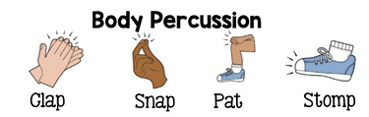
We will take part in short daily phase one phonics sessions which will help us to develop our sound discrimination and listening skills. This half term we will be focussing on body percussion and rhythm and rhyme.

Key vocabulary: fiction, non-fiction, rhyme.
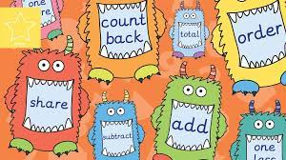
Nursery Maths  Maths happens all day in Early Years, during the  register, at snack time and while the children play. Before the day has even started, we have counted and added up how many children we have at school and recorded this using Numicon and on tens frames.  This half term we will focus on:  Counting up to 5 objects accurately  Matching amounts of objects to numicon pieces  Beginning to recognise numerals  Continue to develop 2D shape knowledge  Secure positional language  Key vocabulary: How many? Numicon, number,match, same, triangle, square, circle, rectangle, 2D shape, flat shape. | Reception Maths  Maths happens all day in Early Years. Each morning at register time, we will count how many children we have, add them up and record this using Numicon and number sentences before our day has even started! Maths is covered in all areas of the provision, but we also take part in a short, directed Maths activity each day. The children can then apply the skills they have used in the provision.  This half term we will focus on:  Numbers 5,6,7,8  Addition and subtraction, number bonds to 5, combining two groups  Key vocabulary: Compare, order, number, quantity, bigger, smaller, add, plus, combine, total, equals, altogether, subtract, take away, minus, number bonds.
Expressive, Art and Design  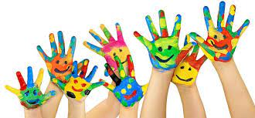  This term the children will have the opportunity to:  Design homes for hibernating animals.  Create collages.  Select the tools and techniques they need to assemble materials that they are using e.g creating animal masks.  Use different techniques for joining materials, such as how to use adhesive tape and different sorts of glue.  Design posters to let people know about our Planet and what we can do to protect it.  Key vocabulary: hibernation, animals, tools, collage, cut, stick, materials, join, attach, Planet, poster. | Understanding the World  This term we will be:  Listening to stories and placing events in chronological order.  Thinking about what we can do here to take care of animals in the Arctic?  Comparing animals from our environment to those in the Arctic.  Exploring a range of Arctic animals. Learn their names and label their body parts.  Learning about nocturnal animals Making sense of different environments and habitats.  Using images, video clips, shared texts and other resources to bring the wider world into the classroom.  After close observation, drawing pictures of the natural world, including animals and plants.  Looking into recycling and how it can take care of our world. Look at what rubbish can do to our environment and animals.  Key vocabulary: animals, habitats, protect, recycle, nocturnal, diurnal, environment, compare.

