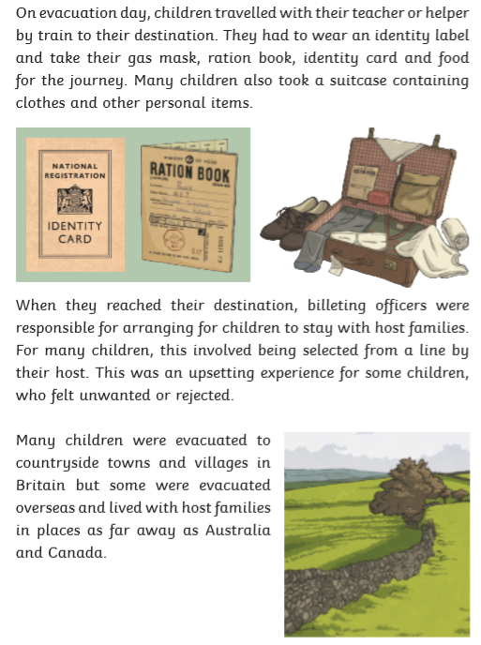
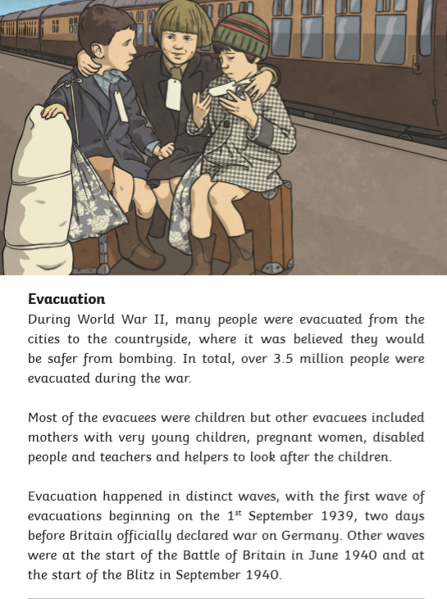

Read this extract carefully.
Describe two ways that the text gives the impression that evacuation was a large-scale operation. Use evidence from the text to support your answer.
[3 marks]

_______________________________________________________________________________________________________________________________________________________________________________________________________________________________________________________________________________________________________________________________________________________________________________________________________________________________________________________________________________________________________________________________________________________________________________________________________________________________________________________________________________________________________________________________________________________________________________________________________________
Answers

Acceptable points:
AP1 A lot of people were evacuated.
AP2 Teachers and helpers were required to look after the children.
AP3 The evacuation occurred in distinct waves.
AP4 Children were required to wear identity labels.
AP5 Children were sent to different countries around the world.

Award 3 marks for two acceptable points, at least one with evidence, e.g.
- Evacuation is made to sound large-scale because a lot of people were involved. The text says that over 3.5 million people were evacuated. It was such a big event that not everyone could be evacuated at the same time. [AP1 + evidence and AP3]
- The text says that children were required to wear identity labels. This must have been because there were so many children that no one could keep track of them. Also, not every child could stay in the UK because there were so many of them, so they were sent to places as far away as Australia and Canada. [AP4 + evidence and AP5 + evidence]

Award 2 marks for either two acceptable points, or one acceptable point with evidence, e.g.
- It must have been large-scale because teachers were needed for the children, which implies that it would be happening for a long time. [AP2 + evidence]
- Evacuation couldn’t happen all at the same time and children were sent all around the world. [AP3 and AP5]

Award 1 mark for one acceptable point, e.g.
- Lots of people were evacuated. [AP1]
- Children were sent to places around the world. [AP5]

