**Orthoptic-led Vision Screening: Information for Teaching Staff and Pupils**

Please use the attached information to prepare the children for the upcoming vision screening test.

**Why do we do school vision screening?**

The aim of this screening assessment is to detect significantly impaired vision which could affect learning. The tests are done by a vision screener within school for maximum coverage.

Parents are informed that the test will be taking place and given the option to opt-out if they wish. They will receive a letter with the outcome of the screening check.

**How do we do the test?**

We will test the children in small groups preferably in a small quiet room near the classroom so we can take the children back after testing. If there are any children you have specific concerns about regarding vision or ability to co-operate with the test eg specific needs or English as a second language, please let us know before testing.

We will ask the children to either name or match letters whilst wearing orange and green glasses to test each eye separately. The letters that we use for the test are V, U, Y, O, X and H. It would help if the children are familiar with these letters.

**What happens if a child does not pass the vision screening check?**

Children will either be referred to a local optometrist or direct to the hospital eye service depending on the screening result. If a child is unable to perform some of the tests they will be offered a telephone review with an Orthoptist.

If a child is absent on day of screening they will be advised to attend a local optician.

**What is a vision screener?**

A Vision Screener is a professional who is specifically trained to undertake the school vision screening assessment. They are trained by an Orthoptist and the screening programme is orthoptic-led. The video link below provides information on what Orthoptists do. Both the Orthoptist and the Vision Screener work for Newcastle Upon Tyne Hospitals. The Orthoptist also assess and treat patients at the Children’s eye clinic at the Royal Victoria Infirmary.

<https://www.orthoptics.org.uk/Videos>

**School Eye Test**

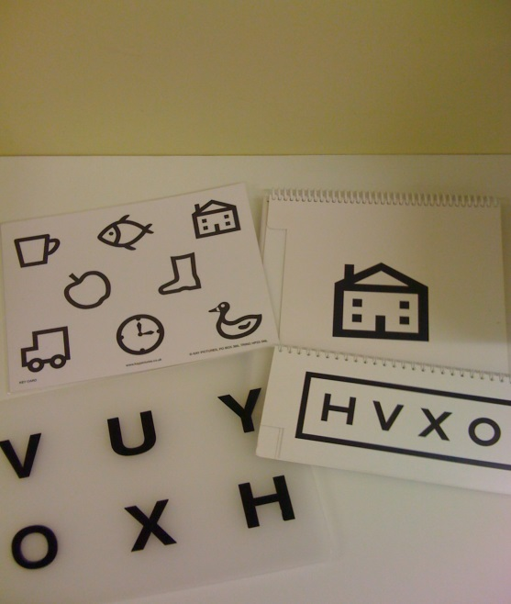

The Vision Screener is coming to make sure that both of your eyes can see well. The screener will ask you to say the names / phonics of these letters, V U Y O X H

Don’t worry if you can’t remember them as you can match them.

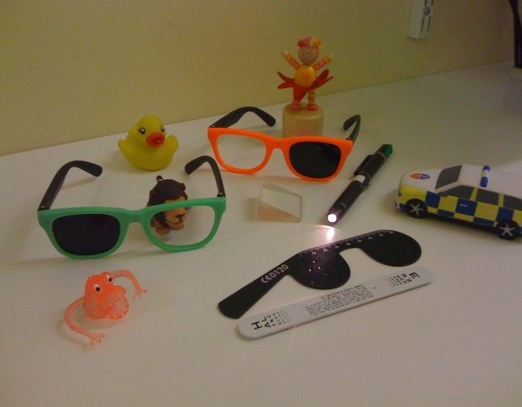

When you do the letters game you will get to wear the orange and green glasses.

There will be nothing to be scared of, the games are fun and you will get a sticker! ☺