

Monday 6th July 2020

**Reading at home and school**

Dear Parents/Legal Guardians,

During one of my meetings with Governors last week a question was asked regarding children’s reading and how were we sharing books for the children to read. I thought the question was extremely valid and thought it would be helpful to update you on our current position.

At the start of lockdown the children were sent home with reading books and parents were given details of the e book service Oxford Owl - <https://www.oxfordowl.co.uk> which also had further links to amazon kindle books, many of which are free.

Your child’s class teacher will also share reading activities with you as part of their online learning.

If your child has been in school, they have continued with their reading. To avoid contamination after the book has been used in school it has been stored for 72 hours before being cleaned and returned to circulation. There has not been the usual sharing of books between home and school.

You may be now running out of things to read and wondering how you are going to continue to support your child’s reading at home for the next two weeks and the summer holidays.

Please remember that reading is everywhere and is not just limited to newspapers and magazines, there are games on School 360, Sumdog Grammar and Spelling games, reading games and apps to name but a few things which can support your child’s reading.

**Libraries -** I have checked NCC website and currently the guidance is –

**Statement on Library Service Provision**

“We know how important our services and spaces are to you and our entire community and as our high streets open back up, we know it’s hard to see our libraries still closed. We are every bit as impatient as you are to open up and welcome you back. Not all of our services will be available, and we will look a little different when we open.

We closed our doors at very short notice and the health and safety of our staff, volunteers and users being our primary concern, we therefore plan to reintroduce our services gradually and only when it is safe to do so in line with the latest public health advice. In our branches which are co-located with other Council Services or partner organisations we will work with them and only permit access when safe to do so.  
  
So, it’s taking us a bit of time to get everything back up and running. Therefore, our enhanced digital offer will remain the main channel for users for the time being, however doorstep deliveries are being made to library members in the vulnerable age category.

We are determined to see you back in our libraries very soon and we can’t wait until we do. Please follow us on [Facebook](https://www.facebook.com/northumberlandlibraries/), [Twitter](https://twitter.com/NlandLibs) or [Instagram](https://www.instagram.com/nlandlibs/) and keep checking our website for regular updates on what’s happening.

Our digital library is available and library members can access eBooks, eAudiobooks and eMagazines with [BorrowBox](https://fe.bolindadigital.com/northumberland" \t "_blank) and [RBdigital](https://northumberland.rbdigitalglobal.com/" \t "_blank).  Newspapers and eMagazines can also be read using [PressReader](https://www.pressreader.com/" \t "_blank). If you are not a library member you can [join online](https://northumberland.spydus.co.uk/cgi-bin/spydus.exe/MSGTRN/WPAC/JOIN) today and access our digital library with your temporary borrower id.”

[Find out how you can you use Northumberland Libraries at home](https://northumberland.spydus.co.uk/cgi-bin/spydus.exe/MSGTRNGEN/WPAC/CORONAVIRUS)

Join the Summer Reading Challenge today

[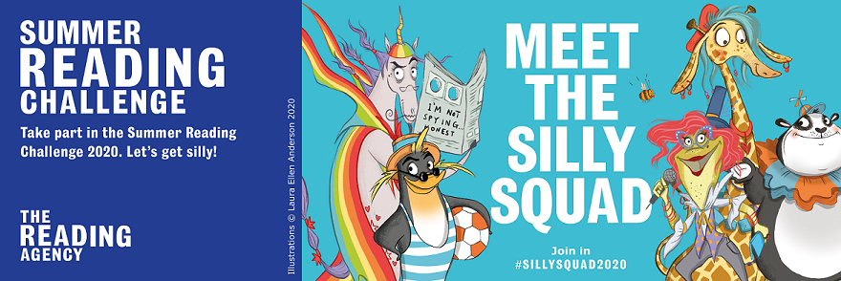](https://northumberland.spydus.co.uk/cgi-bin/spydus.exe/MSGTRNGEN/WPAC/SRC)

**Access our Digital Library 24/7**

Access our digital library 24/7 from the comfort of your own home for free. [BorrowBox](https://fe.bolindadigital.com/northumberland) has hundreds of eAudio and eBooks for children and adults. This great selection of eBooks and eAudio are guaranteed to be available for you to borrow today.

**Barter Books**

Barter Books is now open. If you have books to ‘barter’ please bring them in and put them on our school account – Whittingham C of E Primary. Families can then feel free to use the account and after reading, return the book to Barter Books to be ‘bartered’.

**A further resource for children in Class 2 and 3**

Year 6 children will probably remember when we accessed First News as part of our reading in school. They now have newspapers and reading online so I have joined for a 30-day trial and can continue this if this is popular. I hope to have this set up for September.

And finally, when I sent out the questionnaire early in the Summer Term on our Online Learning Provision, I only received 9 replies. Limited response will mean that limited action will be taken.

Please do not be afraid to give your class teacher or myself direct feedback as listening to your suggestions and questions enables us to improve. Without this we will assume that everyone is happy and the ‘status quo’ will continue.

We all look forward to hearing from you!

Best Wishes, Belinda Athey – Headteacher.