**7th February**

**Bingo Fun!**

**1.30pm**

**In school**

**eady?**

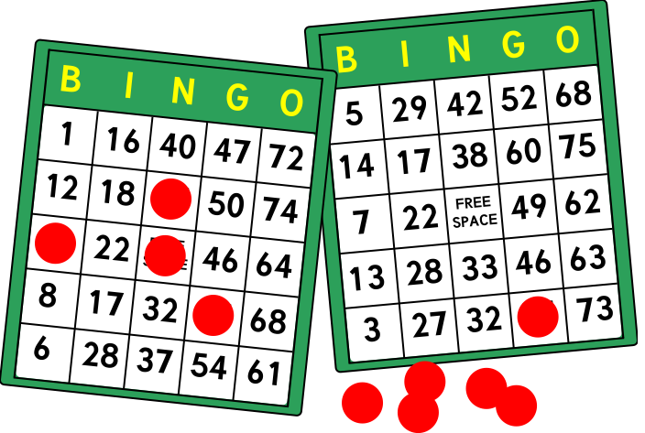

Are you ready?