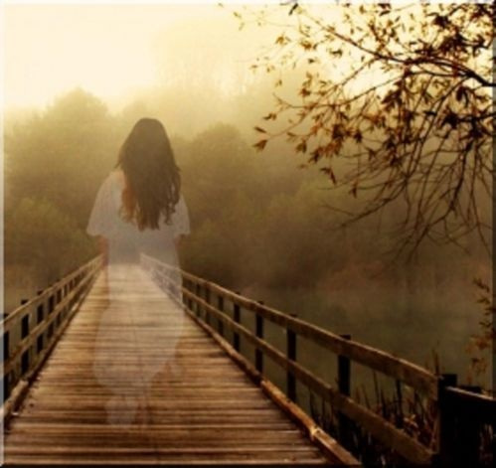
Creative Writing

The scarlet sun was beginning to set, illuminating the misty skyline. Gradually, a strange female figure appeared. She seemed to be strolling, almost drifting, across the dilapidated wooden bridge.

Creative Writing
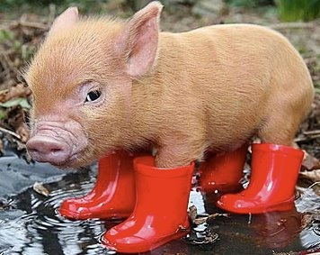

Across the deserted yard, and standing in the middle of a murky puddle, was a pig. Not just an ordinary pig, but a pig wearing wellington boots no less! It stared right at John, it’s eyes penetrating into his very soul, as if he could read his every thought.

Creative Writing
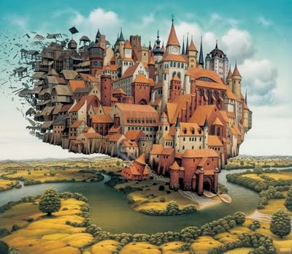

“THE TOWN… IT’S… IT’S… STARTING TO COLLAPSE AND FLOAT AWAY!” screamed Milly, as she stared in shock at the quickly disappearing town of Willow.
“What are we going to do?!” questioned Matt, with a worried expression, frozen to the spot, helpless.

Creative Writing
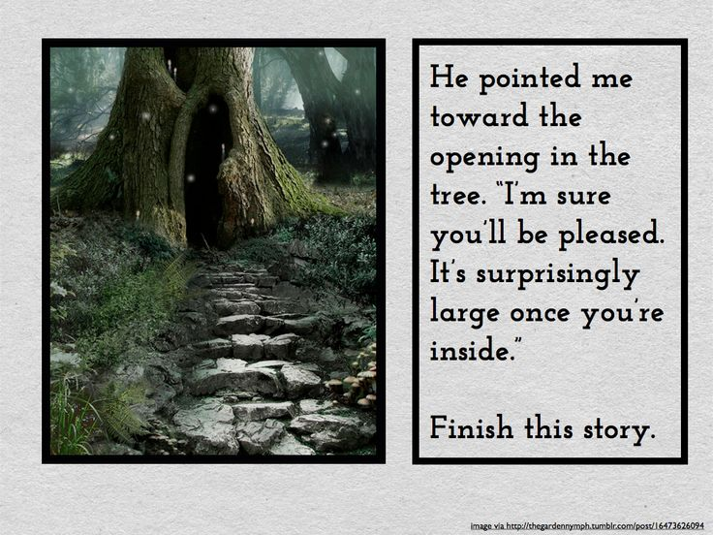

Creative Writing
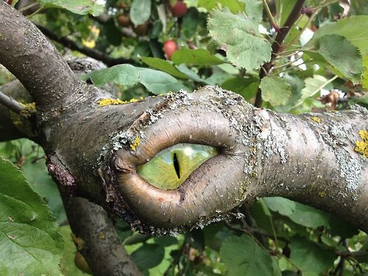

You are walking through a strange forest full of odd sounds and noises. You stop for a short rest, knowing that you want to get home as quickly as possible. You sit next to a tree. Hearing a noise you look next to you and see the tree LOOKING at you.

Creative Writing

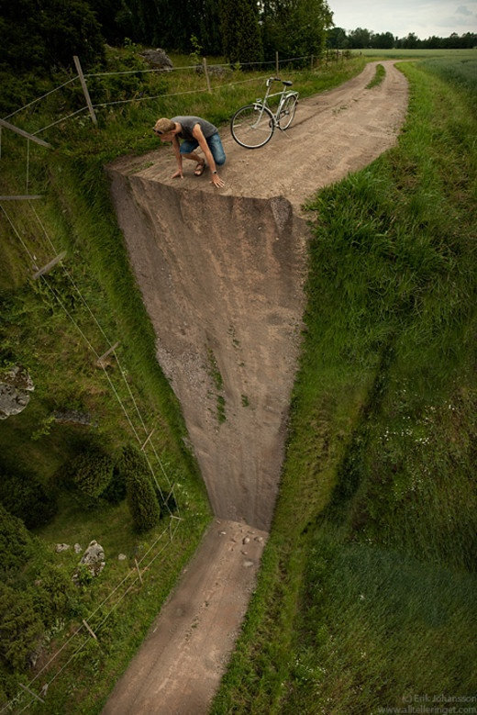

Creative Writing

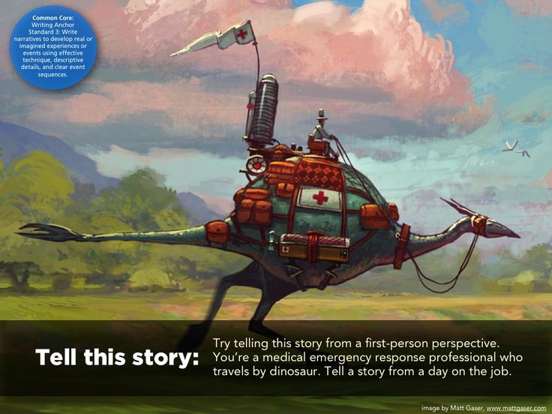

Creative Writing
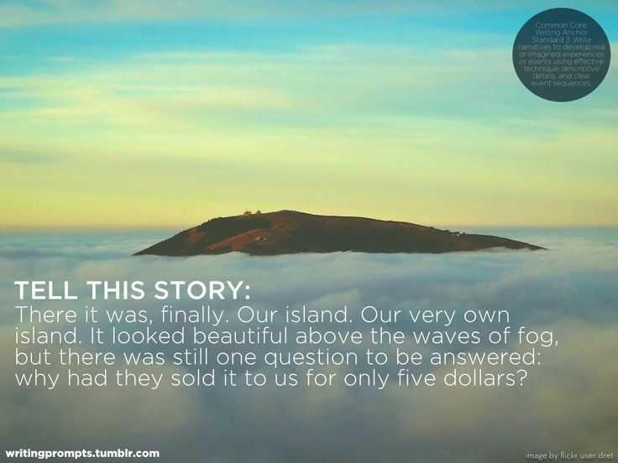

Creative Writing

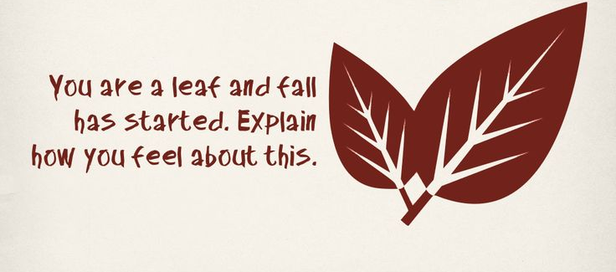

Creative Writing
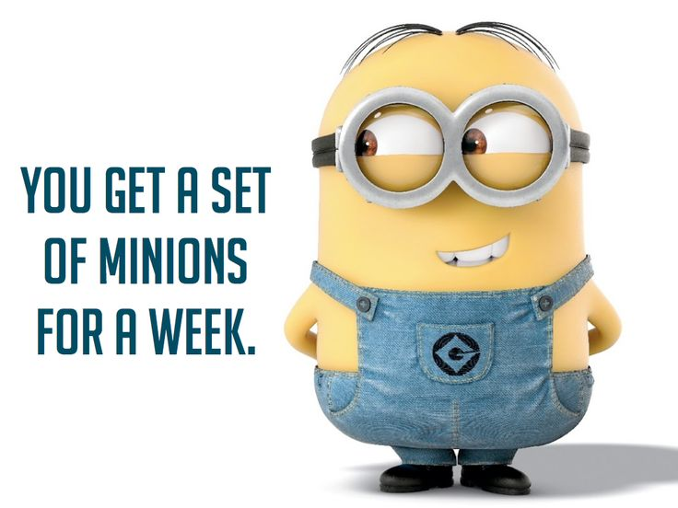

Creative Writing
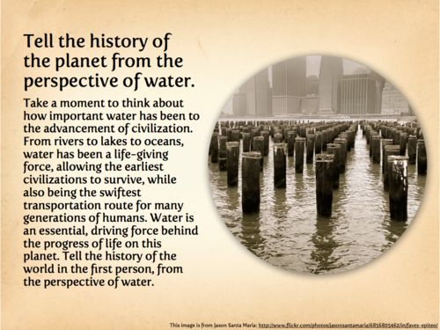

Creative Writing
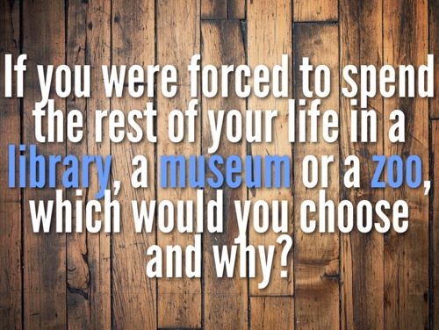

Creative Writing
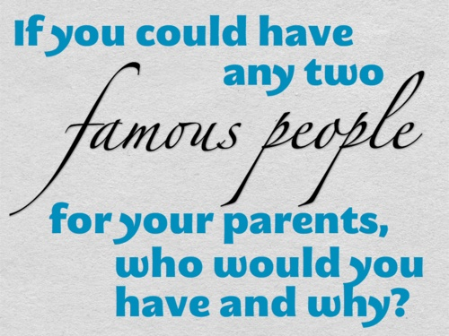

Creative Writing
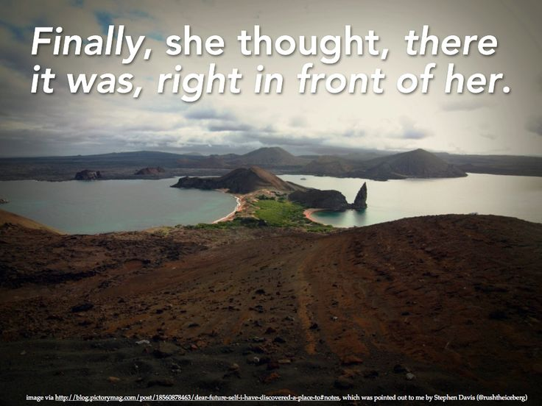

Creative Writing

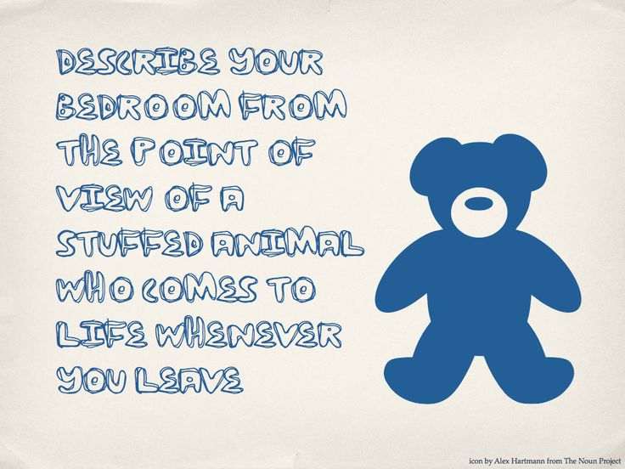

Creative Writing
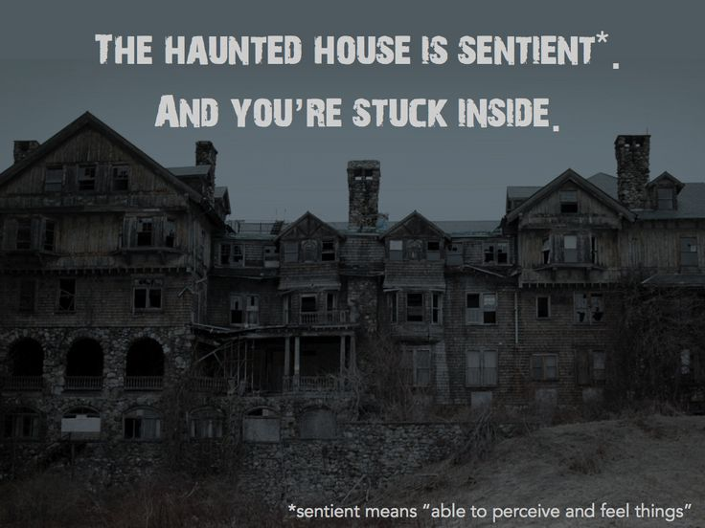

Creative Writing
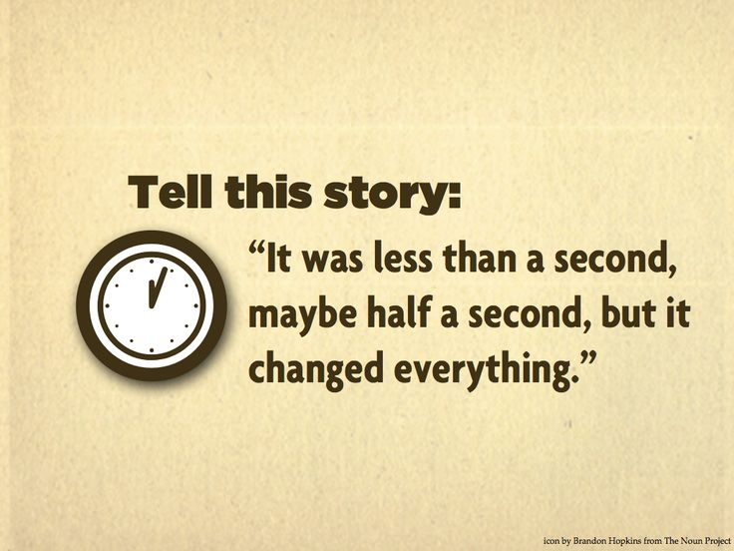

Creative Writing

