Class One Autumn 1
Working in Class 1 there will be myself ( Miss Armstrong) and Miss Clark
Dear Parents/Guardians,
It has been an interesting year so far but it is so good to see all the children back. We have had an excellent start to the year with some exciting activities like making dream catchers and writing about our wishes. I am looking forward to exploring the topic ‘Coasts’ with the children this term.
English
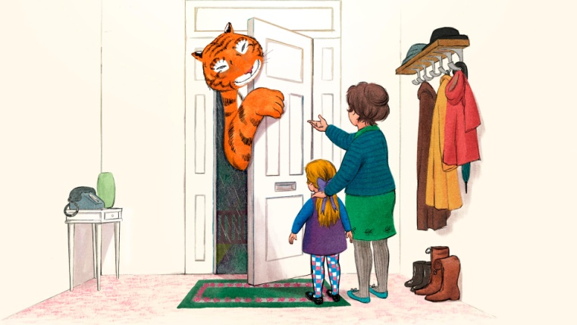
We will be looking at stories within a familiar setting including some of my favourites like, ‘The Tiger Who Came to Tea,’ and ‘Whatever Next.’ We will be focusing on using a range of punctuation (full stops, exclamation marks etc.), coordination (and, but, or) and most importantly leaving finger spaces between our words. Then we will look at some interesting texts like ‘Oi, Get of our Train’ and ‘The Magic Bed,’ to write our own scene for what happens next. We will finish by looking at some fantastic short poems where we will be focusing on using expanded noun phrases to build some amazing descriptions.
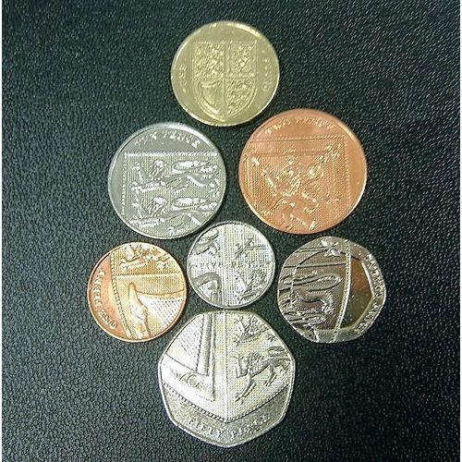
Maths
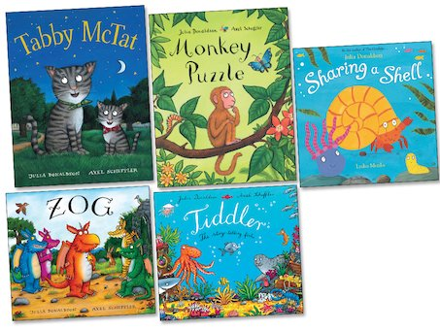
This is one of my favourite subjects which I hope I will inspire the children in their learning. We will be focusing on building strong foundations in their understanding of place value which is the basis for all the next steps in learning. We will be also looking at tens and ones, one more/less than a given number and counting in 2’s, 5’s and 10’s. We will then be learning about addition and subtraction including the use of money.
Reading
I must say I do love story time in class. There is always time for a story and I love it when the children ask me to read their favourites or familiar stories from home. It’s always great to see when they can join in with the parts of the story they remember. We will be using the RWI Phonics programme with the children so they build their fluency in reading and also spelling. I ask that you support your child at home in learning their High Frequency Words as this helps to make reading easier for them. Please also encourage your child to practise spelling these words as well as often these cannot be sounded out. It is also of great help if you can read some stories to your child as well as this helps to build their imaginations along with their range of vocabulary.
Science
In Science we will be exploring the topic of Animals including humans. This is always an exciting topic exploring what animals eat, where they live and describing what they look like. Then looking at the human body and how it functions. We will also carry out some simple science experiments making predictions about what might happen and seeing if we are correct.
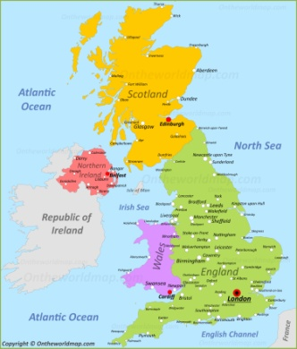
Geography
We will be exploring our coastline along with the human and physical features which it is made up of. We will also be looking at the different parts of the UK and the countries within understanding what makes each of them special.

Art and Design
Based on our topic coasts we will be using clay to create some amazing lighthouses and maybe even a boat or two. We will be using different painting and sketching techniques to create some amazing animals designs and prints.
Computing
We will be exploring using paint, logging on and off and internet safety.
RE
We will be looking at Hinduism and Christianity. Within Hinduism we will be exploring Diwali and in Christianity we will be exploring the Harvest festival and Christmas.

I look forward to this exciting jam packed half term and if you have any queries or questions please don’t hesitate to ask.

Miss Armstrong

