Early Years Topic Letter – Autumn 2

Our topic this half term is - When I grow up I’d like to be a.....

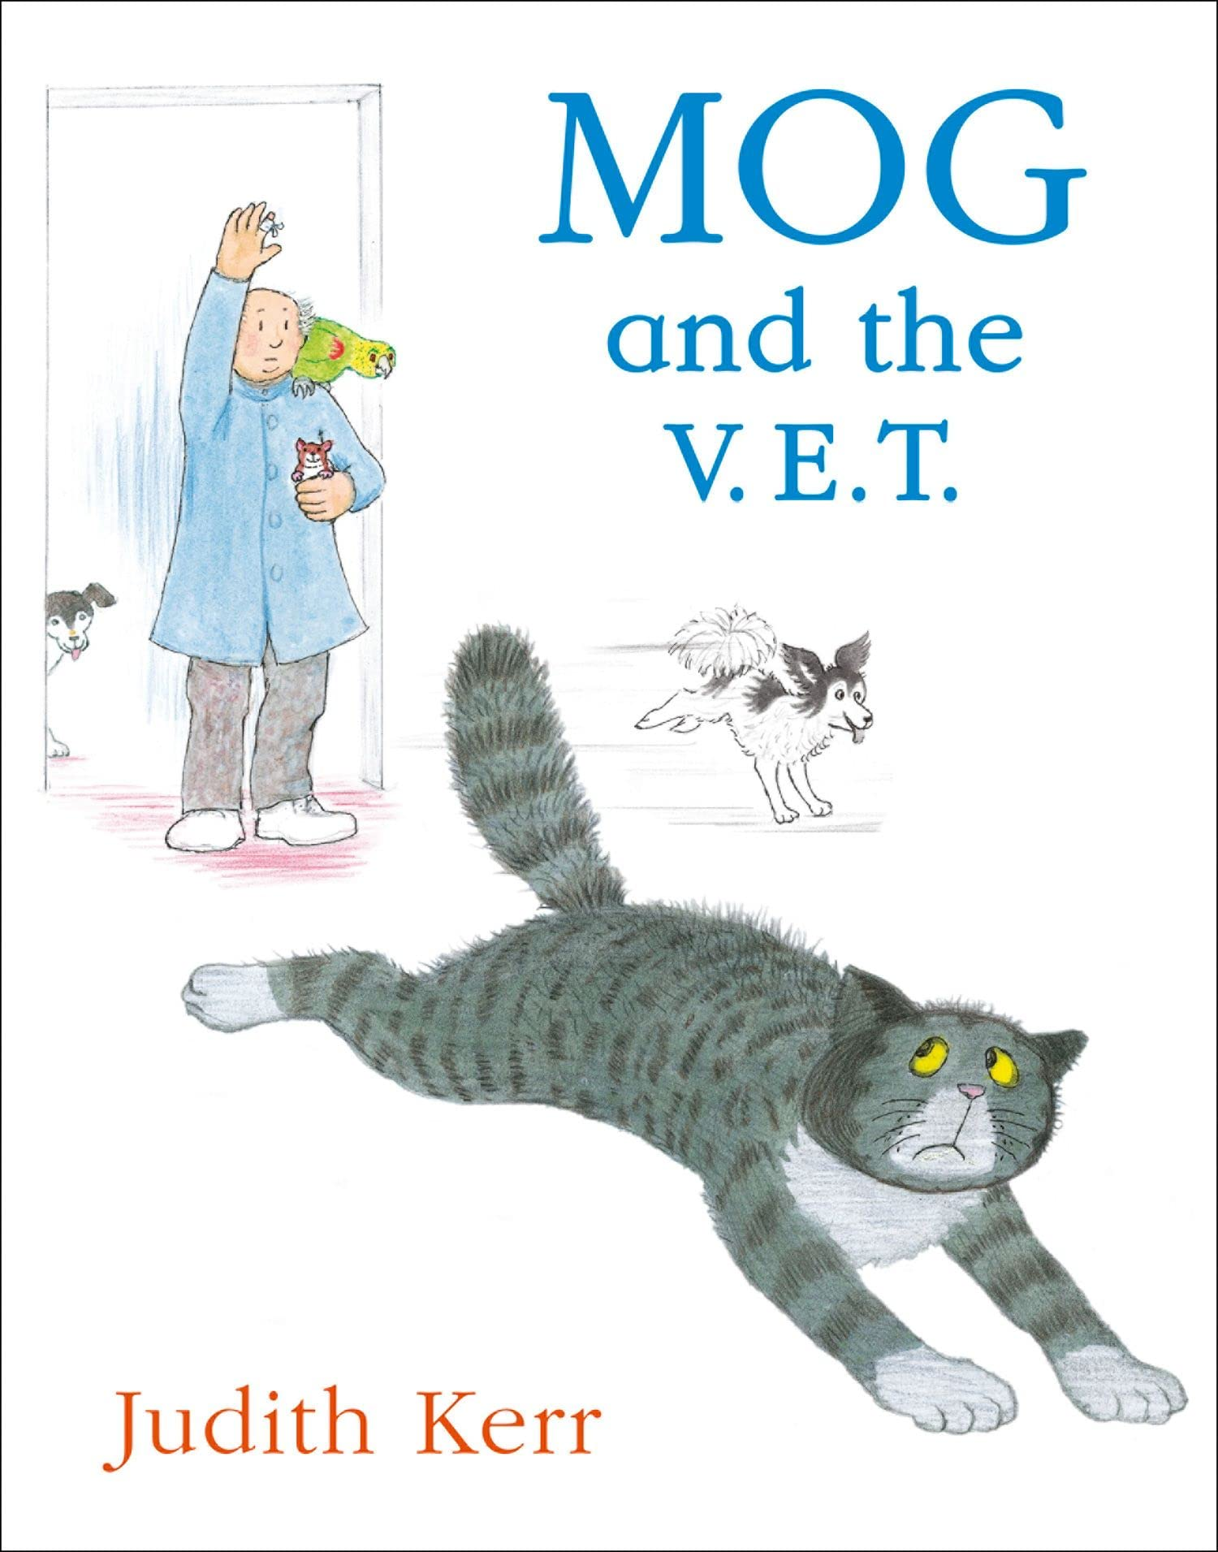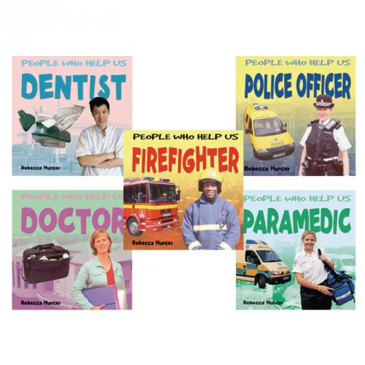

Welcome back! I hope you have all had a wonderful half term holiday. I cannot wait to hear about all your adventures and tell you all about mine too!

Gentle reminders

Drop off for all children is 8.45am (prompt please as this allows our day to run smoothly.) If you are late and the gate into Early Years is locked, please go in via the main office, pick up is 3.15pm or 11.45am if your child goes home before lunch.

Please ensure your child has a change of clothing in school in case we need them. If your child is in nappies, please provide nappies/pull ups, wipes and nappy bags. Children in Early Years should only bring a book bag reading folder to school as our cloakroom and storage space is very small! I am happy for changes of clothes to be left on the children’s pegs either in a carrier bag or a drawstring style bag as these do not take up too much space.

Please email any end of day changes to Mrs Kennedy in the office – I cannot always guarantee messages on tapestry will be seen straight away.

Please always remember a waterproof coat, we go out in all weathers! As the weather changes and is colder a hat and gloves may be needed, water bottles are also essential please. Please make sure every item of clothing and water bottle is clearly marked with your child’s name. This makes it easier for us to make sure items are not lost and are reunited with their owner quickly.

PE and forest school will continue to be on a Monday and a Thursday, so please can your child come to school dressed in their PE kit on these days. If there are ever any changes to this, I will notify you on tapestry.

One of the big things we have been working on last half term and will be continuing to work on is independence – we are encouraging all children to try and be independent when taking off or putting on their coats, shoes and wellies, please also practise these life skills at home, these are skills that the children need to learn and help to ensure our days are full of fun and learning time is kept to a maximum. Thank you for your support with this.

Please remember to log onto your child’s tapestry account regularly, this will help you to see what your child’s next steps are and will help you to support your child’s learning. Further to this, it is a lovely way to see what we have been up to and talk about school with your children. Don’t forget to upload achievements and experiences from at home too! If anyone is having any problems accessing tapestry, please just let me know.

Visits and trips – We are very lucky that some of the parents of our class have said they will come in and talk to us about their jobs, if this is something you think you would like to do please just let me know and I am sure we could arrange something.

As ever if you have any queries or concerns, please do not hesitate to contact me, I am always available at drop off or pick up times.

Dates for your diary:

30th November – School PTA Christmas Fayre at the Village Hall 10-12 – if any parents are able to help out please contact us

11th December – Nativity production – 10am is a dress rehearsal – advised to bring toddlers and babies, 1.30pm is the afternoon performance

17th December – Early Years Christmas lunch and party day – children can come in party/Christmas clothes on this day

20th December – Christingle service at Church at 1.30pm - break up for the Christmas holidays

| Personal, Social and Emotional Development    We will reinforce positive behaviour at all times in EYFS. Supporting the children to develop their personal, social and emotional development is at the core of what we do in every way.  This half term we will place particular emphasis on:  Getting on and falling out.  How to deal with anger Emotions  Self - Confidence  Build constructive and respectful relationships.  Ask children to explain to others how they thought about a problem or an emotion and how they dealt with it. | Physical Development    This half term we will be continuing to develop our independence! We will be working on putting our own shoes or wellies on, going to the toilet, identifying when we need our nappy changed, going on the potty or toilet, putting our coat on, peeling our fruit and putting our straw in our milk! You can help at home by supporting your child to get dressed by themselves and have a go at putting their coat on before you help them. You can also support them to wash their hands.  We will also be working hard to develop our fine motor and gross motor skills. We will be doing this through our dough disco and ‘squiggle while you wiggle’ sessions as well as daily name writing.  We will promote gross motor activities like climbing, jumping, running, throwing and catching through physical activities and when using our climbing frame and the cars and bikes.  We will be taking part in lots of fine motor activities which will help to develop the strength in our fingers, and support us to hold a pencil effectively. These will include things like pinching, threading, using pegs, twisting, brushing, stacking, dough disco and using tweezers.  We will be developing our pencil control and Reception will be focussing on accurate letter formation in our names and other words. In Nursery, if we are ready we will also be working hard to write our names.  In our P.E sessions the focus will be fundamental skills such as; moving in different ways, balancing and climbing. |
| --- | --- |
| RE    This half term Reception will take part in RE sessions and our main focus this term will continue to be looking at being special and where we belong, we will cover this by looking at some Multi –faith comparative units.  We will be learning:  To have an awareness of our Christian Church community as well as other religions and beliefs.  To understand why Christmas is special to Christians. | Communication and Language    We develop the children’s listening and attention, understanding and speaking skills all the time and often based on your child’s next steps as the children often have specific areas to work on.  This half term we will be focusing on:  Asking questions about people's job roles as part of our topic, listening to what people's jobs are and what they do.  Sharing stories that shows us about people's job roles e.g., Mog at The Vet etc.  Singing and learning lots of new and familiar nursery rhymes.  Having two channelled attention, being able to listen and ‘do’ at the same time. |

| Reception Literacy  This half term in Reception we will continue to learn RWInc set 1 sounds through short and snappy ‘speed sounds’ sessions each morning, designed to teach the children to recognise and pronounce the pure sounds, before reading them in simple CVC words such as ‘cat, top, sit.’ As we learn new sounds I will continue to put them in your child's plastic wallet, please support us and practise these at home daily, little and often is key and really does make a BIG difference. If you can pop a little note in your child’s reading record with what you have done and how they have got on, this is a good way to communicate between home and school as well as tapestry.  We will also begin to introduce new red words this half term such as ‘I, the’. These words are words that cannot be sounded out and they just need to be learnt by sight.  We will continue to send a ‘reading for pleasure’ book home each week – please keep this at home and return to school on a Thursday – when we will change them. These books along with books you have at home are a great way to share how stories are structured so that your child becomes used to and can possibly join in with repeated refrains, please take the opportunity for your child to listen to you reading the story, create their own retelling of the story and talk about the characters and settings and the characters feelings.  We will be developing our writing skills this half term so that children can begin to label pictures and write for various purposes using initial sounds and single words. It is very important as children pick up the sounds in Read, Write, Inc that they practise forming them correctly, starting in the correct place.  We will encourage dominant hand, tripod grip, mark making, giving meaning to marks and labelling. We will write labels, speech bubbles and letters to Father Christmas. |
| --- |
| Nursery Literacy  This half term in Nursery we will work on having a go at writing our names and developing our mark making skills.  This half term we will be placing our emphasis on creating confident mark maker’s, allowing the children to explore the different marks they make using a variety of tools including chalk, pens, pencils, crayons, water and in sensory trays. We will take part in ‘Squiggle While you Wiggle’ sessions to help us to develop our early writing skills in an energetic and fun way.  We will also be promoting drawing and supporting the children to talk about what they have drawn and the marks they have made. We will take part in short daily phase one phonics sessions which will help us to develop our sound discrimination and listening skills. This half term we will be focussing on body percussion and rhythm and rhyme.  *Key vocabulary: fiction, non-fiction, rhyme.* |

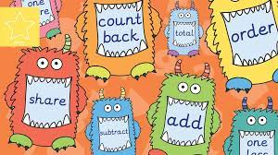

Maths happens all day in Early Years. during the register, at snack time and while the children play. Before the day has even started, we have counted and added up how many children we have at school and recorded this using Numicon and on tens frames.

| Nursery Maths  This half term we will focus on:  Continue developing counting to 10 and beyond  Counting small amounts of objects accurately using 1 to 1 correspondence, playing with and exploring Numicon  Exploring concept of everyday time  Talking about 2D shapes  Explore positional language  *Key vocabulary: How many? Numicon, number, first, next, later, morning, afternoon, yesterday, today, tomorrow, triangle, square, circle, rectangle, 2D shape, flat shape, under, behind, next to, in front of, on top.* | Reception Maths  Maths is covered in all areas of the provision, but we also take part in a short, directed Maths activity each day. The children can then apply the skills they have used in the provision.  This half term we will focus on:  Numbers 1, 2, 3 – Comparing and composition.  Circle and triangle and shapes with 4 sides.  Positional language  Representing numbers to 5 and one more/one less.  Time – night and day, ordering key events, days of the week.  *Key vocabulary: Compare, order, number, quantity, bigger, smaller, shapes, circle, triangle, rectangle, square, under, behind, next to, in front of, on top, more, less, one more, one less, night, day, light, dark, first, next, later, morning, afternoon, Monday, Tuesday, Wednesday, Thursday, Friday, Saturday, Sunday.* |
| --- | --- |
| Expressive, Art and Design    This term the children will have the opportunity to:    Practise for the Christmas play, promoting singing and dancing with confidence.  Use accurate colours for a purpose when drawing and painting.  Exploring instruments and sounds.  Use different textures and materials to make vehicles and pictures of vehicles that help us.  Listen to music and make their own dances in response.  Firework pictures, Christmas decorations, Christmas cards, Christmas songs/poems.  The use of story maps, props, puppets will encourage children to retell, invent and adapt stories about people who help us.  Role Play Parties and Celebrations. Role Play of The Nativity and people who help us.  *Key vocabulary: family, Christmas, celebrations, Bonfire night, fireworks, puppets, re-enact, retell, role play.* | Understanding the World    This term we will be:  Talking about what they have done with their families during Christmas’ in the past.  Sharing photos of how Christmas used to be celebrated in the past.  Use world maps to show children where some stories are based. Use the Jolly Postman to draw information from a map and begin to understand why maps are so important to postmen.  Share different stories of roles that people do and jobs to help us.  Introducing children to a range of fictional characters and creatures from stories and to begin to differentiate these characters from real people in their lives.  Talking about occupations and how to identify strangers that can help them when they are in need.  Talking about World War Two and the importance of Remembrance for Remembrance Day.  Thinking about where we live in comparison to other places across the world and what different homes look like.  *Key vocabulary: family, Christmas, celebrations, past, now, maps, location, job, occupations, help, stranger, safe, home, house, live, place, world.* |