

Date: ___________________________

LO: to write decimals (lesson 2)

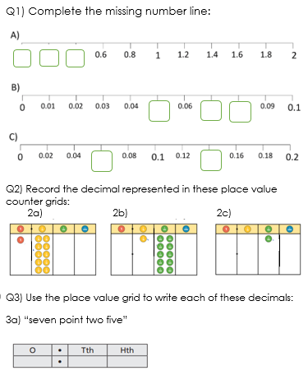

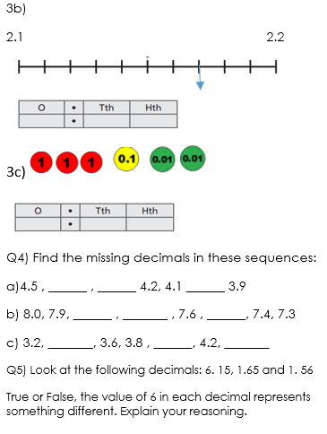

2



Date: ___________________________

LO: to write decimals (lesson 2)

Q1) Complete the missing number line:







Q2) Record the decimal represented in these place value counter grids:

2a) 2b) 2c)

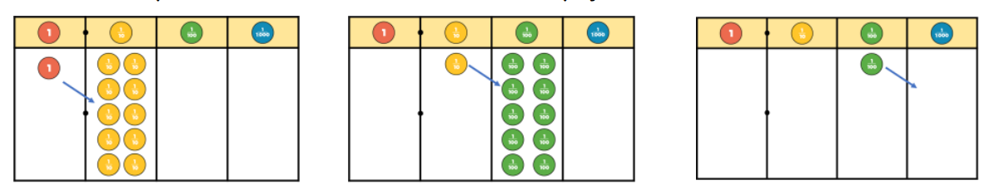

Q3) Use the place value grid to write each of these decimals:

3a) “seven point two five”

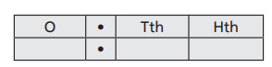

3b)

2.1 2.2





3c)  



Q4) Find the missing decimals in these sequences:

a)4.5 , ______ , ______ 4.2, 4.1 ______ 3.9

b) 8.0, 7.9, ______ , _______ , 7.6 , ______, 7.4, 7.3

c) 3.2, _______, 3.6, 3.8 , ______, 4.2, _______

Q5) Look at the following decimals: 6. 15, 1.65 and 1. 56

True or False, the value of 6 in each decimal represents something different. Explain your reasoning.

