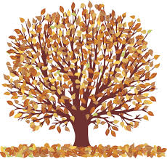
Class Teachers -Ms F Buckingham
(Monday -Thursday in Mrs Fletcher’s absence)
Mrs B Athey (Friday)
Supported by Mrs Morris and Mrs Chisholm for PPA cover.
Well done to Jamie who became a Millionaire Reader this half term.

Literacy  Our first topic of the half term is  Instructions and Explanation Texts -  Hover boards and Doggie Umbrellas meet new-fangled escalators and dial telephones in a unit which explores instructions and explanations, in the context of changing technology. Children try pitching their own designs in the ‘Den’ and create guides for futuristic travel.  Recount Texts - UFOs and Aliens. We will be exploring recounts, investigating genuine documents, discussing famous sightings and researching notorious hoaxes. The children will then write a diary entry and create their own hoax UFO report.  Our poetry topic this term is Classic Poems by Lewis Carroll.  Lewis Carroll's Walrus and the Carpenter stimulates performance, discussion and persuasive writing.  Hilaire Belloc's Cautionary Tales provide cause for debate and the children end the unit writing their own modern day cautionary poems.  We will continue to develop our reading comprehension skills through our guided reading sessions and use of Accelerated Reader, as well as increasing understanding of written grammar through writing analysis.  Please hear your child read daily and write a message on Class Dojo after hearing them read with any comments you may have as we are using this as our record instead of a paper-based Reading Record.  The children will be expected to learn, use and spell correctly all of the spellings from the Years 3,4,5, and 6 spelling lists. https://whittingham.eschools.co.uk/website/class_three_2020_-_2021/503924  This will be tested randomly at points throughout the week and children are expected to spell these words correctly in their everyday work. We also follow the Read Write Ince Spelling Scheme and there will be a spelling session each day. | Numeracy  Four Operations  - Multiples and Common Multiples  - Multiplying numbers up to 4 digit by 2 digits  - Factors and Common Factors  - Division – short and long  Fractions  - Equivalence and Simplifying  - Improper and Mixed Number Fractions  - Counting in Fractions  - Compare and Order Fractions  - Adding and Subtracting Fractions  - Multiplying and Dividing Fractions  - Finding Fractions of Amounts  We will continue to improve our Problem Solving and Reasoning skills and strategies through daily tasks.  Please note: ALL children MUST know their times tables up to 12 times 12, and be able to recall quickly.  We are working hard as a school to help our children to become confident and fluent mathematical thinkers. We will continue our daily arithmetic lessons so that we are able to answer questions at speed.  In addition to our daily lessons, it would be helpful if your child could go on School 360 Times Table Blast and Sumdog plus KS2 SATS Blaster ( for Year 6 pupils) at least 4 x per week to develop speed and fluency.
Music – We will be making the most of Ms. Buckingham’s specialism in this subject and developing our appreciation of and skills in music. With Mrs Athey in computing we will be making music with Garage Band. | In our RSHE /RHE work we will be continuing to focus on Mental Health and Wellbeing, Anti Bullying and E Safety.
Forest School  We will not be having a weekly Forest Schools Session this half term as we would like to further develop our Art and Music Provision.  However, we will be having a Forest Schools Day later in the term creating outdoor Christmas decorations using natural materials.  We will also be creating our own outdoor Remembrance Poppy decorations using stones with Mrs Athey so please don’t forget to bring a stone into school as well as any stones you have been able to decorate at home as part of our half term Holiday Family Learning Project.  Art/DT – We will develop observational portrait skills to design wanted posters for criminals and Van Gogh’s ‘The Scream’ | Geography  Once we have finished our very popular History topic we will be developing our geographical skills  Where in the World - Location knowledge  The children will learn to:  - Locate the World’s countries using maps.  - Identify the position and significance of latitude, longitude, Equator, Northern  Hemisphere, Southern Hemisphere, the  Tropics of Cancer and Capricorn, Arctic and Antarctic Circle,  - the Prime/Greenwich Meridian and time zones (including day and night).
Computing  We will be reminding ourselves of the importance of being safe online, not sharing passwords. We will be using images to create our own digital wanted poster and also using control technology such as ‘scratch’. | Modern Foreign Language - French  We will recap our French studies so far and develop them further using our Jolie Ronde Scheme of Work for French
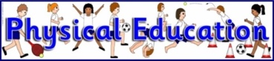  On Monday’s the children will be learning the skills necessary for Tri Golf and on Friday’s the children will be learning the skills necessary to play tennis. If you wish your child may wear their PE kit on these days. Please ensure they wear joggers and the school PE hoodie, trainers to change into and light jacket / waterproof that can be worn during sports as we intend to be outside wherever possible  Homework reminder –  Please continue to complete the weekly tasks in the CGP homework books and parents/ carers please ensure you mark them afterwards so that the children can complete their corrections. Don’t forget to download photos onto Class Dojo of your work completed. In Mrs Fletcher’s absence Mrs Athey will be regularly checking this. | In RE -We use the Northumberland County Council  Agreed Syllabus for Religious Education and will be looking at how religions are celebrated around the world.
REMINDERS:
Please could you ensure all equipment and clothing is clearly labelled with your child’s name and that they have a well-equipped pencil case in school (please see uniform list).
Children will continue to not be given planners or reading logs this half term. We are now using Class Dojo. One piece of English and one piece of Maths work should be completed in homework task books each week, along with daily reading, Sumdog and School360 activities.

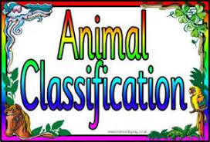  In Science / STEM - we will learn to describe the differences in the life cycles of a mammal, an amphibian, an insect and a bird.  We will describe how living things are grouped and classified based on similarities and differences. Year 5 will also be part of the ‘Growing Up Talk’ next half term – letters to follow. | 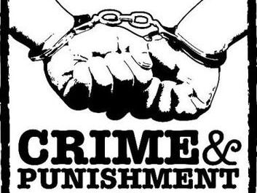  In History we will continue our journey through British History to discover how crime and punishment has changed through the Early Modern Period and the Victorians. We will discover how changes in society create changes in the kinds of crimes that are committed, as well as the ways in which they are punished.

