

**Celebrating Similarities & Differences and Show Racism the Red Card**

**Nursery – Year 6**

**Friday 16th October 2020**

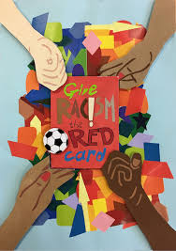

Dear Parents/ Legal Guardians,

Thank you for the extremely positive response regarding my question regarding dressing up to support ‘Show Racism the Red Card’ on Friday 16th October.

Please be assured that this will be dealt with in an age appropriate way and the work we are going to be doing with the younger children will be all about celebrating our similarities and differences to others.

We will be using the books pictured above to help us with this. The older children will be using the ‘Show Racism the Red Card’ resources which are designed for Primary School aged children.

The aim of the day will be for all our children to have a greater understanding of how it is important to celebrate our similarities and differences and to also develop the children’s skills to challenge negative opinions confidently.

I would therefore like to encourage the children to wear a piece of clothing which is red, but they may also which to enhance this with their own colour choice (s), the more colourful the better!

Best wishes,

Belinda Athey - Headteacher