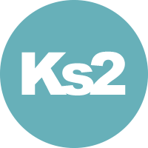
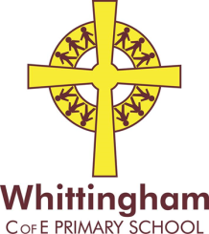
Key Stage 2 Topic Letter
Autumn 2 2016
In Literacy the children are learning about the features of biography writing and will be writing an extract for their own autobiography.  We will then be looking at dialect poetry and having a go at writing poems of our own. The children will also be doing lots of drama as we prepare for our school production. | 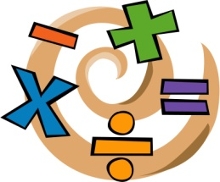  In Numeracy the children will be using the four number operations in problem solving. We will also be looking at properties of shape and understanding fractions this half term.
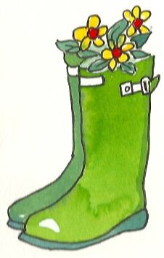  In Art and Design the children are continuing to work with Mrs Durie to produce art work for our local study book. This will include sketching, printing and painting, as well as many other exciting activities. | In Science the children are continuing to learn about the lifecycles and reproduction of plants and animals. This will include work on classification of living things, looking at how changes to the environment can pose dangers to living things and how human activity can affect habitats.
In French the children will continue their language learning through the happy language scheme ‘La Jolie Ronde’. We will begin to use our language skills to describe ourselves and the world around us. | In R.E the children will be learning about the Christian church and know some of the similarities and differences between places of worship in other world religions.
In Computing the children will be developing their understanding of word processing using word, powerpoint and publisher, as well as online programs. They will also be using the App Morfo to bring historical characters back to life. | Topic  The children will be learning about the Victorians this term. We will be looking at how life was different for children in the past.  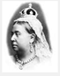
In Music class 2 will be receiving violin tuition, this will continue until February half term. Class 3 will be composing descriptive music,  understanding rhythmic patterns  and performing together. All children will be doing lots of singing practice as we prepare for our show. | 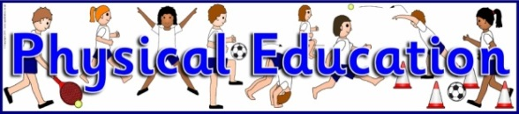  In P.E at Willowburn on a Monday the children will be swimming. On a Thursday the children will be participating in hockey in school, led by Mrs Burroughs.
In PSHE The children are thinking about what makes them unique and why it is ‘good to be me’. We will also be looking at controlling emotions and feelings associated with growing up. | In Design and Technology Year 4 (class 3) will be looking at food hygiene and learning cookery skills with Mrs Athey. Class 2 and Year 5 will be creating mechanisms using paper and designing a story book for younger pupils.
We are hoping to continue to make the most of our fantastic school grounds over the winter months. It would be really helpful if all children could please have a pair of named wellies in school at all times, so we can use the field whenever we want to. Many thanks, Mrs Fletcher and Mrs Fortescue.

