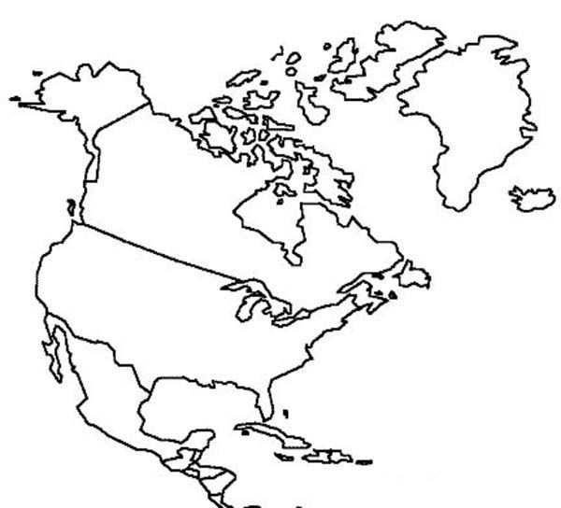

Countries in this area include:

Countries in this area include: