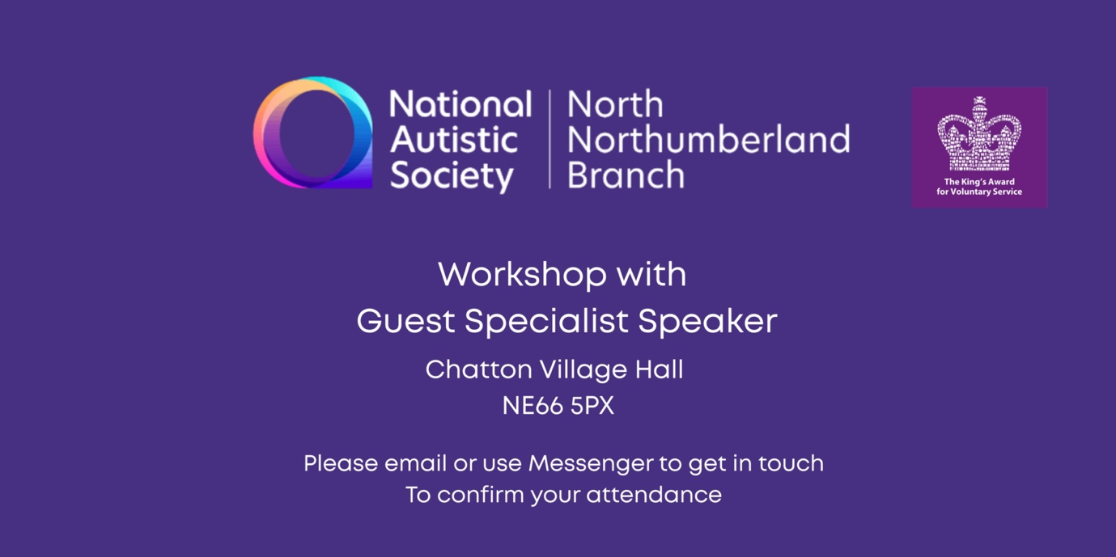

**Monday October 13th 2025 – Chatton Village Hall NE66 5PX**

**6.30 - 8pm**

LIFE PLANNING GUIDANCE for PARENTS & CARERS

of

DISABLED CHILDREN & ADULTS

Presented by Mandy Cheung

This is the second in our series of Life Planning sessions, this one will focus on health and welfare in relation to capacity, deputyship, POA & wills, etc.

Mandy Cheung is a solicitor practising with EMG Solicitors, Gosforth.

You can find more information about the branch and its services on

<https://www.facebook.com/nasnorthnorthumberlandbranch>

To help us ascertain numbers for the refreshments, it would be helpful

if you could email to confirm your attendance by messaging:

Helen Sutherland at

[northnorthumberland.branch@nas.org.uk](mailto:northnorthumberland.branch@nas.org.uk)