Free Online Music Apps

Try out these free music apps and games.

- Explore different sounds and instruments using your desktop or laptop keyboard and mouse.
- Create your own music by selecting drum beats and sounds.
- Record and playback your own music.

Try them all out and choose the ones you like best. The games are listed in order of how easy they are to use.

Papatap

https://www.patatap.com/

Press the keys on your computer keyboard - listen to the sounds and enjoy the shapes and colours on your screen.

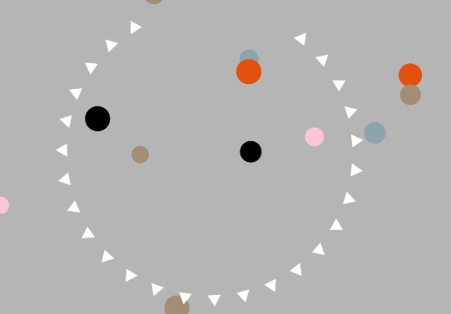

Nickelodeon Games

http://www.nick.co.uk/search?q=music+games

Test your listening and responding skills in these music games from Nickelodeon.

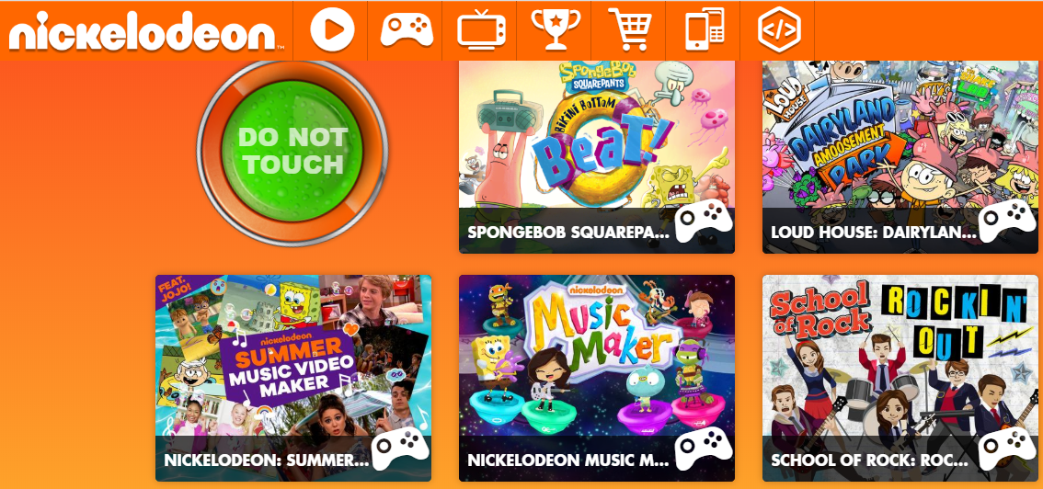

Block Games

http://creatingmusic.com/BlockGames/NewGames/BlockGames.html

Test your listening skills with these 3 games. Listen to the instructions first and then see if you can complete them all.

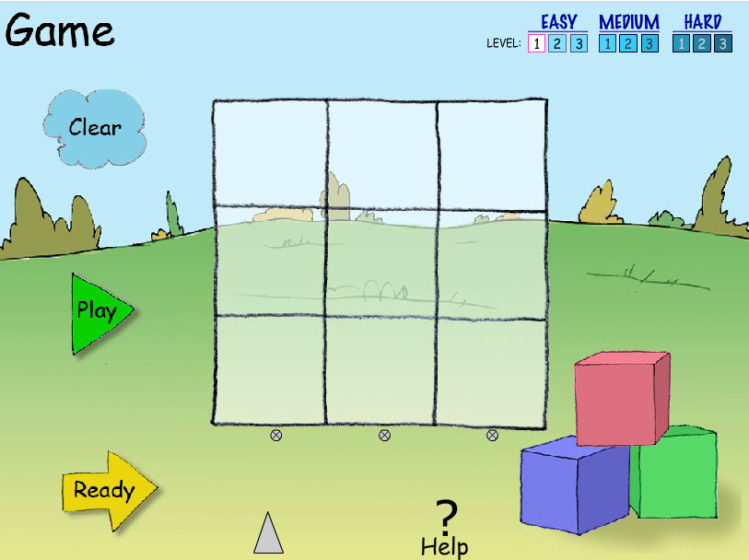

Sampulator

http://sampulator.com/

Press the keys on your keyboard. Explore and listen to the sounds. Record your sounds and playback.

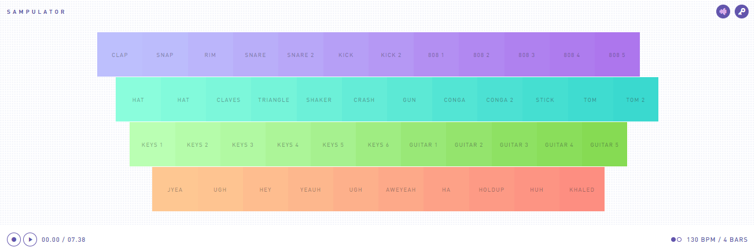

Typatone

https://typatone.com/

Use your keyboard to type letters, words or sentences (or just press keys at random!) then listen to the music you have created. You can change the instrument sounds: circled in green. To stop the music playing you need to use your ‘delete’ key.

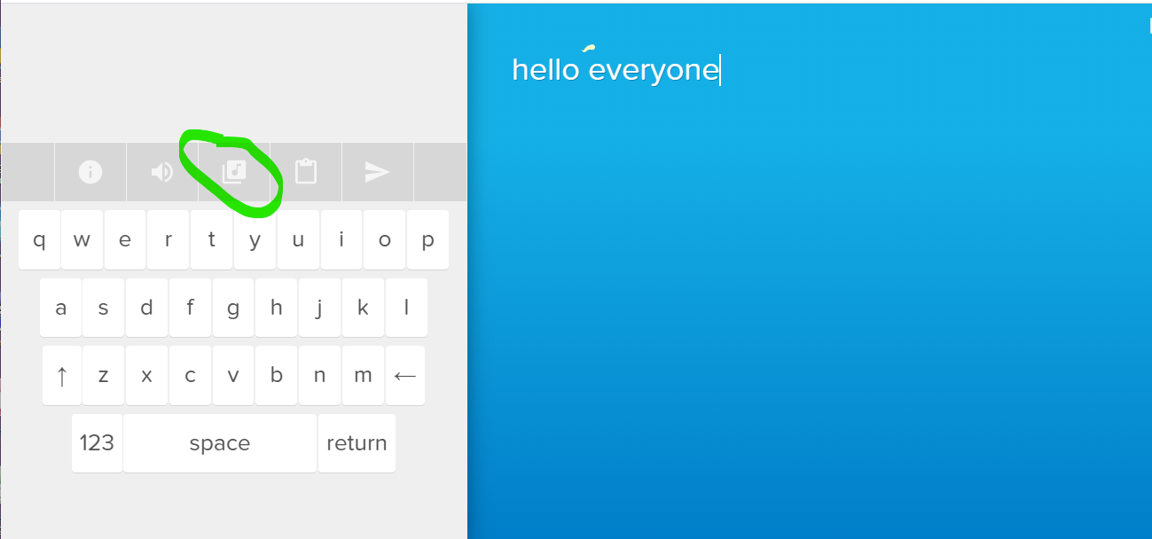

Incredibox

https://www.incredibox.com/

Try the free web version of this fun music maker. Choose a style of music. Use your mouse to drag and drop different sounds on the cool looking dudes (see the image below with the green arrows). Listen to the music they make. You can stop and start the music by clicking on the cool dudes. You can change the sound by deleting it and selecting a new one (see image below)

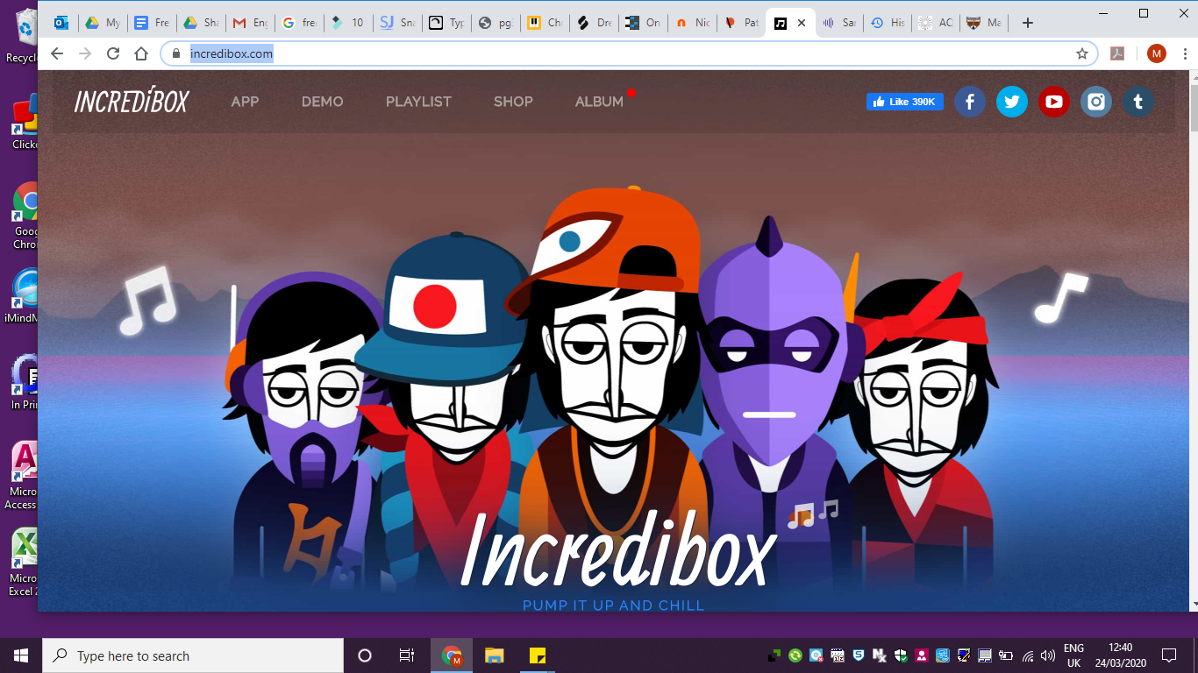

Try the sounds out by dragging them up.
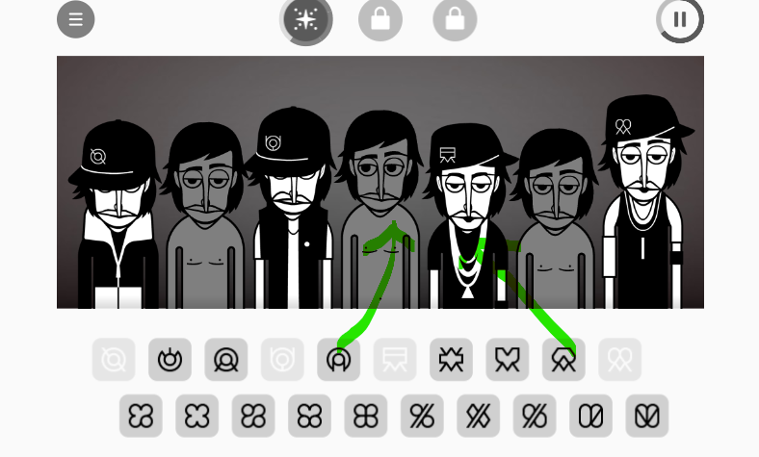
Change the sound using the delete button here.

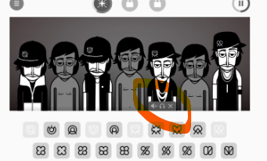

Chrome Music Lab

https://musiclab.chromeexperiments.com/Song-Maker/

Create your own drum beat and melody and playback. Just click anywhere on the square grid and listen to the sounds. Make Low and high sounds and long and short sounds. Make a drum beat with the bottom two rows (triangles and circles).

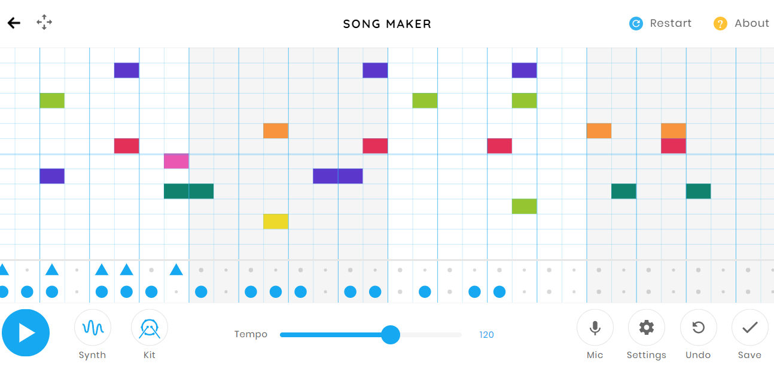

Mario Paint Music https://danielx.net/composer/

Click on the grid to create music. You can select different sounds using the images at the top of the screen.

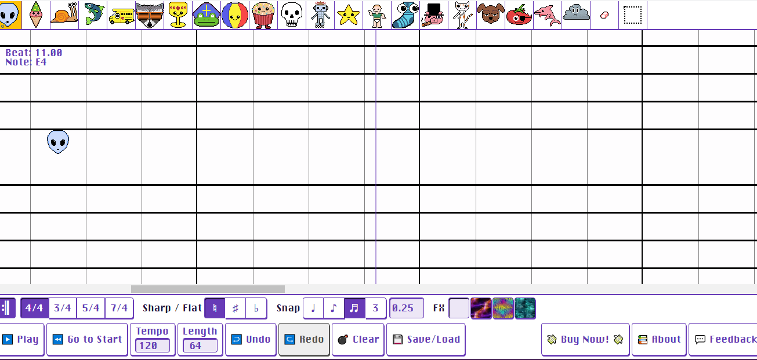

AQWERTYON

https://apps.musedlab.org/aqwertyon/?video=R7iNSUoQ4Lk&sound=rock_organ&

Select a song track then use your keyboard to play along with the music.

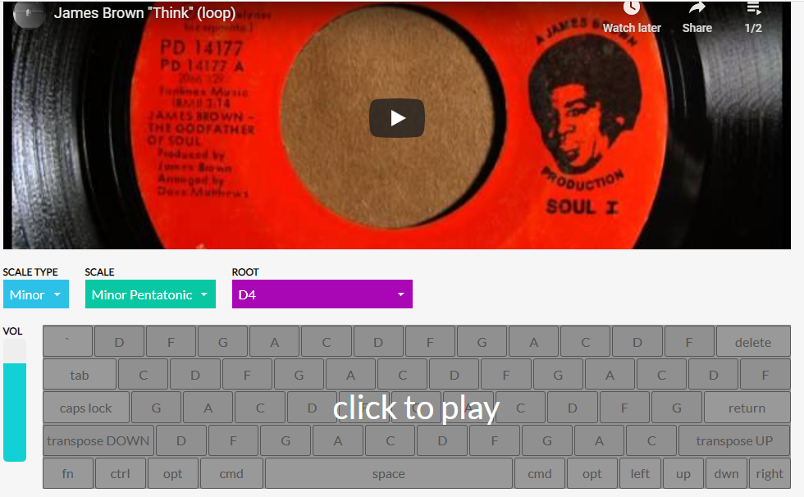

I hope you all enjoy trying these apps out. If you can, send me an email and let me know which ones you like.

Happy music making!

