Date: ___________________________

LO: understanding thousandths (lesson 5)

2)

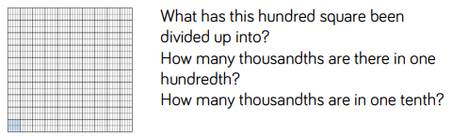

3) Complete the table:

|  |  |  |  |  |
| --- | --- | --- | --- | --- |
| **Decimal** | 0.003 | 0.35 L |  | 0.4 |
| **Fraction** | ______ | _____  1000 | 350  1000 | _____  1000 |

4) Write these fractions as decimals:



5)

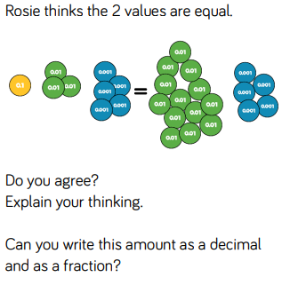



1)Record both the fraction and decimal.

a) 23 thousandths = _____ =

b) 4 thousandths + 6 hundredths = _____ =

