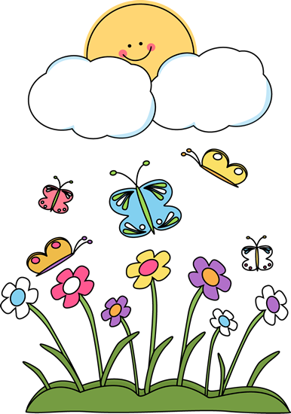

Class 1 Spring (2) 2017

Teacher - Mrs.Maule. Supported by TA – Miss Clarke, Mrs.Lewis and Mrs Chisholm.

Dear Parents/Legal Guardians,

I hope that you had an enjoyable and restful half term. This half term we will be continuing with our previous topics (we are teaching on a **termly basis** instead of a half termly basis). This will enable us to cover each topic in more depth and allow for more cross curricular links.

Here are some reminders and information which I hope you will find useful.

*Mrs Maule*

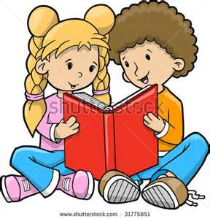



**Literacy**

The children will progress through our Literacy programme – Read Write Inc (RWI), that teaches reading, writing and spelling. They will continue to learn new letter sounds which will help them to become fluent readers. They will explore different genres of writing including narrative and non-fiction, for example, writing an information report.

**Reading**

In Class One we read in Guided Reading groups. This involves a small group of children taking turns to read from the same book. During these sessions we will analyse a text in detail – discussing new vocabulary, making predictions and ensuring we understand the text.

Please keep your child’s reading book and reading record in their book bag each day.

Please support your child at home by reading a little each night. ‘Little and often’ will help make reading more enjoyable for both you and your child. Please sign and date your child’s reading record each time you read. Thank you.

**High frequency words (HFW)**

High frequency words (HFW) are often called sight words because they must be memorised by sight.  The reason for this is that many HFWs can not be sounded out.  These words should be memorised a few at a time, and constantly revisited until your child is able to read, write, and spell them easily.

Learning these words is of huge benefit to your child as it helps them become more **confident** in their reading, it helps their **comprehension** and it provides clues to the **context** of the text.

Please help your child to practice reading the high frequency words distributed at Parent consultations.

The following website has some online games which will make learning these more fun:

<http://www.familylearning.org.uk/sight_word_games.html>

Thank you.Mrs Maule

Thank you.

Thank you.

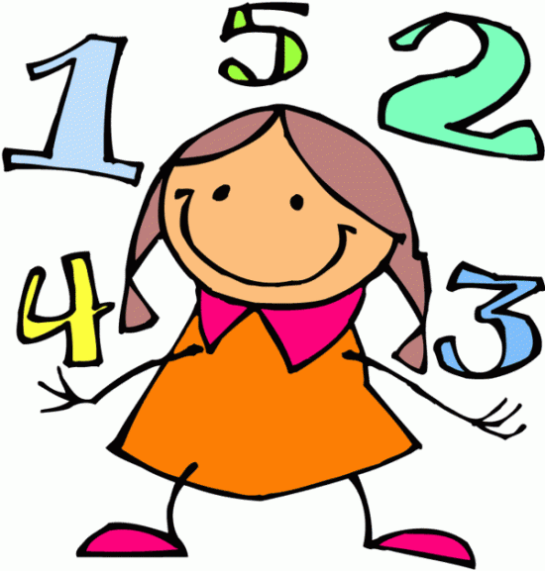

**Maths**

Year 1 children will learn: name and describe 2D shapes, use a table to help sort objects, find halves and quarters of shapes, odd and even numbers, find doubles to double 20, find 10 more and 10 less than a 2 digit number.

Year 2 children will learn: name, describe and draw regular and irregular common 2D shapes, use Venn diagrams and Carroll diagrams to sort shapes and objects, find halves and quarters of shapes, find doubles to double 20 and related halve, add two 2 digit numbers (23+34), compare numbers using < and >.

**Times tables (Y2)**

Year 2 children will continue to have a weekly times table test.This test will be on a **Monday.** Year 1 children will start to learn times tables later in the year.

**Number Bonds**

Please continue to help your child practice their number bonds of 5 and 10 (Year 1) and bonds of 10, 20 and 100 (Y2). These are very important number facts which will help your child greatly in their maths.

The children are thoroughly enjoying our current topics and are looking forward to learning more:

**Science** – Materials and their uses

**History**– Neil Armstrong

**Computing** – Coding using J2Code.

**Art** **and** **DT** – 3d forms - Making space crafts, space themed art - Van Gogh – Starry Night, Easter crafts

**RE** – Judaism – celebration of Hanukkah, Jewish lifestyle, different artefacts Jewish people

have in their home, Jewish scripture (Torah).

**Music** –Experiment with, create, select and combine sounds.

[](http://www.google.co.uk/imgres?imgurl=http://www.wheatfieldsjm.herts.sch.uk/images/curriculum_images/science_images/science_clipart.jpg&imgrefurl=http://www.wheatfieldsjm.herts.sch.uk/curriculum/science/science.html&h=312&w=291&tbnid=9D_v0-JhMrnKNM:&zoom=1&docid=OzFdHfAx34VImM&ei=pr0IVIIkhao79bmAwAQ&tbm=isch&ved=0CA4QMygGMAY4ZA&iact=rc&uact=3&dur=1191&page=6&start=92&ndsp=21)

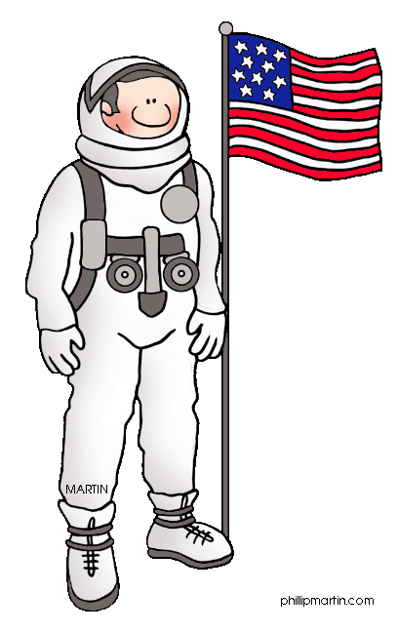



**Homework**

**Spelling homework** will continue to be given out **every Friday.** The children will have a **spelling test** the following **Friday**.

These spellings will focus on a key sound/pattern each week. Please spend some time discussing the spelling rules provided with your child so that they fully understand.

Please continue to practice spelling the **days of the week** with your child as these are tricky words.

**Please keep your child’s Homework book in their book bag each day** as we do practice our spellings throughout the week.

**Maths homework** will be given on a **Monday** on School 360. The children will have a week to complete this task.

Thank you for your continued support.

[](https://www.google.co.uk/url?sa=i&rct=j&q=&esrc=s&source=images&cd=&cad=rja&uact=8&ved=0ahUKEwiugfTPoq7SAhVoLMAKHeufCIMQjRwIBw&url=http://www.clipartbay.com/kids-arts-and-crafts-clip-art&bvm=bv.148073327,d.cGc&psig=AFQjCNE5P-bSw1weGsOA49idqrgc3fXeBg&ust=1488215911250173)

**DT Day**

We will be making our space crafts on **Friday 17th March.** Please continue to collect junk materials including, **bottle lids**, **plastic bottles**, yoghurt pots, kitchen roll tubes etc. Please **do not** bring in your junk materials until Friday 17th March as it is a health and safety hazard to store them in our classroom. Many thanks.

[](https://www.google.co.uk/imgres?imgurl&imgrefurl=http://www.engravingcreations.com/clipart/religion.htm&h=0&w=0&sz=1&tbnid=-iJDu2Xvaxu2bM&tbnh=220&tbnw=229&zoom=1&docid=qUGgsZbLFBuKIM&ei=w28PU6yuOuLP0AWWroEQ&ved=0CAsQsCUoAw)



PE

This half term Class 1 will do trampolining on a **Monday** afternoon at Willowburn. Please ensure your child is dressed in their school sports uniform on this day. On **Tuesday** afternoons, the children will learn how to play different games. Please ensure your child brings their school sports uniform to change into on this day.



[](http://www.google.co.uk/url?sa=i&rct=j&q=&esrc=s&frm=1&source=images&cd=&cad=rja&docid=R6mqHTrtl7NB6M&tbnid=iC5EQ5X9SgQSlM:&ved=0CAUQjRw&url=http://bestclipartblog.com/11-sports-clip-art.html&ei=AXEPU7DNMeWu0QWmw4HwDQ&bvm=bv.61965928,d.ZGU&psig=AFQjCNGR59JcUjxyOUWa6xUoR43GOHeRAg&ust=1393607108542674)



[](https://www.google.co.uk/imgres?imgurl&imgrefurl=http://siliconangle.com/blog/2013/08/26/3-nails-in-ballmers-coffin-mobile-music-windows/music-clipart/&h=0&w=0&sz=1&tbnid=BB88WxrftFWXzM&tbnh=196&tbnw=257&zoom=1&docid=KlIn57xq-lRKiM&ei=RW8PU5q2Ncam0QXxtoCYBQ&ved=0CAUQsCUoAQ)

[](http://www.google.co.uk/url?sa=i&rct=j&q=&esrc=s&frm=1&source=images&cd=&cad=rja&docid=kM-M_Pdsp4dN2M&tbnid=rKXj6mxrz3DtVM:&ved=0CAUQjRw&url=http://www.clker.com/clipart-240600.html&ei=BG8PU83ZB6Pv0gWU-oDIAg&bvm=bv.61965928,d.ZGU&psig=AFQjCNF7Syk0CrvsYNqLmC4dL9b8JqJU0Q&ust=1393606710764443)

**Gentle reminders**

Willowburn (Trampolining) – Monday

P.E. – Tuesday

Library – Friday

Times tables test – Monday (Y2 children)

**Spelling test - Friday**

Please ensure that your child has got both their reading book and reading record in their book bag each day.

Please ensure that your child brings a **labelled water bottle** to school each day.

Many thanks for all your help and support. If I can be of any further help please let me know. *Mrs Maule.*