Early Years Topic Letter

Welcome back and I hope you have had a fantastic holiday break!

We are thrilled to announce that Mrs Marsden will be staying with us in Early Years and will share the teaching with Miss Dick. Miss Dick continues to teach Monday, Tuesday, Wednesday and Mrs Marsden teaches Thursday and Friday.

Gentle reminders:
Please continue to support us as we work to keep your children safe, especially in light of the new restrictions. We hope to make your child’s experience as fun and inspiring as possible and are thinking of creative ways of doing this without our usual visitors and school trips. Please remember to social distance at all times on our school site and remember only one adult should be picking your child up from school to reduce numbers on our school site.

Please remember a WATERPROOF COAT at all times, we go out in all weathers so a hat, scarf and gloves will be needed as the weather begins to get colder!

Please make sure every item of clothing is clearly marked with your child’s name. There have been lots of items of uniform go missing this half term or end up going home with someone else. I am still picking up cardigans, jumpers and hoodies on a daily basis with no name in… making it impossible to reunite them!

Please remember to log onto your child’s tapestry account regularly, this will help you to see what your child’s next steps are and will help you to support your child’s learning. Further to this, it is a lovely way to see what we have been up to and talk about school with your children. Don’t forget to upload achievements and experiences at home!
Don’t forget, we are always available to chat, if you or your child have any concerns, please get in touch!

The Early Years Team
Personal, Social and Emotional Development  We will continue to reinforce positive behaviour at all times in EYFS. Supporting the children to develop their personal, social and emotional development is at the core of what we do in every way.  This half term we will place particular emphasis on:  Developing our friendships and playing with a wider range of children. Initiating play and asking other children to join in with our games. We will be placing a huge emphasis on developing relationships.  Accepting delay and being able to share our own thoughts and feelings.  Developing our confidence in a range of ways through small group times and whole class activities.  We will use our focus text ‘Owl Babies’ to continue to think closely about different feelings including sad, happy, cross and being scared or worried. We will develop this by thinking more about other people’s feelings. We will take ownership for how we make people feel and will be introduced to our new ‘special friend’ in our classroom who hides if he doesn’t see kind children. We will think lots about what we can do to make other people feel happier.  Developing our ability to accept delay and understand that we can’t always have what we want straight away.  To share our desires and needs with confidence. | Physical Development  This half term we will be prioritising developing our independence! We will be working on putting our own shoes or wellies on, going to the toilet, identifying when we need our nappy changes, putting our coat on, peeling our fruit and putting our straw in our milk! You can help at home by supporting your child to get dressed by themselves and have a go at putting their coat on before you help them. You can also support them to wash their hands; this is something we have been working on lots at school!  We will also be working hard to develop our fine motor and gross motor skills. We will be continuing with dough disco sessions and will also introduce a new activity called ‘squiggle while you wiggle’ .This is a new programme which we have bought to help support the children to develop their gross motor skills and early writing in a fun and energetic way!  We will continue to promote gross motor activities like climbing, jumping, running and squatting outdoors and at forest school.  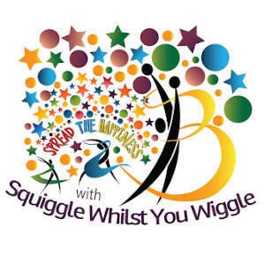  We will be taking part in lots of fine motor activities which will help to develop the strength in our fingers, and support us to hold a pencil effectively. These will include things like pinching, threading, using pegs, twisting, brushing, stacking and using tweezers.  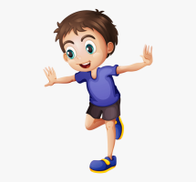  We will be developing our pencil control and Reception will be focussing on accurate letter formation in our name and other words. In Nursery, if we are ready, we will also be working hard to write our names.
RE  This half term Reception will continue to take part in RE sessions to understand Christianity and will focus on ‘Communities’. During this we will look at the ‘Stone Soup’ and how we can help our community. Reception and Nursery will also talk about special times, take part in special worships, learn about different celebrations such as Diwali, Christingle, Hannukah and Christmas!  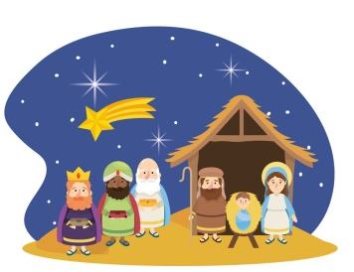 | Communication and Language  We develop the children’s listening and attention, understanding and speaking skills all of the time and often based on your child’s next steps as the children often have specific areas to work on. This half term we will be focusing on:  Having two channelled attention, being able to listen and ‘do’ at the same time.  Singing and learning lots of familiar and new nursery rhymes.  Learning the ‘Owl Babies’ story off by heart through our Talk4Writing approach and learn new vocabulary in relation to the story and characters.  Using more complex sentences to link our ideas and thoughts.  Some of the children will take part in ‘TalkBoost’ sessions later in the half term when all of the EYFS staff have been trained.
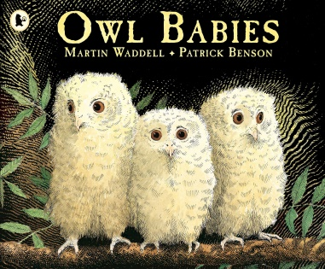
Reception Literacy

This half term in Reception we will continue to focus on learning out RWInc set 1 sounds through short and snappy ‘speed sounds’ sessions each morning, designed to teach the children to recognise and pronounce the pure sounds, before reading them in simple CVC words such as ‘cat, top, sit’.
For those children who are confidently doing this, we will be moving on to introduce set 2 sounds later in the term (ay, ee, igh, ow, oo). We will also be introducing new red words this half term, including ‘my, go, to, said, no’. We have already learnt the tricky red words ‘I’ and ‘the’. We will be recapping these words and supporting the children to apply these in their own writing within the provision. We will be developing our writing skills this half term so that the children begin to label pictures and write for various purposes using initial sounds, single words or simple captions where they are able. It still remains very important that as the children pick up the Read, Write, Inc. sounds that they practise forming these accurately, starting in the correct place.

We will also continue to develop our recognition of rhyming and alliteration through fun games, songs and rhymes. It is vital that the children develop their sound discrimination skills before they can become fluent readers.

We will be developing our ‘Talk 4 Writing’ skills this half term by linking lots of what we do to our focus text ‘Owl Babies’. We will be learning to retell this story by creating story maps, learning actions and taking part in lots of fun activities relating to the text.

We will share non-fiction books about Owls and learn about how information can be retrieved from books and computers. We will work together to write our own Owl fact file and will label a picture of an owl and a picture of the nests we make at forest school.
We will be continuing to write for a purpose - writing letters to Santa, labelling models and writing Christmas lists!

You can support your child at home by helping them with their oral blending and segmenting. Play games like ‘can you put on your c-oa-t’, ‘sit on your b-e-d’…. and see if your child can follow your instructions. Practise reading daily and share lots of stories! Don’t forget to practise your RWinc green word cards which we send home with the children. You can support your child to write by being very positive if they have a go and by modelling writing for lots of different purposes.

Nursery Literacy

This half term in Nursery we will be continuing to focus on learning and retelling familiar and new Nursery rhymes. We will be sharing our focus text of ‘Owl Babies’ as we take part in many activities linked to the story and we will learn to retell the story and put actions to it. We will share non-fiction texts about Owls and enjoy learning about them through various videos and books.

We will be working on having a go at writing our names and developing our mark making skills.
This half term we will be continuing to place our emphasis on creating confident mark maker’s, allowing the children to explore the different marks they make using a variety of tools including chalk, pens, pencils, crayons, water and in sensory trays. We will use our new programme ‘Squiggle While you Wiggle’ to help us to develop our early writing skills in an energetic and fun way.

We will also be promoting drawing and supporting the children to talk about what they have drawn and the marks they have made.
We will continue to take part in short daily phase one phonics sessions which will help us to develop our sound discrimination and listening skills. This half term we will be focussing on body percussion and rhythm and rhyme.
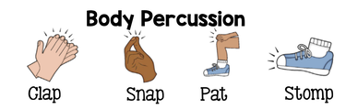

Nursery Maths  Maths happens all day in Early Years, during the  register, at snack time and while the children play. Before the day has even started we have counted and added up how many children we have at school and recorded this using numicon and on tens frames.  This half term we will focus on:  Developing our counting, in order, to 10 and beyond.  Counting small amounts of objects accurately using 1 to 1 correspondence.  Playing with and exploring numicon.  Exploring the concept of everyday time, for example – what do you do in the morning or before bed? Do you know what we do after lunch time? We will learn lots about day and night as we look at our book ‘Owl Babies’.  Talking about 2D shapes  Explore positional language | Reception Maths  Maths happens all day in Early Years. Each morning at register time, we will count how many children we have, add them up and record this using numicon and number sentences before our day has even started! Maths is covered in all areas of the provision but as the children move into Reception they also take part in short directed Maths activities. The children can then apply the skills they have used in the provision.  This half term we will focus on:  Composition of 1,2 and 3 (how we can make these numbers)  Circles and triangles and shapes with 4 sides.  Positional language  Representing numbers to 5 and beyond.  Time – night and day, ordering key events, days of the week.  We will also continue to work on number formation sing the rhymes we learn at school.
Expressive, Art and Design  This term the children will have the opportunity to:  Construct with a purpose in mind and explore different techniques used to attach things together.  Explore musical instruments, making noise like various animals and independently making sounds.  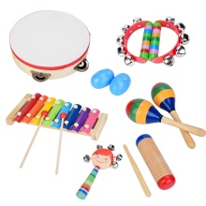  Explore open ended resources and use construction materials to build and make things (including natural resources at forest school).  Explore light and dark colours and how to alter and change these.  Developing and practising Christmas songs and acting out the nativity (if we can’t have a Christmas play).  Make a variety of artwork linked to our topic, including collage pictures, paintings and clay sculptures. | Understanding the World  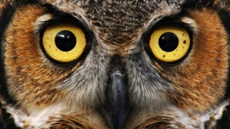  Sadly we had planned to have some a visit from some real owls in school so that we could excite the children, due to the current pandemic and more recent 2nd lockdown we won’t be able to do this.  This term we will be:  Exploring seasonal changes and the environment in Autumn/Winter - leaves falling, freezing and melting.  Learning about nocturnal animals including Owls.  Learning about an Owls life cycle.  Learning about why and how animals hibernate.  Exploring day and night and light and dark.  Learning about and celebrating Diwali and Christmas. Comparing these celebrations to our own traditions and lives.  Using cameras to take photos and videos and use age appropriate programmes on the IWB by ourselves.

