Miss Trafford supported by Miss Clark
Welcome back Class 1 and happy new year! I Hope you all had an amazing Christmas and you are all ready to start learning this half term. I have heard that you completed some fantastic work last term so I am looking forward to supporting you with your learning this term. Our topic letter will cover what we should have been doing in school this half term, so may give you some ideas of things additionally you can do at home.
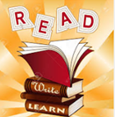  In Literacy we will be using the Oak Academy video lessons. We will be covering fiction stories which include ‘stories in familiar settings’ and ‘tales from a different culture.’ with a focus on retelling and character description.  When writing, in year one, we will be encouraging the children to use capital letters, full stops and finger spaces. In year two we will be adding adjectives, conjunctions and subordinate clauses to our writing.  It is important that children are using their CGP books and sumdog for grammar and spelling daily.  Key vocabulary: Nouns, verb, adverb, adjective, conjunction, subordination, subordinate clause, command, capital letter, exclamation mark, question mark, past and present tense. | 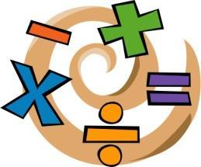  In Numeracy year 1 children will be focusing on addition and subtraction within 20 and place value up to 50.  Year 2 will be learning about multiplication, division and statistics. Children will complete their home learning following the White Rose scheme which we use in school, using video lessons alongside worksheets and problem solving activities.  CGP books and Sumdog should also be used at home for maths activities daily.  Key vocabulary for multiplication and division:  Group, grouping, sharing, half, halves, share equally, equal groups, share, divide, multiply, times, groups of, lots of, array.  Key vocabulary for statistics: pictogram, tally chart, block diagram, category, quantity.  Key vocabulary for addition and subtraction: more, less, plus, make, total, less, subtract, take away.  Key vocabulary for place value: compare, same as, order, tens, ones, equal to.
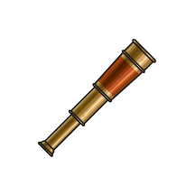
In History we will be learning about significant explorers from history and what makes a person significant with a focus on Neil Armstrong and his space exploration. We will be comparing the space mission to other expeditions such as Matthew Henson’s voyages to the arctic. We will be discussing, researching and writing about these significant explorers.
Key vocabulary: Significant, explorer, Neil Armstrong, space, missions, astronaut, apollo, orbit, compass, navigation, ocean, shuttle, voyage.
In R.E we will be using the Oak National Academy lessons to learn about Christianity and God. We will be discussing parenthood and friendship to support children’s understanding of God and the Christian religion.
Key vocabulary: Christianity, Christian, parent, friendship, God, prayer, church.
In Science we will be investigating materials and their uses. We will discuss and describe the properties of different materials and use this information to make a model of a rocket which will be waterproof and be able to survive a journey to space!

Key vocabulary: wood, plastic, glass, metal, water, rock, properties, materials, strong, stretchy, waterproof, soluble, insoluble, hard, soft, rough, smooth.
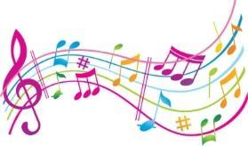  In music we will be following the charanga scheme of learning and will be listening carefully to the beat and tapping out the pulse and rhythm of the music. We will also be learning new songs and practicing performance.  Key vocabulary: pulse, rhythm, perform, performance, volume. | 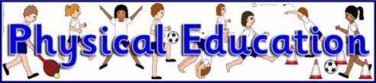  In P.E I would like you to try and complete some form of exercise at least once a day, whether this is the daily mile, Joe Wicks PE lesson or another kind of exercise such as dancing or yoga. If possible, you can also practice your ball skills using a football or tennis ball e.g. dribbling, throwing, catching and kicking.
In PSHE we will be learning about our physical health and mental wellbeing. We will learn about the people who keep us healthy such as doctors, nurses and dentists. We will also be learning how to describe and talk about our feelings and discuss different strategies that we can use to regulate our emotions when needed.  Key vocabulary: safe, protect, healthy, unhealthy, hygiene, feelings, mood, calm. | In Art/DT we will be creating our own representations of planets using a range of different materials including oil pastels, pencils and watercolour paint. We will also be designing and making a vehicle to transport a rocket to a rocket launching pad using wheels and axles.  Key vocabulary: model, template, design, mixing, colour, materials, construct, pastel, watercolour, pattern, texture, shape.
Reminders:
- All home learning will be posted on the class 1 home learning section of the school website.
- Please send in pictures of work using class dojo, so I can monitor and feedback.
- Regular keeping in touch phone calls, intervention or Google meet will be taking place roughly every 2 weeks.
- Please alongside the lessons set, try to complete some Sumdog and CGP workbooks each day.

Stay safe everyone, I look forward to meeting you soon!
Miss Trafford

